Title: Legal uncertainty and the cost of capital for SMEs: new insights from the Italian manufacturing industry

Keywords: legal uncertainty, length of proceedings, SMEs, manufacturing industry,

Authors: Falavigna G.; Ippoliti R.;* Ramello G.B.

Extended Abstract
The intersection of judicial efficiency and corporate finance has long intrigued scholars and policymakers alike. This study investigates the impact of legal system performance—specifically, the duration of judicial proceedings—on the cost of corporate borrowing. Drawing on a multidisciplinary framework that integrates legal institutional theory with financial economics, we propose the following hypothesis: the longer the duration of legal proceedings, the higher the interest rate paid by firms on their financial debts.
Using a panel dataset of firms across first instance jurisdictions (i.e., Circondari Giudiziari) with varying levels of judicial efficiency, we examine whether prolonged litigation timelines correlate with increased perceived risk among lenders, thereby elevating borrowing costs. Our empirical strategy controls for firm-specific financial indicators, macroeconomic conditions, and jurisdictional legal characteristics. Preliminary findings suggest a statistically significant positive relationship between the length of proceedings and interest rates, underscoring the role of legal infrastructure in shaping financial outcomes.
This research contributes to the growing literature on law and finance by highlighting how inefficiencies in the legal system can translate into tangible economic burdens for firms. The implications are particularly relevant for policymakers aiming to foster more competitive credit markets through judicial reform.
Considering judicial district of first instance in 2019, Figure 1 shows some preliminary highlights on the expected relation that we test in our empirical analysis. In detail, the Figure proposes a scatter plot that uses these districts as observations, with the number of SMEs as frequency weights. On the one hand, we have the average interest rate paid by manufacturing SMEs at time t while, on the other hand, we have the average length of proceedings in enforcing an insolvency procedure of mortgage foreclosure (real estate) at time t-1. As the reader can observe, we have a positive relation between the two proxies, suggesting that the higher the judicial delay, the higher the cost for external financial resources. In detail, increasing the length of proceedings by 1% in a district, we expect to observe an increase in the interest rate of 2.22%. According to our hypothesis, this result is due to higher legal uncertainty in case of insolvency, which can push lenders to increase the cost for such financial resources. The econometric models proposed in the successive section will verify whether this hypothesis is sensitive to model definitions (i) or other potential alternative explanations (ii), as well as whether it is robust to potential endogeneity (iii).

Figure 1 – Relation between length of proceedings and cost of capital for SMEs (Italian manufacturing industry, 2019).

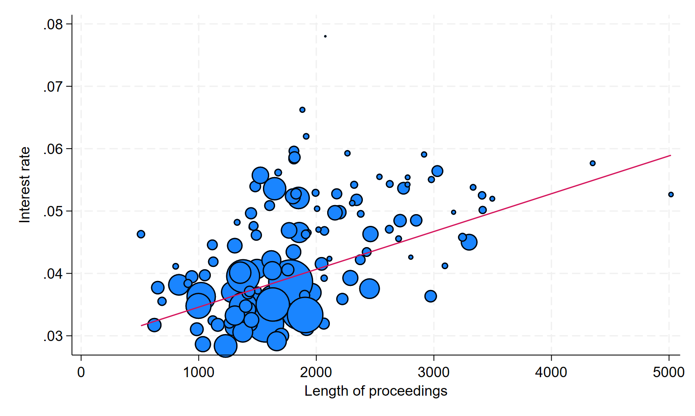
Notes: interest rate is estimated at time t, while length of proceedings at time t-1. We use number of active SMEs as weight of the judicial districts of first instance.

Selected bibliography

Moro, A., Maresch, D., & Ferrando, A. (2018). Creditor protection, judicial enforcement and credit access. The European Journal of Finance, 24(3), 250-281.
Shvets, J. (2013). Judicial institutions and firms' external finance: Evidence from Russia. The Journal of Law, Economics, & Organization, 29(4), 735-764.
Fabbri, D. (2010). Law enforcement and firm financing: Theory and evidence. Journal of the European Economic Association, 8(4), 776-816.
Deakin, S., Mollica, V., & Sarkar, P. (2017). Varieties of creditor protection: insolvency law reform and credit expansion in developed market economies. Socio-Economic Review, 15(2), 359-384.
Fabbri, D., & Padula, M. (2004). Does poor legal enforcement make households credit-constrained?. Journal of Banking & Finance, 28(10), 2369-2397.
Alok, S., Chaurey, R., & Nukala, V. (2022). Creditors’ Rights, Threat of Liquidation, and the Labor and Capital Choices of Firms. The Journal of Law and Economics, 65(4), 687-714.
Jappelli, T., Pagano, M., & Bianco, M. (2005). Courts and banks: Effects of judicial enforcement on credit markets. Journal of Money, Credit and Banking, 223-244.
De Vito, A., & Jacob, M. (2023). The role of creditor protection in lending and tax avoidance. Journal of Financial and Quantitative Analysis, 58(5), 2096-2130.

Research Institute on Sustainable Economic Growth (IRCrES) National Research Council of Italy (CNR),
Department of Law and Political, Economic and Social Sciences (DIGSPES), University of Eastern Piedmont (UPO)
Department of Economics and Statistics “Cognetti De Martiis” University of Turin (UNITO) * Corresponding author. Mail: roberto.ippoliti@uniupo.it

