Non-Majoritarian Institutions – A Menace to Constitutional Democracy?

Stefan Voigt
University of Hamburg and CESifo, Munich

Abstract:
Over the last couple of decades, non-majoritarian institutions (NMIs) have been introduced in many countries. Of late, they have been criticized as promoting technocracy to the detriment of democracy. A number of political scientists even argue that they would strengthen populists and be, hence, one reason for democratic backsliding. This paper does three things: It firstly briefly discusses the empirical evidence for the claim that NMIs have strengthened populists. It secondly argues that not all NMIs are born equal and therefore proposes a taxonomy enabling us to distinguish different types. And it finally discusses the question how the delegation of policy-making competence to experts can be legitimized relying on a specific version of social contract theory. To develop the argument, the interdependence cost calculus developed by Buchanan and Tullock (1962) is modified by explicitly including the respective decision-making procedure, distinguishing between direct democracy, representative democracy, and expert decision-making.

Keywords: Nonmajoritarian institutions; constitutional democracy; technocracy; independent regulatory agencies; populism; social contract theory.
JEL Codes: H11; K38; P51.
- Introduction
Over the last couple of decades, so-called non-majoritarian institutions (NMIs) such as central banks, independent regulators, competition agencies, but also ombudspersons, anti-corruption agencies, and electoral management bodies have become very prominent (Jordana et al. 2018 is an overview). There is hardly any policy area in which such bodies are completely absent: governments have established climate councils and as a consequence of the COVID pandemic, health councils have been proposed – and established in some countries. In Germany, an independent commission has been founded that has the task of determining the minimum wage.
However, the enthusiasm in favor of these institutions is not universally shared. Both political scientists and philosophers have criticized this trend toward NMIs: There is talk of “technocracy” endangering democracy. Some scholars (e.g. Schäfer and Zürun 2021) even believe that the rise of non-majoritarian institutions is one factor responsible for the rise of populist parties that are, in turn, responsible for the democratic backlash that has been on the rise over the last decade.
This paper takes a more nuanced position. Its starting point is that independent regulatory agencies have many potential advantages such as making more informed decisions, mitigating time-inconsistency issues, and enhancing the capacity of the state to make credible commitments. Its second starting point is that constitutional democracy is a desirable form of government and should, hence, be made sustainable. These two starting points are likely to imply a tradeoff: how many independent agencies can constitutional democracy possibly sustain before turning into some kind of technocracy? This paper proposes a way how to think about resolving this seeming tradeoff.
To date, the case of non-majoritarian institutions being an engine promoting populism rests on shaky empirical grounds and is, hence, not the primary focus of this contribution. But some of the questions that have been raised with regard to NMIs are highly relevant. Here are some: which policy issues should be decided on the basis of established procedures of representative democracy and which issues should be delegated to NMIs? What competences should be delegated to the experts; should they “only” advise legislators – or should they be decision-makers in specific policy areas? And finally, the big question lurking behind all the more detailed questions regarding NMIs: how much competence delegation can a representative democracy endure without losing its main trait, namely being a democracy?
This paper does not contain an answer to all of these questions. Rather, it proposes a framework how we could go about thinking about the relevant issues. To do so, it recaps the basic ideas of the interdependence cost calculus first introduced by Buchanan and Tullock (1962). They propose to use interdependence costs as a criterion to decide which activities should be carried out voluntarily and which activities should be carried out by the state. In case an activity is to be carried out by the state, the interdependence cost calculus can be applied to ascertain the optimal decision-making rule. In their presentation of the calculus, Buchanan and Tullock do not distinguish between various decision-making procedures though. Here, I propose to take three procedures of collective decision-making explicitly into account, namely decision-making by direct democracy, representative democracy, and NMIs. The calculus can then be used to allocate specific activities to the best suited decision-making procedures.
The rest of the paper is organized as follows: Section 2 lists a number of reservations that have been raised against non-majoritarian institutions. In Section 3, I propose to narrow the scope of the analysis to organs that are referred to as independent regulatory agencies. The section thus has the purpose of more precisely delineating our research object. Relying on the interdependence cost calculus and social contract theory, Section 4 contains a proposal of how to think about independent regulatory agencies in a systematic fashion and Section 5 concludes.

Reservations Against Non-Majoritarian Institutions
The critique of NMIs by some political scientists can be summarized in a straightforward fashion: representatives of NMIs lack (by definition) an immediate democratic legitimation (see, e.g., already Pinelli 2011, but also Manow 2020). Accordingly, important decisions are made by unelected technocrats, rather than by legislators who are accountable to their voters and who can be kicked out of parliament in regular intervals. As a consequence, important policy decisions might not reflect the preference of the median voter (although the argument is not necessarily expressed in these terms).
In addition, critics of NMIs often assume that these organs are staffed with members of “the elite” and since populists are conventionally defined as challenging the influence of the elite, the rise of NMIs is also, at least in part, responsible for the rise of populist politicians. It has also been claimed that experts only function as a camouflage to implement neoliberal policies. Bertsou and Caramani (2020, 5), e.g., write: “In reality, technocratic experiences point to an affinity between technocracy and neoliberal economic policies, but always in the guise of objectivity.”
These allegations are not convincing. They seem to rest on the assumption that democracy and technocracy are incompatible and that one would need to make a decision in favor of one over the other. However, this only seems to make sense if one thinks of democracy as more or less unconstrained majority rule. I do not think that this dichotomization is helpful. In Section 4 below, I therefore discuss how representative democracy and reliance on NMIs can be beneficially combined.
The argument insinuating that NMIs may foster populism because they are staffed with members of “the elite” also deserves scrutiny: It seems to rest on the assumption that there is a monolithic bloc that can be referred to as “the elite”. I doubt whether this is helpful: It would seem to make sense to separate a “power elite” from a “knowledge elite”.
Much has been written in the line of the above-citation from Bertsou and Caramani. In that sense, it is quoted here only as a pars pro toto. Finally, some of the critique raised against NMIs seems too general. Schäfer and Zürn (2021), e.g., do not distinguish between domestic and international bodies. Also, the delineation of the objects they criticize is often not very precise. This is why I propose to distinguish two types of NMIs in the next section, namely between independent regulatory agencies on the one hand and so-called “fourth branch” institutions on the other.

Delineating Independent Regulatory Agencies from Other NMIs
Before focusing on the differences between different types of NMIs, let’s focus on their commonalities. Trivially – and by definition - none of them are popularly elected. Further commonalities are that they are conventionally supposed to be independent and that their decisions are supposed to be based on knowledge and expertise that members of the elected branches are unlikely to have.
Over the last 20 years, a literature proposing a modification of the well-known separation of powers à la Montesquieu has appeared. The sum of the institutions proposed in that literature beyond the trias made popular by Montesquieu has been variably referred to as an “integrity branch” (Ackerman 2000), a “guarantor branch” (Khaitan 2021) or simply a “new fourth branch” (Tushnet 2021) and the institutions most frequently named as belonging to this branch are electoral commissions, human rights commissions, auditors general, and anti-corruption commissions.
To separate fourth branch institutions from other unelected bodies, I propose to focus on their respective primary functions. The constitution can be read as containing a number of promises to the citizens (with regard to basic human rights, for instance, but also to property and so forth). Since constitutions are not self-enforcing, these promises are not credible per se. Both independent courts as well as the fourth branch institutions can be interpreted as enhancing the credibility of constitutional promises, and optimally even to turn them into credible commitments. By monitoring members of government, these bodies make government more accountable. Their function is, hence, to make governments comply with the constraints laid down in the constitution.
Regulatory agencies have different functions. To spell them out, I first propose to separate different types of IRAs:
- Regulators of network industries. Many network industries are natural monopolies, implying that it is resource-efficient to have a single net. This is, e.g., the case with regard to rail tracks, energy and water supply. Since most everybody depends on their services but granting a monopoly (or licenses to a limited number of competitors) entails dangers, these agencies define the concrete rules of a particular market and are also given the task to ensure that the licensed companies comply with these rules.
- Managers of the commons. Commons are defined as goods from whose consumption nobody can be excluded but that may be subject to rivalrous consumption. This is why individual agents do not only have any incentives to act in favor of their conservation but, to the contrary, have incentives to consume them. Commons regulators – such as environmental agencies – have the function to help conserve existing commons.
- Time-inconsistency mitigators. The most frequently cited example for time-inconsistent behavior is monetary policy: increasing monetary supply may have positive effects on employment in the short term, make citizens happy and increase the chances of politicians to be re-elected. In the medium to long run, however, inflation will increase and make everyone worse off. Worse still, if citizens expect an expansive monetary supply, positive employment effects are unlikely whereas the negative effects will still materialize. By delegating the competence over monetary policy to an independent central bank, the incentives to increase monetary supply can be curtailed and price stability can be gained.,
Beyond the three types of IRAs just proposed, I suggest to ask where competence is delegated to and propose to distinguish between delegation remaining within the nation state on the one hand and delegation beyond the nation state on the other. This distinction will be taken up at the end of Section 4.

How Many NMIs can Democracy bear?

The Interdependence Cost Calculus – a Variant of Social Contract Theory
How should we decide if decision-making competence ought to be delegated to IRAs? And if the question is pro delegation: for what policy areas is it desirable? How can we succeed in legitimizing these decisions democratically? It is stunning how little this question has been discussed while IRAs have spread over the last couple of decades. If social contract theory is used as a tool to think about these questions, then the possibility to create such entities and the procedures used to create them ought to be mentioned in the constitution which should, in turn, be approved unanimously (at least conceptually).
For some people, the right to be left alone or the right to do certain things (such as practicing their religion) is likely to be so important that they will only support the constitution if a number of rights are made basic, i.e. are exempt from majority decision-making. This amounts to the well-known potential conflict between the rule of law on the one hand and majoritarian decision-making on the other. If there are people who will only consent to the social contract if certain rights are exempt from majoritarian decision-making, then the notion of unconstrained majoritarian decision-making should not be the starting point in thinking about assigning policy areas to the respective decision-making procedures.
To couch my argument in social contract theory, I here rely on a version that is today considered the birth document of the economic analysis of constitutions, or constitutional economics for short, and which also formulates a basic democratic intuition. In Buchanan and Tullock’s (1962) theory of constitutional choice, each individual needs to decide on two basic questions, namely
(1) Which activities should be carried out by the state and - once a decision in favor of state-provision has been taken:
(2) Which majorities should be used for making concrete decisions regarding concrete activities?
To answer the first question, Buchanan and Tullock consider two options besides state collective decision making, namely the provision of goods by individuals and by voluntary associations, such as firms or clubs and propose that that option ought to be chosen that causes the lowest interdependence costs. According to them, each activity potentially involves two types of costs, namely external costs and decision-making costs. External costs are the negative externalities put on others by a certain activity. With regard to goods provided by the state, they focus on a person’s obligation to participate in the financing of such goods even if the person does not consume the respective good. Decision-making costs, on the other hand, are those costs that arise because more than one individual needs to agree on something.
Under unanimity rule, external costs are zero since individuals who do not expect to be better off by the provision of a certain good can simply veto its provision. In Figure 1, all possible decision-making rules are depicted on the abscissa: on the very left, any randomly chosen individual can make decisions that are binding for the entire community and at the very right hand side, all society members must consent to a particular activity before it can be carried out. ”n” is hence, equivalent with the unanimity rule. On the other hand, decision-making costs increase in the proportion of the members of a group who need to consent to the provision of a certain good. To take both types of costs into consideration, Buchanan and Tullock propose to simply add them up. The sum of these two costs are then referred to as interdependence costs.
Figure 1 around here
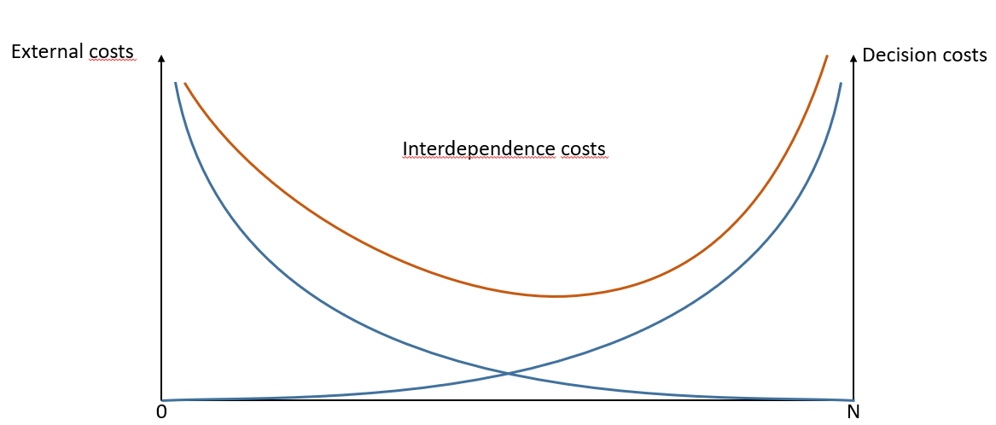

This simple calculus can now be used to answer the two questions spelled out above: only those activities in which the minimum of the interdependence costs is lower than the costs of providing the good on a voluntary basis should be carried out by the state. Once a decision in favor of state provision has been made, the second question can be answered: that decision-making rule should be applied where the interdependence costs have their minimum.
So how can Buchanan and Tullock hope to ever secure unanimous answers to either question, after all, individuals are heterogeneous and might come up with very different cost curves? By way of an assumption reminiscent of Rawls’ veil of ignorance. Whereas Rawls asks his individuals to pretend that they do not know who they are, Buchanan and Tullock simply assume that individuals are uncertain about their future position in society which would give them incentives to opt in favor of general rules not disadvantaging anybody. This can be referred to as the veil of uncertainty. Similar to Rawls, this assumption induces people to consent to general rules that disadvantage no one.
In a sense, this calculus constitutes a radical break with more established economic arguments. Conventionally, economists try to maximize social welfare that is thought of as reflecting the utilities of all members of societies that need to be aggregated “somehow”. Buchanan and Tullock (ibid.) claim to rely on a strictly individualistic approach that does not rely on interpersonal utility comparisons. It also constitutes a radical break because conventionally, the existence of market failure is considered a necessary condition for any activity being allocated to the state. Not here: market failures are neither necessary nor sufficient for such delegation.

Extending the Interdependence Cost Calculus
The interdependence cost calculus thus tells us something about what issues should be put to collective decisions in the first place and – given that collective decision-making is to be applied – what decision rule ought to be used. It is, however, quiet on the different procedures that can be used to make collective decisions. Implicitly, however, Buchanan and Tullock use direct democracy as the relevant procedure. External costs refer to expected costs given that any single individual is authorized to undertake some actions (1962:65; regarding all further citations to the 1962 book, I drop the year and just quote the page) and no delegation of whatever kind is, hence, involved. They continue: “Before leaving the discussion of this any person rule, it is necessary to emphasize that it must be carefully distinguished from a rule which would identify a unique individual and then delegate exclusive decision-making power to him. … To the individual who expects … to be among the governed, the external costs expected will be lower than those under the extreme any person rule that we have been discussing” (67).
Decision-making costs are increasing in the size of the group of individuals who have the right to participate in decision-making. All else equal, decision-making will be more costly under direct democracy than under representative democracy implying that the optimal decision rule under direct democracy should be less inclusive than that under representative democracy. Although this is a direct consequence of the interdependence cost calculus argument, Buchanan and Tullock nowhere explicitly discuss the issue regarding the optimal modus how collective decisions ought to be made. As the main reason for relying on the interdependence cost calculus is to develop an argument regarding NMIs, I propose to distinguish three such procedures here:
- Direct democratic decision-making; all members of society vote themselves. Beyond a certain size of society, direct-democratic decision-making becomes impractical.
- Representative democratic decision-making; collective decisions are made by legislators who are elected by the citizens and assumed to represent their preferences.
- Expert decision-making; decision-making on a number of policy areas is delegated to experts. It is thus explicitly exempted from control by majorities of either the representative chamber(s) or the citizens at large.
This means that an additional question is added to the two questions named at the outset. So the sequence of questions to be answered would now be
- Which activities should be carried out by the state?
- What is the adequate procedure of decision making, differentiating between direct democratic, representative, or independent agency, and finally
(3) Which majorities should be used for making concrete decisions regarding concrete activities?
Unfortunately, adding this question makes the entire exercise a bit more complicated. The answer to the first question may, e.g., depend on how the second question is answered: as just argued, it makes sense to assume that the minima of the interdependence costs also depend on the procedure of decision making. If the letter “g” is used to depict the overall costs that need to be borne if an activity is carried out by government, then the costs connected to the three different decision-making procedures here under consideration can be denoted by gD, gR, and gA for the minima regarding the government provision of goods relying on direct democracy, representative democracy, or independent agency, respectively. Assume that in the Buchanan and Tullock framework
g > a
(where a indicate the costs of an activity carried out on a voluntary basis). In this case, the activity would optimally not be carried out by government. Based on external costs taking the procedure of decision making explicitly into account, we would have three such inequalities, e.g.:
gD > a
gR > a
gA < a.
Above, I equated “any person rule” with direct democracy. In a similar vein “specific person rule” could be equated with decision making by independent agencies. Buchanan and Tullock (1962) do not go all the way from „any person rule” to “specifically qualified individuals” but do deal with the switch from any person rule and specific individuals: „One method of eliminating bargaining costs is to delegate decision-making authority to a single individual and agree to abide by the choices that he makes for the whole group.” (99); And further, they describe “an interesting paradox”: “If the ‘public interest’ or the ‘common good’ is something that can be determined with relative ease, and if the individual participants in collective choice act so as to promote this ‘common good’ rather than their own interests, there seems to be little rational support for the many cumbersome and costly institutions that characterize the modern democratic process.”
Buchanan and Tullock thus admit the possibility that delegating decision-making authority to a single individual might be rational. For that possibility to hold, it must, however, be possible to identify the ‘common good’ with “relative ease.” I want to argue here that the exact opposite might also be true, in other words that it can be rational to delegate decision-making power to a single individual (or a small number) when identifying the public interest is particularly challenging.
Let us assume that specifically qualified individuals can make decisions that serve the common good with a high probability. This would mean that the external costs for all members of the group would be lower. The just quoted argument of Buchanan and Tullock refers to decision-making costs for the situation in which specific individuals are granted decision-making powers. Since both types of costs are hence lower under expert decision-making than under direct democratic decision-making, the resulting interdependence costs must also be lower.
Another argument leads to the same conclusion: Buchanan and Tullock ignore the costs an individual needs to incur in making up her or his mind (68). In fact, they assume that the individual can order the relative costs of the three ways in which goods can be provided “for each conceivable human activity, from tooth-brushing to nuclear disarmament.” (51) This is, of course, only possible if every individual is aware of his or her own external cost and decision-making cost function. Giving up that assumption is equivalent to introducing a third cost category, namely information costs. Two questions then loom large: who has incentives to incur information costs? And are there cost-minimizing ways to deal with information costs? Let us discuss both questions in turn.
First, who has incentives to become informed? Becoming informed about highly technical issues is, of course, costly in terms of time. It can take years to understand the intricacies of monetary policy, climate change, or epidemiology. The ignorance of many voters with regard to almost all policy-relevant issues has been documented time and again (Brennan 2016 and Caplan 2011 contain brief overviews over the relevant literature). These findings have often been used to argue against direct democratic decision-making and in favor of representative democracy. But a follow-up question is: how well informed are legislators regarding these questions? In all likelihood, most politicians will not be experts on many issues. If expertise is of the essence, this may be one reason to delegate decision-making power to experts. They are highly informed by definition. This is, after all, the reason why they are referred to as experts.
What does the explicit recognition of information costs mean for the interdependence cost calculus? A small number of experts do not need to incur any additional information costs for the areas in which they are experts. For all others, information costs can be assumed to be substantial. If we think of the experts as potentially making the decisions, their information costs can be added at the left hand side of the figure familiar by now. The kink in figure 2a depicts the difference between no information and substantial information costs and thus depicts the transition from experts to non-experts.
Figures 2a and 2b around here
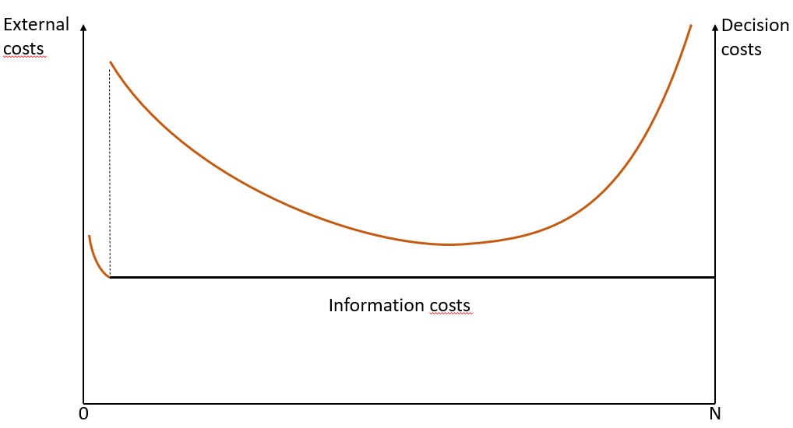
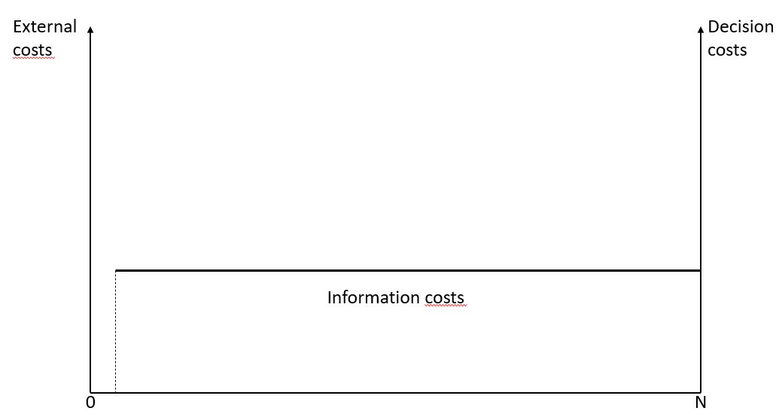

In figure 2b, I simply added the information costs to the familiar figure. It can be seen that there may be cases in which it is optimal to delegate decision-making power to experts.
Ever since Adam Smith, economists have documented the welfare-increasing effects of a division of labor. The allocation of issue areas on the three different decision-making procedures can also be considered in that perspective: the more expensive it is to become knowledgeable in a certain issue area, the higher the potential benefits of a division of labor according to which only some invest into becoming knowledgeable.
This is, hence, an argument that policy areas requiring a high amount of expertise for making decisions that are in the public interest might best be delegated to a small number of highly specialized decision-makers. Of course, important follow-up questions such as how to distinguish “high knowledge policy areas” from other policy areas loom large. What would an argument regarding policy areas that are subject to time-inconsistent preferences of the voters look like? And – once these questions have been answered: how can it be ensured that the delineations once decided upon will be complied with in the future?
As discussed above, if voters are subject to time-inconsistent preferences, candidates have incentives to instrumentalize them as this increases their probability of being (re-)elected. If making the “right” choice implies that short-term gains need to be foregone in order to reap the long-term gains, voters might be tempted to opt in favor of the short-term gains. Politicians who are aware of this and who aim to be re-elected have an incentive to be responsive to their citizens and favor the short-term gains although they are completely aware of the negative consequences in the long run.
Given that voters are subject to time-inconsistent preferences and that representatives are likely to be responsive to voters – which is the idea behind democratic decision-making after all – delegating decision-making competence to experts who are not subject to the re-election constraint is a potential way of mitigating the time-inconsistency fallacy. Experts should, hence, be made directly accountable to neither the voters nor their representatives. In other words: they should be made independent. This does, however, not preclude the necessity of establishing alternative mechanisms of accountability. After all, granting decision-makers independence always entails the danger that such independence may be misused.
Within political economy, the possibility that the individual participants in collective choice act so as to promote the ‘common good’ rather than their own interests – as mentioned by Buchanan and Tullock and as quoted above – is often considered as a hypothetical possibility only. Yet Buchanan and Tullock go on (100) and write: “If some means can be taken to insure that the dictator will, in fact, remain ‘benevolent,’ the argument becomes even stronger.” In other words we now need to ask if it is possible to establish mechanisms to keep the single individual (“the dictator”) accountable.
Here are two potentially important accountability mechanisms. To establish and safeguard legitimacy, IRAs should regularly explain their decisions to the public. This might be in an annual report, but might also be in explaining single decisions. Secondly, to the degree that decisions by IRAs are administrative acts, they can be challenged in front of administrative courts. One might think about extending standing to various actors such as other IRAs, parliament etc. One may even consider the possibility to challenge IRA decisions in a country’s apex court.
Another important issue concerns the appointment of experts. At least two issues are highly relevant: how to make the positions sufficiently interesting such that the best experts have incentives to join the relevant IRA and to prevent that experts are or become partisan over time. Convincing the best experts to join is unlikely to be a question of remuneration but more of the competences allocated to them. Independence from interference by others seems key. Preventing that experts are – or become – partisan in the sense of developing allegiance to a particular party is more challenging. Excluding experts who are members of a political party does not seem to be a good idea as people might support a political party without compromising their knowledge as experts. And people can be highly partisan without being a member of a party. In other words: Party membership is neither a necessary nor a sufficient condition for being partisan. There are many ways to determine the leading experts of IRAs. One attractive option could be to assemble a list of highly qualified experts and then draw lots to determine those who are to fulfill the respective function.
IRAs are often regulating specific industries. In such cases, repeated interactions over a rather long period of time are highly likely. This increases the possibility that experts will be developing too much empathy for the interests of particular lobby groups. There are, however, means to reduce the likelihood of this becoming a serious problem such as the obligation to reveal any benefits received from interested parties, a cooling off period preventing revolving doors etc.
Over the last couple of paragraphs, I have tried to show that constitutional democracy and the reliance on independent experts do not need to be mutually exclusive options. Instead, we have been looking for criteria how to assign policy areas to one of the three decision-making procedures. The interdependence cost calculus described above is mute regarding the choice of the best decision-making procedure. Yet, it can be used as a starting point to think about this issue.
Social contract theory in combination with the interdependence cost calculus implies that majority voting is only legitimate if it is unanimously agreed upon: on the constitutional level people agree unanimously (at least conceptually) that a certain policy area will be made subject to majority voting on the post-constitutional stage, in other words: they (now) agree to disagree (later on). Exactly the same logic can be used to justify the delegation of certain policy issue areas to decision-making by experts: if citizens know that they might be tempted by a certain campaign promise, they might be willing to delegate the respective issue area to an expert body, thus making respective campaign promises by political candidates meaningless.

Applying the Interdependence Cost Calculus to Delegation of Policy Areas to the International Level
Above, I proposed to distinguish between different types of NMIs. Here I argue that delegation within a nation-state might be categorically different from delegation beyond the nation-state. It seems important to stress this as some of the critics of NMIs overlook some important differences between the two. Again, the interdependence cost calculus may help to structure our thinking.
Assume that at the nation-state level, provision of a particular good involves the lowest cost if it is provided by the state and we assume that the respective good is, indeed, provided by the state. But now there is a discussion whether the respective good should be provided at the supranational level, e.g. by the European Union. Relying on the interdependence cost calculus would mean to compare the minimum costs that are borne by the provision of the good at the nation-state level with the expected minimum that would materialize were the good to be provided at the supranational level. In all likelihood, only a small portion of the goods provided at the nation-level should be transferred to the supranational level. Here is why.
Suppose the supranational union is home to citizens with preferences that are far more heterogeneous than the preferences shared by citizens within a single nation-state. To rely on a little-disputed example, this could, e.g., be a reflection of the differences in geographic conditions in different areas: in areas close to the open sea different goods are in high demand than in hilly regions where avalanches may constitute a serious threat. The higher level of preference heterogeneity directly translates into higher expected external costs. But the higher level of preference heterogeneity also implies that decision-making costs will be higher. People having very different preferences will need more time for bargaining an outcome that most everybody can agree on, in other words: decision-making costs also increase in the heterogeneity of the group. If both external and decision-making costs are higher, then interdependence costs will also be higher.
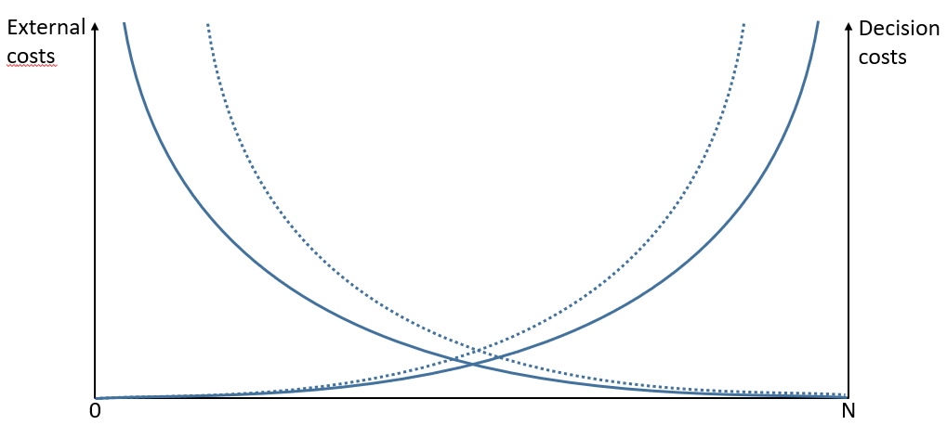
Figure 3 around here

Legend: the solid lines represent the costcurves in case the public good is provided at the nation-state level, the dashed lines the cost curves if the good is provided at the supranational level. To keep the figure simple, the resulting interdependence cost curves are not depicted.

This is a general argument. It does, of course, not apply to all policy areas, otherwise delegation of policy-making competence to supranational bodies could never be justified. One example for a possible exception are negative externalities: if the policy decisions of a neighboring government on which I do not have any influence negatively affect my utility, than the internalization of externalities via transferring the respective policy competence to the supranational level could imply that my expected external costs are not higher, but lower. Environmental policies might be a case in point.
Some critics of NMIs focus on the European Monetary Union and the European Central Bank (such as, e.g., Schäfer and Zürn 2021, 138ff.). The way the EU, and the ECB in particular, dealt with the financial crisis in 2008/9 is interpreted as detrimental to those who suffered most from the crisis. In other words, the ECB should have been less tough on those member states that were hit hardest by the financial crisis. What could a response possibly look like?
The first question would be whether delegation of monetary competence to a supranational organization could be justified. Harmonizing monetary policy implies that countries that find themselves in very different situations are all treated alike: whether an economy is subject to currency appreciation or devaluation pressure, whether unemployment is low or high etc. cannot be taken into account once monetary policy is centralized. Decades ago, economists developed the concept of optimal currency areas, i.e. areas that are sufficiently similar in economic conditions such that a common monetary policy could potentially benefit the entire area (Mundell 1961). Before the EURO was introduced, many economists warned that the EURO was not such an optimal area and that the introduction of the EURO was, therefore, not a good idea. In the language used in this paper: the interdependence costs of a joint currency are above those incurred at the nation-state level.
European governments agreed on a number of accession criteria that candidate countries would need to fulfil to qualify for membership in the EURO area. This can be read as an attempt to exclude very high degrees of heterogeneity. It is well known that the decisions regarding the membership of various countries were then made ignoring these criteria.
In Section 4.2., I argue that delegation to expert bodies should be accompanied by accountability mechanisms. A prerequisite for such mechanisms to make sense is that the goals as well as the competences of the respective expert body are defined as clearly as possible. With regard to the EURO, that seems to be the case. Article 127 of the Treaty on the Functioning of the European Union stipulates that the “primary objective of the European System of Central Banks … shall be to maintain price stability.” If price stability is not reached and the European Central Bank can be made responsible for this, then this should have consequences.
To sum up: many policy areas that should be dealt with at the nation-state level should not be delegated to the supranational level. A possible implication of this insight is that delegation of competence to international bodies should be subject to very careful domestic scrutiny. This could imply that the number of veto players is particularly high. One such veto player could be “the majority of citizens” as realized in some EU member states (such as Ireland that relies on referenda for such decisions). Another measure possibly complementing the veto players is approach to rely on more inclusive decision-making rules such as 5/6 or similar (as realized in Denmark). The costs of overturning delegation decisions are high (but not prohibitive as the example of Brexit shows). To prevent them from occurring, high self-imposed entry barriers seem advisable.

Conclusions and Outlook
This paper argues that NMIs promise a number of benefits that can be reaped without endangering the core of democracy. But that leaves open the question what policy areas should be delegated to NMIs. This is why I propose a conceptual framework that can be used to identify policy areas most amenable to NMIs. It is based on the well-known interdependence cost calculus (Buchanan and Tullock 1962) but goes beyond it by explicitly including information costs and distinguishing between three different procedures of collective decision-making, namely direct democracy, representative democracy, and NMIs.
At the end of this process, it should be possible to agree unanimously on a draft constitution that assigns different policy areas to different decision-making procedures and establishes the decision-making rules for all of these policy areas. Reaching unanimous consensus for the allocation of policy areas to decision-making procedures is likely to establish a high level of constitutional legitimacy among the citizens.
But this paper is only a first conceptual step in thinking about these issues. Many additional questions need to be settled: Should one insist on real unanimous consent or is hypothetical consent sufficient? And – concerning the design of NMIs – what is the optimal size of NMIs? How to contain the transaction costs that will arise as a consequence of having numerous NMIs with possibly overlapping competences? Also: the decisions regarding the two central questions (what decision-procedure and what majorities) are unlikely to be identical for all countries. Assuming that the discount rate can vary across countries, decision making costs are higher in countries with a higher discount rate, implying that the respective majorities should be less inclusive.
Technological progress is likely force us to think about these issues even more. Until now, we are discussing the degree to which decision-making power can or should be delegated to human experts. With the progress in Artificial Intelligence and the development of decision-making algorithms, the making of many decisions could be delegated to software programs. This could speed up decision-making in many areas such as criminal justice, but also health insurance and others. But as of now, it is unclear to what degree we will be ready to delegate important decision-making powers to nonhumans.

References
Ackerman, B. (2000). The new separation of powers. Harvard law review, 633-729.
Ackerman, B. (2010). Good-bye Montesquieu. In Comparative administrative law. Edward Elgar Publishing.
Bagg, S. (2022). "Sortition as Anti‐Corruption: Popular Oversight against Elite Capture." American Journal of Political Science.Bertsou, E., & Caramani, D. (2020). People haven't had enough of experts: Technocratic attitudes among citizens in nine European democracies. American Journal of Political Science.
Bjørnskov, C., & Rode, M. (2019). Regime types and regime change: A new dataset on democracy, coups, and political institutions. The Review of International Organizations, DOI: 10.1007/s11558-019-09345-1.
Brennan, J. (2016). Against democracy. Princeton University Press.
Buchanan, J. M., & Tullock, G. (1962). The calculus of consent: Logical foundations of constitutional democracy. University of Michigan press.
Caplan, B. (2011). The myth of the rational voter. Princeton University Press.
Gutmann, J., & Voigt, S. (2021). Militant constitutionalism: a promising concept to make constitutional backsliding less likely?. Public Choice, 1-28.
de Haan, J., & Eijffinger, S. (2019). The Politics of Central Bank Independence.” In: Congleton, R., B. Grofman & S. Voigt (eds.) Oxford Handbook of Public Choice, Volume 2, 499-519.
Jordana, J., Fernández‐i‐Marín, X., & Bianculli, A. C. (2018). Agency proliferation and the globalization of the regulatory state: Introducing a data set on the institutional features of regulatory agencies. Regulation & Governance, 12(4), 524-540.
Majone, G. (2001). Nonmajoritarian institutions and the limits of democratic governance: a political transaction-cost approach. Journal of institutional and theoretical economics (JITE)/Zeitschrift für die gesamte Staatswissenschaft, 57-78.
Khaitan, T. (2021). Guarantor Institutions. Asian Journal of Comparative Law, 1-20.
Majone, G. (1994). Independence vs. accountability?: non-majoritarian institutions and democratic government in Europe.
Manin, B. (1997). The principles of representative government. Cambridge University Press.
Manow, Philio 2020. (Ent-) Demokratisierung der Demokratie. Suhrkamp Verlag.
Mundell, R. A. (1961). A theory of optimum currency areas. The American economic review, 51(4), 657-665.
OECD (2016a), Governance of Regulators' Practices: Accountability, Transparency and Co-ordination, The Governance of Regulators, OECD Publishing, Paris, https://doi.org/10.1787/9789264255388-en.
OECD (2016b), Being an Independent Regulator, The Governance of Regulators, OECD Publishing, Paris, https://doi.org/10.1787/9789264255401-en.
OECD (2017), Creating a Culture of Independence: Practical Guidance against Undue Influence, The Governance of Regulators, OECD Publishing, Paris, https://doi.org/10.1787/9789264274198-en.
Streit, M. E., & Voigt, S. (1996). Toward ever closer union—or ever larger? Or both? Entry to the European Union from the perspective of constitutional economics. International Review of Law and Economics, 16(3), 385-388.
Schäfer, A., & Zürn, M. (2021). Die demokratische Regression. Suhrkamp Verlag.
Tushnet, M. (2021). The New Fourth Branch: Institutions for Protecting Constitutional Democracy. Cambridge University Press.
Vibert, F. (2007). The rise of the unelected: democracy and the new separation of powers. Cambridge University Press.
Voigt, S. (2021). Mind the Gap: Analyzing the Divergence between Constitutional Text and Constitutional Reality; International Journal of Constitutional Law https://doi.org/10.1093/icon/moab060 (2021).
Voigt, S., & Salzberger, E. M. (2002). Choosing not to choose: When politicians choose to delegate powers. Kyklos, 55(2), 289-310.

University of Hamburg, Institute of Law and Economics, Johnsallee 35, D-20148 Hamburg, Germany; email: stefan.voigt@uni-hamburg.de and CESifo, Munich. This paper emerged out of the joint research project “The Economics of Compliance with Constitutions” supported by the DFG (381589259) and the NCN within the Beethoven 2 initiative. The author thanks Erich Brousseau, Peter Cserne, Jerg Gutmann, Carola Hesch, Mahdi Khesali, Hartmut Kliemt, Jasmin König, Raphael Messchalk, Peter Niesen, Eva Nissioti, Betül Simsek, Eva van der Zee, Karol Zdybel, and the participants of the workshop on Comparative Regulatory Governance (Florence June 2022) for helpful suggestions.
As far as I know the term was coined by Majone (1994).
Schäfer and Zürn even include independent courts into their list of NMIs. Formally, this is, of course, correct. I am neglecting them here nevertheless as a direct-democratic legitimation of members of the judiciary leads to a host of additional questions. Elsewhere, I have stressed that an independent judiciary is a precondition for the constitutional rule of law-state (Feld and Voigt 2003).
Surveys indicate that independent regulators enjoy a high degree of trust among the population at large. Tigre (2021), e.g., compare the average level of trust that national administrations, the EU administration, ministries, nation-state parliamentarians, accreditation agencies, and courts enjoy with the level enjoyed by data protection agencies, financial and food regulators. Trust in the latter is generally higher than the average level of trust in the former. Prima facie, there is hence little evidence in support of the hypothesis that NMIs are a central reason for the recent strength of populist politicians.
Interestingly, the critique by Bertsou and Caramani (2020) is not entirely compatible with their empirical results. This is already apparent in the title of their paper which reads “People Haven’t Had Enough of Experts: Technocratic Attitudes among Citizens in Nine European Countries.”
Vibert (2007, 21-30) proposes to distinguish between five categories of NMIs, namely (1) service providers, (2) risk assessors, (3) boundary watchers, (4) inquisitors, and (5) umpires and whistle blowers.
In a sense, fourth branch institutions can also be interpreted to serve as mitigators of time-inconsistency and the functions of the two different types of NMIs would, hence, overlap. Yet, we assume that voters’ endorsement of government overstepping its competence is significantly less likely than voters endorsing expansive monetary policy. With regard to IRAs, their main function is to prevent the (mis-)use of the shortsightedness of the electorate.
The empirical evidence shows that countries that have central banks that operate independently of their governments have significantly lower inflation rates than countries in which this is not the case (de Haan and Eijffinger 2019).
Most likely to the international or supranational level but possibly also to other nation-states as, e.g., if one government has its own currency pegged to one of another state.
This is, at least, how I interpret the following sentences from the Calculus of Consent: “However, collective action, if undertaken, will also require that the individual spend some time and effort in making decisions for the group, in reaching agreement with his fellows. (64) So the individual is part of the group that makes a decision; no delegation of competences to any parliament or the like seems to have occurred.
Buchanan and Tullock (1962) further distinguish between the costs accruing out of purely individualistic activities compared to those accruing out of voluntary collective action. I disregard that distinction here as it is irrelevant for the argument here developed.
Things might even be more complicated as the decision whether an activity will be decided via direct democratic decision-making or via representative democracy can be the consequence of the activity of various actors: referendums with regard to some activities might be mandatory, others might be kicked off by the legislature (optional ones). Still others might be the result of initiatives kicked off by citizens. But as we are interested in a first approach, we do not take up these additional complications.
The OECD (e.g. 2016a, but see also 2016b and 2017) proposes quite a number of means to make independent regulators accountable. Among them are to make regulators accountable to parliament, the “rigorous ex ante assessment and ex post assessment of decisions” (ibid., 11) and the involvement of supreme audit institutions to assess the performance of independent regulatory agencies.
In addition to the competences allocated to the experts, the reputation coming with it may be another reason to join. Membership in an expert body may be interpreted as an award (e.g. Frey 2010), or the esteem shown to someone (Brennan and Pettit 2004). Then again: the reputation connected to the membership in an expert body is likely also to be a function of the competences allocated to the respective body.
Manin (1997) is an excellent account of both the empirical use of lots in history and of the theory behind it. They have also re-appeared on the research agenda of political scientists, Bagg (2022) being a recent example.
The first two manifests issued by German economists can be found here: https://www.uni-goettingen.de/de/document/download/13ed6bc990f7c9be5650a97f27a00ed6.pdf/Maastricht%20Manifeste%20deutsch-englisch.pdf.
More recently, the ECB became actively involved in the EU’s Green Deal. The only way to justify this is to argue that climate change endangers price stability; and this is exactly what the ECB has been arguing. As in this press statement: https://www.ecb.europa.eu/press/pr/date/2021/html/ecb.pr210708_1~f104919225.de.html

