Chapter 4

Evaluation of the effect of OSH ISI-Inail’s policy on firms’ survival

- Introduction
Public policies on occupational safety and health (OSH) indeed play a crucial role in improving working conditions. The European Agency for Safety and Health at Work emphasises the need to promote a mixed approach by relying on both legal regulation and its enforcement (sticks) and economic incentives (carrots). Nevertheless, in Europe the use of carrot is significantly less widespread than stick, and the former, even where implemented, is not provided as structural tool. Considering the risk of underinvestment in OSH in the private sector (see Chapter 3), this stylized fact is a critical issue because OSH policies do not only displace a direct effect on work well-being but could also affect indirectly on firms economic performance (Ugur and Vivarelli 2021; Fernández-Muniz et al.; 2009; Veltri et. al 2007; Shikdar and Sawaqed, 2003; Andreoni, 1986).
In this vein, the underestimation (or mis-consideration) of OSH investment’s economic implications has enhanced the interest of scholars in the field and triggered a new strand of research. However, this stream of literature the focus is primarily oriented to classify and estimate the costs of occupational accidents and diseases rather than exploring the relationship between OSH investments and economic performance of enterprises.
Thus, to this end, this paper aims to contribute to the latter research line by evaluating the indirect effect on the survival probability generated by the ISI initiative promoted by the National Institute for Insurance against Accidents at Work (Inail) in 2013.
Therefore, with respect to the existing literature, we test the following hypothesis:
Hypothesis: the 2013 ISI Inail Call by supporting private firms fixed investments in OSH can be seen as an industrial policy tool that generates a positive effect on the survival probability of enterprises.
The identification strategy benefits from the characteristics of the assignment selection process, i.e., the Click Day: since the decision to assign or not to assign a unit is made on the basis of a time criterion on the order of hundredths of a second, this administrative procedure ensures randomised allocation to the assignment. However, after random assignment-to-treatment, during the administrative process, some companies admitted via Click Day do not reach the end of the treatment (so-called drop-out firms), generating a possible selection bias in the estimates.
The empirical estimation strategy relies on two main paths.
First, in order to avoid the risk of sample selection bias, a baseline estimate of the policy effect can be obtained by recurring to the intention-to-treat (ITT) analysis (Gupta, 2011; Frangakis and Rubin, 1999). This approach includes in the quasi-experiment setup every firm which is randomized according to the randomized treatment assignment (i.e., all the companies that participated in the click day), regardless of whether they are subsequently treated or not (i.e., companies effectively funded by the policy). However, since not all the firms have actually received the funding and carried out the intervention among the assigned group, indeed the ITT analysis provides a conservative and downward estimate of the ISI-Inail initiative effect (Hirano et al., 2000).
Secondly, to tackle the sample bias selection risk and to more appropriately measure the effect of the policy by including only the recipient firms among the assigned, we estimate the ATE after implementing two different types of matching since in the matched samples systematic differences between treated and untreated can be controlled for, reduced or eliminated (Austin, 2009). The first matching method used is the Nearest-Neighbour (NN) matching on covariates, based on Mahalanobis distance; next, following Rosenbaum and Rubin (1983), we pair treated and untreated units using the Propensity Score Matching (PSM).
Overall findings are as follows. The ITT estimates show that the 2013 ISI Inail’s initiative generates an impact on the firms' ability to survive, identifying a statistically significant policy’s negative effect (decrease) on the probability of bankrupts of assigned compared to not assigned firms. The ATE estimate obtained after the NN and PS matching suggests that Inail's policy implemented in 2013 displaces an indirect effect on the firms' resilience and ability to survive. In a policy implication perspective, this analysis contributes in providing further support to the inclusion of direct incentives (carrots) in addition to regulation and enforcement (sticks) in the OSH policy mix.
The paper is organised as follows: Section 2 describes the data used to estimate the policy effect. Section 3 presents the empirical and identification strategies. Section 4 reports the estimation. Section 5 argues about the limits of the results obtained and Section 6 concludes.

- Data and Descriptive Statistics
To build the database for our analysis, I first start by collecting information from two unique and original datasets provided by Inail: the primary source of the data collects administrative information (company name, location, company tax code, project value, amount granted, etc…) on the firms participating to the ISI call for the 2010-2019 time span from which we extract firms participating to the 2013 ISI call; we then merge 1:1 this DB with a second source provided by Inail – “Information Flow” (Flussi Informativi) – that contains, in the same time frame, firms specific insurance information (sector, company size, national average tariff rate, etc…).
Secondly, I match the resulting dataset with the balance sheet database provided by Aida (Bureau van Dijk). Aida records the economic-financial, statutory, and commercial information of all corporations operating in Italy; in particular, Aida database collects detailed data on the nature of the firm, including the date of establishment, the location, the sector of activity, data regarding firm activity, such as revenue, profitability, number of employees, wages costs, and the data related to the insolvency proceedings. These additional information are compulsory for conducting the survival analysis among assigned and not assigned firms.
The dependent variable is a dichotomous variable that takes the value 1 if the company goes bankrupt or 0 if it survives. Considering Aida classification, the value of 1 is attributed to the firm at the first signal of financial distress in the time-horizon 2015/2019 according to the occurrence of the following events: bankruptcy; dissolution and liquidation; arrangement with creditors; closure of liquidation; closure due to bankruptcy; voluntary liquidation; ex officio cancellation following institution of detention by the Chamber of Commerce, Industry, Handicrafts and Agriculture; dissolution; cancellation from the firms’ official public register; judicial declaration of insolvency; dissolution by act of the authority; judicial liquidation; cancellation ex officio pursuant to art. 2490 of the Civil Code; compulsory administrative liquidation; cessation of all activities; judicial administration. The independent variables used are those able to predict firms’ bankruptcy according to the literature (Giannetti, 2019; Esteve-Pérez and Mañez-Castillejo, 2008; Musso and Schiavo, 2008; Agarwal and Gort, 2002) and their availability. Table 1 defines and describes the variables used in the analysis and the data source.
Table 1. Description of the variables
Variable | Definition | Source
Enterprise survival | Dichotomous variable: = 1 if firm goes bankrupt, = 0 if firm survives | Aida
Maturity | Difference between the Click Day year (2014)  and the year of company establishment | Aida
Debts | Total debts in millions of Euro | Aida
Assets | Total equity in millions of Euro | Aida
Production | Total value of production value in millions of Euro | Aida
Revenues | Revenues from sales in millions of Euro | Aida
ROE | Return of Equity (profit divided by equity, percentage) | Aida
Employees | Number of employees employed in the enterprise | Inail
Value Added | Value of production minus the value of intermediate costs per worker in Euro | Aida
EBITDA | Earnings Before Interest, Taxes, Depreciation and Amortisation in millions of Euro | Aida
Ateco | Stratification variable: = 1 when the sector is manufacturing (reference stratum), = 2 when referring to construction sector, = 3 for all other sectors. | Inail
Company type | Stratification variable: = 1 if company is an S.r.l. (reference stratum), = 2 if the company is an S.p.a., = 3 if the company assumes the form of Cooperatives and Consortia, = 4 for other forms | Aida
Macro region | Stratification variable: = 1 if the company operates in North Italy (reference stratum), = 2 if the company operates in the Center, = 3 if the company operates in the South | Inail
Technology | Dichotomous variable: = 1 if the company operates in a high technology sector , = 0 otherwise | Istat

In order to compare the financial status of the assigned and not assigned groups, the following Tables highlight the comparison of the most important balance sheet variables describing the financial condition before (average for 2010-2013 timeframe) and after (average for 2015-2019 the timeframe of the policy intervention (Table 2).

Table 2. Comparison of the balance sheet data
before-and-after the policy intervention by “assignment” status
Before
Not assigned | Mean | SD
Maturity | 17.888 | 14.387
Debts | 2,348.147 | 6,078.151
Assets | 1,129.557 | 4,205.085
Production | 3,350.018 | 8,806.721
Revenues | 3,249.617 | 8,671.196
ROE | 8.614 | 20.292
Employees | 17.150 | 58.548
Value Added | 47,439.890 | 29,855.560
ABITDA | 250.961 | 845.050
Assigned
Maturity | 18.147 | 14.337
Debts | 3,054.947 | 14,674.170
Assets | 1,229.601 | 3,242.632
Production | 4,067.272 | 11,710.390
Revenues | 3,922.410 | 11,099.160
ROE | 8.514 | 19.660
Employees | 18.562 | 38.001
Value Added | 50,016.060 | 31,488.050
EBITDA | 303.451 | 859.174
After
Not assigned | Mean | SD
Maturity | 17.888 | 14.387
Debts | 2,623.548 | 7,402.622
Assets | 1,346.607 | 5,195.403
Production | 3,973.213 | 13,291.300
Revenues | 3,834.102 | 13,094.13
ROE | 9.035 | 19.116
Employees | 18.209 | 33.366
Value Added | 52,180.070 | 33,722.980
EBITDA | 315.779 | 1,009.499
Assigned
Maturity | 18.147 | 14.337
Debts | 3,188.376 | 10,761.140
Assets | 1,544.824 | 4,708.377
Production | 4,708.572 | 12,179.75
Revenues | 4,498.767 | 10,986.140
ROE | 10.605 | 18.150
Employees | 21.408 | 74.644
Value Added | 56,241.87 | 53,946.66
EBITDA | 404.688 | 1,207.135

Table 3 shows the descriptive statistics (number and percentage) concerning the stratification and dichotomous variables chosen for the analysis.

Table 3. Descriptive statistics (number and percentage) relative to
the stratification and dichotomous variables
Variables | Not assigned |  | Assigned
 | Obs. | Percentage | Obs. | Percentage
Ateco
Manufacturing | 2,857 | 43.6 | 928 | 44.6
Construction | 1,683 | 25.7 | 545 | 26.2
Other | 1,881 | 28.7 | 578 | 27.8
Unknown | 137 | 2.1 | 28 | 1.3
Company type
Srl | 5,927 | 90.4 | 1856 | 89.3
Spa | 317 | 4.8 | 141 | 6.8
Cooperative and Corsortia | 286 | 4.4 | 70 | 3.4
Other | 28 | 0.4 | 12 | 0.6
Macro region
North | 3,148 | 48.0 | 928 | 44.6
Centre | 1,294 | 19.7 | 560 | 26.9
South | 2,116 | 32.3 | 591 | 28.4
Technology
High | 3,877 | 59.1 | 1239 | 59.6
Low | 2,681 | 40.9 | 840 | 40.4

In our estimates we apply log-transformation to the non-negative variable (namely, “Debts”, “Revenues” and “Employees” variables) presenting a large variance and/or asymmetric distribution. For variables occurring with negative values (namely, “Assets”, “Production”, “ROE”, “Value Added” and “EBITDA”), we apply a rank-transformation. Following (Table 4) are show the descriptive statistics relative to the log and ranked-value of the transformed variables before (average for 2010-2013 timeframe) and after (average for 2015-2019 timeframe) Click Day year.

Table 4. Comparison of logarithm and ranked variables describing the balance sheet data before and after policy intervention by “assignment” status
Before
Not assigned | Obs. | Mean | SD
Maturity | 6,555 | 17.888 | 14.387
(ln)Debts | 6,388 | 6.808 | 1.364
(Ranked)Assets | 6,558 | 42.543 | 24.916
(Ranked)Production | 6,558 | 42.339 | 24.995
(ln)Revenues | 6,328 | 7.143 | 1.403
(Ranked)ROE | 6,558 | 43.021 | 25.120
(ln)Employees | 6,327 | 2.389 | 0.916
(Ranked) Value Added | 6,558 | 42.509 | 25.059
(Ranked)EBITDA | 6,558 | 42.339 | 24.945
Assigned
Maturity | 2,070 | 18.147 | 14.337
(ln)Debts | 2,009 | 6.995 | 1.348
(Ranked)Assets | 2,079 | 45.230 | 24.888
(Ranked)Production | 2,079 | 45.873 | 24.555
(ln)Revenues | 1,990 | 7.335 | 1.375
(Ranked)ROE | 2,079 | 43.721 | 24.337
(ln)Employees | 1,990 | 2.499 | 0.903
(Ranked) Value Added | 2,079 | 45.335 | 24.414
(Ranked)EBITDA | 2,079 | 45.874 | 24.702
After
Not assigned | Obs. | Mean | SD
Maturity | 6,555 | 17.888 | 14.387
(ln)Debts | 6,475 | 6.918 | 1.344
(Ranked)Assets | 6,558 | 42.285 | 24.943
(Ranked)Production | 6,558 | 42.205 | 25.002
(ln)Revenues | 6,390 | 7.212 | 1.505
(Ranked)ROE | 6,558 | 42.768 | 25.107
(ln)Employees | 6,385 | 2.426 | 0.971
(Ranked)Value Added | 6,558 | 42.355 | 25.090
(Ranked)EBITDA | 6,558 | 41.982 | 24.936
Assigned
Maturity | 2,070 | 18.147 | 14.337
(ln)Debts | 2,040 | 7.141 | 1.298
(Ranked)Assets | 2,079 | 46.045 | 24.696
(Ranked)Production | 2,079 | 46.297 | 24.466
(ln)Revenues | 2,022 | 7.459 | 1.415
(Ranked)ROE | 2,079 | 44.521 | 24.339
(ln)Employees | 2,021 | 2.567 | 0.944
(Ranked)Value Added | 2,079 | 45.823 | 24.254
(Ranked)EBITDA | 2,079 | 46.999 | 24.547

- Empirical and Identification Strategies
The aim of this analysis is to assess the impact on firms’ survival of the 2013 ISI-Inail Call, oriented to support the purchase of a new machinery or the replacement/upgrading of work equipments/assets for a safer workplace. The 2013 ISI call founded about 307 million euro and the size of the grant provided was the 65% of the eligible project value, with a maximum grant payable (cut-off) of 130,000 euros. At the Click Day 4,211 firms were admitted and 18,770 rejected, (i.e., the rejection rate was about 82%).
The first step of data processing starts by identifying the statistical population of assigned and not assigned firms through the merge between the two previous databases (Inail – ISI 2013 call DB and Inail Information Flow) provided by Inail. This results in a same sample of 22,981 firms: 4,211 firms are assigned and 18,770 firms are non assigned.
Secondly, we drop from the dataset firms presenting projects that fall in the alternative “Adoption of organizational and social responsibility models” support area of interest. This choice is strictly related to the aim of our empirical exercise, that is to assess the effect of the ISI call for axis related to the investment (tangible) projects. The resulting sample reduces to 21,015, of which 3,802 assigned firms and 17,213 not assigned firms.
Among the assigned enterprises the so-called drop-out firms are identified as firms that pass the Click Day but do not complete the eligible investment. Accordingly, three groups can be distinguished: the treated assigned enterprises (1,958 treated firms), the untreated assigned enterprises (1,844 drop-out firms) and the untreated unassigned enterprises (17,213 untreated or not assigned firms).
Finally, by merging this sample with the balance sheet data provided by Aida, since the companies participating to the Click Day (treated, drop-out and untreated firms) are not all capital corporations, I end up with a final sample of 8,639 firms of which 1,069 treated 1,010 drop-out firms and 6,559 untreated firms.
Table 5 summarizes the descriptive statistics relative to the dichotomous dependent variable.

Table 5. Number and percentage relative to the dependent dichotomous dependent variable
(Bankrupt=1, Not Bankrupt=0)
Sample Groups | Not Bankrupt |  | Bankrupt
 | Obs. | Percentage | Obs. | Percentage
Treated (= 1069) | 1015 | 95% | 54 | 5%
Drop-out (=1010) | 908 | 90% | 102 | 10%
Untreated (= 6559) | 5934 | 90% | 645 | 10%

As Angrist and Krueger (1999) point out, «the most challenging empirical questions in economics involve "what if” statements about counterfactual outcomes», and the causal relationships at the core of the questions involve comparisons of counterfactual states of the world. In this framework, the key word is “comparison”. In randomized experiments, the results of the two assignment groups may usually be directly compared in the light of similarity of their units; instead, in nonrandomized experiments such direct comparisons may be misleading because the units exposed to the treatment generally differ systematically from the units not exposed to the treatment (Angrist and Krueger, 1999; Rosenbaum and Rubin, 1983; Rubin, 1974).
The identification strategy adopted benefits from the characteristics of the selection process to the assignment-to-treatment, i.e., the Click Day. Whether a unit is assigned or not assigned is decided based on a time criterion in the order of hundredths of a second, and this administrative procedure makes reasonable to assume a randomized assignment-to-treatment.
In order to provide some elements to corroborate this reasonableness two preliminary analysis are presented at the very beginning of the identification strategy.
The first analysis relies on a multivariate test on the non-ability of the control variables to predict the treatment assignment: in Table 6 a logistic model is implemented using as dependent variable the “assignment” variable (=1 if firms is assigned =0 if firms is not assigned) and the aforementioned covariates (Table 3 and 4) as independent variables.

Table 6. Multivariate test of the non-ability of the control variables to predict assignment-to-treatment
Variables | Logistic Model  (Dependent Variable: Assigned)
Debts | 1.032  (0.040)
Assets | 0.998  (0.002)
Production | 1.002  (0.004)
Revenues | 0.970  (0.064))
ROE | 1.000  (0.001)
Employees | 1.056  (0.062)
Value Added | 1.003  (0.002)
EBITDA | 1.002  (0.002)
Construction | 1.018  (0.151)
Other | 0.969  (0.661)
Unknown | 0.642*  (0.151)
Spa | 1.203  (0.140)
Cooperative and Consortia | 0.874  (0.128)
Other | 1.523  (0.537)
Centre | 1.606***  (0.106)
South | 1.091  (0.074)
Technology low | 0.956  (0.062)
Intercept | 0.192***  (0.066)
Observations | 8,316
LR $χ^{2}$ | 101.49
Pseudo $R^{2}$ | 0.011
Robust standard errors in parentheses: *** p<0.01, ** p<0.05, * p<0.1

The results provided in Table 6 reveal that none of the balance sheet covariates are effective in predicting the assignment-to-treatment.
Among the dichotomous and stratification variables, only the Centre Macro region is highly statistically significant with respect to the reference strata. However, this evidence is not surprising given that participating companies in the North and South are significantly larger in number than in the centre and that regional budgets are fixed. That is to say, the firms operating in the latter geographical macro hold a higher probability of being assigned-to-treatment.
The second preliminary analysis for checking the reasonableness of the initial assumption, relies on the computation of the Area Under the Receiver Operating Characteristic Curve (AUC) and the ROC probability curve. The AUC score measures the ability of a classifier to distinguish between classes and is often used as a summary for the Receiver Operating Characteristic (ROC) curve. The latter is generated by plotting the True Positive Rate (TPR) against the False Positive Rate (FPR) to examine the predictive ability of the model.
The ROC curve is a graph of specificity against 1 minus sensitivity, thus, a model with no predictive power would be a 45° line. The greater the predictive power, the more bowed the curve, and hence the area beneath the curve is often used as a measure of the predictive power. A model with no predictive power has area 0.5. The graph of the ROC curve in this specific case is shown in Figure 1.

Figure 1. ROC curve to asses the performance of logistic model about imbalanced datasets
(Dependent variable: assignment)
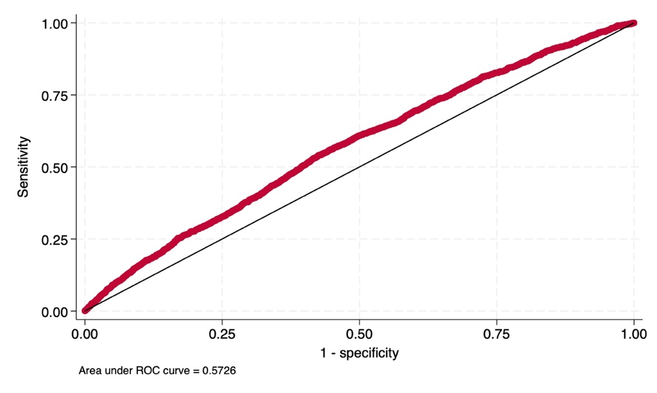

The logistic regression model results with a prediction score of about 0.57. Since the value of the area under the ROC curve is very close to the threshold of 0.5 (45° line), we can assume the tested model has no prediction power over assignment-to-treatment. That is to say, some further elements seems to emerge and to be coherent with the starting assumption of the present analysis.
The identification proceeds further by checking the covariate balancing considering that, even in randomised experiments, imbalances may exist on a prognostically relevant covariates (Morgan and Rubin, 2012). It has long been recognized that while pure random assignment ensures that the treatment and control groups have identical characteristics on average, in any particular random assignment, the two groups will differ along some dimension, with the probability of those differences being large decreasing with sample size (Bruhn and McKenzie, 2009). To assess the covariates balancing before Click Day between the assigned and not assigned group we perform the univariate test of standardized mean differences (Austin, 2009; Austin et al., 2007; Flury and Riedwyl, 1986) as shown in Table 7.
Table 7. Standardized differences between pre-assignment variables
of assigned-to-treatment and not assigned-to-treatment groups
 | Not Assigned |  | Assigned |  | Std Diff
 | Mean | SD | Mean | SD
Maturity | 17.89 | 14.387 | 18.15 | 14.337 | -0.018
Debts | 6.808 | 1.364 | 6.995 | 1.348 | -0.138
Assets | 42.540 | 24.916 | 45.230 | 24.889 | -0.108
Production | 42.340 | 24.995 | 45.870 | 24.555 | -0.143
Revenues | 7.143 | 1.403 | 7.335 | 1.375 | -0.138
ROE | 43.020 | 25.120 | 43.720 | 24.337 | -0.028
Employees | 2.389 | 0.916 | 2.499 | 0.903 | -0.121
Value Added | 42.510 | 25.060 | 45.340 | 24.414 | -0.114
EBITDA | 42.340 | 24.949 | 45.870 | 24.703 | -0.142
Ateco | NA | NA | NA | NA | 0.062
Company type | NA | NA | NA | NA | 0.098
Macro region | NA | NA | NA | NA | 0.172
Technology | NA | NA | NA | NA | 0.009
Table 7, on the one side, shows that among the covariates, Maturity, ROE, Ateco, Company type and Technology, display a standardized difference below the 0.1 (10%) considered the threshold recommended in literature for a negligible imbalance of the covariates among groups (Austin, 2009). On the other side, Debts, Assets, Production, Revenues, Employees, Value Added, EBITDA and Macro region variables exhibit a standardized difference above the threshold. However, it is possible to take into account these covariates by including them in the regression adjustment analysis.
Based on this background we start the analysis by implementing an ITT analysis, comparing outcomes by assignment, ignoring the actual treatment status. We first estimate the “assignment effect” (ITT) by recurring to the regression adjustment (RA) estimation and then implement a logistic regression model, controlling for all the available observables characteristics (see Table 1).
In particular, the RA Intention-to-Treat (ITT) estimate relies on the following model specification:
${Fail}_{i}{= β_{0}+ β_{1}{Assignment}_{i}+β_{2}{Maturity}_{i}+ β_{3}{ln⁡(Debts)}_{i}+ β_{4}{(Ranked)Assets}_{i}+ β_{5}{(Ranked)Production}_{i}}+ β_{6}{ln⁡(Revenues)}_{i}+ β_{7}{(Ranked)ROE}_{i}+β_{8}ln⁡({Employees)}_{i}+β_{9}(Ranked){Value Added}_{i}+β_{10}({Ranked)EBITDA}_{i}+β_{11}{Ateco}_{i}+{β_{12}{Company type}_{i}+β}_{13}{Macro region}_{i}+β_{14}{Technology}_{i}+ ε_{i}$ (1)
where $i$ indexes firms, $β_{1}$ represents the ITT-ATE estimator, that represents the difference between the expected outcome of being assigned-to-treat and the alternative outcome (of not being assigned), conditional on the wide set of covariates above mentioned.
Secondly, a logistic regression is implemented to estimate the ITT effect by recuring to the following specification model:

$ln\left(\frac{Fail}{1-Fail}\right)=β_{0}+β_{1}{Assignment}_{i}+β_{2}{Maturiry}_{i}+β_{3}{ln⁡(Debts)}_{i}+β_{4}{Assets}_{i}+β_{5}{Production}_{i}+β_{6}{ln⁡(Revenues)}_{i}+β_{7}{ROE}_{i}+β_{8}{ln⁡(Employees)}_{i}+β_{9}(Ranked){Value Added}_{i}+β_{10}({Ranked)EBITDA}_{i}+β_{11}{Ateco}_{1}+β_{12}{Company type}_{i}+β_{13}{Macro region}_{1}+β_{14}{Technology}_{1}+ε_{i}$ (2)

where $i$ indexes firms, and all the other coefficients and covariates are those indicated in Eq. 1. To interpret the estimation results, a statistically significant hazard ratio lower (higher) than one implies that the feature decreases (increases) the corresponding probability of bankrupt, other things being equal.
However, after random assignment-to-treatment, during the administrative process, some companies admitted via Click Day abandon the investment programme and do not reach the end of the treatment (so-called, drop-out firms). In this perspective, the ITT provides an analysis that ensures the absence of an analyst-determined selection bias. Nevertheless, it offers an initial indication of the potential effect of the policy, albeit estimating it conservatively (Gupta, 2011). That is to say, since in the assignment group not all the firms actually receive the funding and carry out the intervention, the ITT analysis can provide a first downward biased estimate of the policy’s effect effect.
In this vein, in order to measure the effect of the public resources spent by the ISI initiative, it appears necessary to structure an evaluation strategy that aims to compare the firms who actually received funds with those not assigned by the the Click-day. Indeed, as in all quasi-experiments, the main challenge to address is tackling the risk of incurring in a sample selection bias.
In our case, this issue is consistent given that a high number of firms (1,844) assigned via Click Day did not complete the investment (so called drop-out firms—see footnote 38). This means that, while all the untreated (not assigned) firms are included in the control sample, for the assigned firms only those firms that completed the investment are included in the treatment group.
To deal with this potential selection bias (Staffa and Zurakowski, 2018; Stuart, 2010), the identification strategy relies on the estimates of the ATE after applying two alternative types of matching methods (exact matching and PSM). The matching procedures adopted are oriented to deal alternatively with the existence of possible systematic differences between treated and untreated subjects (Austin, 2009, D'Agostino, 1998).
By definition, all matching techniques are orientend to recover the potential unobservable outcome of a unit using the observable outcome of similar units – having homogeneous structural characteristics – in the opposite status (Cerulli, 2015). In practice, the first matching method that we apply is a standard 1:1 Nearest-Neighbour (NN) matching considering the Mahalanobis Distance Matching (MDM) algorithm. In particular, we match firms using the pre-treatment value of the whole set of covariates (Maturity, Debts, Assets, Production, Revenues, ROE, Employees, Value added, EBITDA, Ateco, Company type, Macro Region, and Technology). The covariance balancing before-and-after matching among groups are tested computing standardized mean differences.
However, when continuous variables are used to match units on covariates, it is difficult (or almost impossible) to find unit with the same value of the variable in the opposite status. That is, when the vector of covariates is large and/or it contains continuous variables, then exact matching could provide not precise matching outcomes (Cerulli, 2015; Abadie and Imbens, 2002).
For this reason, we opt for two main approaches to address this drawback. On the one hand, the NN exact matching procedure is refined by using the bias-corrected matching estimator, which adjusts the difference within the matches for the differences in their covariate values (Abadie et al., 2004).
On the other hand, to address the dimensionality problem, following Rosenbaum and Rubin, (1983), the analysis alternatively relies on the PSM before computing the ATE. This method allows to reduce multidimensionality to a single scalar dimension estimated, namely the propensity score p(x), defined as the conditional probability of assignment to a particular treatment status given a vector of observed covariates (Dehejia and Wahba, 1999; Rosenbaum and Rubin, 1983). This approach facilitates the matching process, because units with dissimilar covariate values may nevertheless have similar values in their propensity scores (Abadie and Imbens, 2016). The propensity score specification, as in the NN matching procedure, includes all the pre-treatment variables mentioned in Table 1.
It is worth to point out, however, that the PSM identifies unbiased ATEs only under three assumptions (Caliendo and Kopeinig, 2008):
- Conditional mean independence (CMI): $E\left(Y_{1} | x,T\right)=E\left(Y_{1} | x\right)$ and $\left(Y_{0} | x,T\right)=E\left(Y_{0} | x\right)$, i.e., the mean of potential outcomes when unit is treated $(Y_{1})$ and the potential outcome when unit is untreated ${(Y}_{0)}$ given $x$(covariates) does not depend on the variation of $T$ (treatment), meaning that it is the same for every value of $T$. This assumption is also known as unconfoundedness.
- Balancing: $\left\{\left(T_|_x\right)|Matching\right\}$, i.e., after matching, the covariates’ distribution in the treated and untreated group has to be equal.
- Overlap: $0<p(x)<1$, where $p(x)$ is the propensity score. If this assumption does not hold, there might exist units with specific characteristics x that either always receive treatment (i.e., $p\left(x\right)=1$) or never receive the treatment (i.e., $p\left(x\right)=0$), thus not permitting us to identify ATE estimate.
Following Aakvik (2001), a sensitivity analysis is performed to assess whether there are no (unobserved) variables that influence the selection-to-treatment checking the sensitivity of the estimated results with respect to deviations from this identifying assumption (Becker and Caliendo, 2007). Given the binary nature of the outcome (survival), we use the Mantel and Haenszel (MH, 1959) test statistic.
A check of the covariates balancing before-and-after matching (Maturity, Debts, Assets, Production, Revenues, ROE, Employees, Value Added, EBITDA, Ateco, Company type, Macro Region, and Technology) is implemented by computing the standardized differences.
The overlap assumption is checked by recurring to a graphical representation of the plots of the estimated densities of the probability in obtaining each treatment status (treated and untreated).

- Estimation results
The analysis starts from the ITT estimation based on RA (Table 8) as specified in Eq. (1).
Table 8. ITT based on RA estimation with the whole set of covariates (Dependent variable: Bankrupt)
Bankrupt | Coefficient | Robust std. err. | z | P>|z| | [95% conf. interval]
ATE  assigned  (1 vs 0) | -0.015 | 0.006 | -2.38 | 0.017 | -0.028 | -0.003

Looking to the RA-ITT estimate controlling for the whole set of covariates, it emerges that assigned firms exhibit a difference in bankruptcy performance compared to not assigned firms. The negative sign of the “assignment” coefficient indicates that assigned enterprises bankrupt less than not assigned enterprises at the 1.7% of significance level.
Implementing the logistic regression model specified in Eq. (2), the corresponding results are presented in Table 9.

Table 9. Logistic regression model (Dependent variable: Bankrupt)
Variable | Logistic model
Assigned | 0.785**  (0.086)
Balance sheet controls | Yes
Ateco control | Yes
Company type control | Yes
Macro region control | Yes
Technology control | Yes
Intercept | -0.057***  (0.039)
Observations | 8,360
Wald $χ^{2}$ | 525.020
Pseudo $R^{2}$ | 0.153
Robust standard errors in parentheses: *** p<0.01, ** p<0.05, * p<0.1

We find an odd ratio for the “assignment” variable that is less than one (0.785), meaning that the “assignment” exerts a protective effect on the probability of bankruptcy. The sign and statistical significance at 5% level of the “assignment” variable remains consistently stable across the two alternative estimation procedures.
The results obtained in the ITT setup, offers an initial indication of the potential positive effect of the policy on the survival of the firms, albeit estimating it conservatively. That is to say, even including the drop-out firms in the assignment group, i.e. firms that actually did not receive the grant, first signs of policy effectiveness do emerge.
Acknowledging the downward bias of the ITT analysis, as explained in the identification strategy section, the analysis proceeds providing an attempt to estimate the ATE of the ISI call by comparing, after excluding the drop-out firms, the treated and untreated groups. The risk of incurring in a sample selection bias (see Section 3) is tackled by estimating the ATE among treated and untreated firms after recurring to two alternative matching procedures.
The first approach implemented is the 1-to-1 Nearest Neighbour Matching based on the Mahalanobis distance. In Table 10 we test whether the standardized mean differences (SMD) of the pre-treatment value of the covariates before-and-after matching between treated and untreated group meet the 0,1 (10%) threshold (in absolute value) suggested in literature (Austin, 2009).

Table 10. Standardized mean differences of the pre-treatment value of the covariates
between treated and untreated group before (Raw) and after (Matched) NN matching
Variables | Standardized differences
 | Raw | Matched
Maturity | 0.169 | -0.014
Debts | 0.218 | 0.024
Assets | 0.285 | 0.059
Production | 0.314 | 0.064
Revenues | 0.318 | 0.079
ROE | 0.015 | 0.048
Employees | 0.188 | 0.040
Value Added | 0.323 | 0.063
EBITDA | 0.319 | 0.094
Construction | 0.158 | 0.001
Other | -0.086 | 0.006
Unknown | -0.076 | -0.005
Spa | 0.133 | -0.001
Cooperative and Consortia | -0.115 | -0.001
Other | -0.023 | 0
North | 0.214 | 0.030
South | -0.392 | -0.039
Technology low | 0.082 | -0.004

As shown in Table 10, after the matching procedure, the standardized differences of all covariates meet the 0.1 threshold at which the imbalance can be considered negligible. This implies that the post-matching balancing improves compared to the raw scenario.
Given the fulfilment of the pre-treatment covariate balancing condition, in Table 11, the result of the ATE post NN-exact matching procedure is presented.

Table 11. ATE estimate after 1:1 NN Matching
Bankrupt | Coefficient | Robust std. err. | z | P>|z| | [95% conf. interval]
ATE  treated  (1 vs 0) | -0.045 | 0.010 | -4.51 | 0.000 | -0.064 | -0.025

When restricting the sample through a 1-to-1 NN-matching the value of the average treatment effect is negative. As expected, the magnitude of the effect is higher than the one obtained through the ITT-RA estimation computed controlling for covariates, providing a further confirmation on the positive effect exerted by the policy on the survival. The statistical significance level is at 1% (controlling for bias adjustment).
The second matching approach is oriented to address also the dimensionality problem by estimating the ATE based on the Propensity Score Matching. Preliminary to the computation of the ATE, however, a check on the unconfoundedness, balancing and the overlapping assumptions are implemented respectively by recurring to the Mantel and Haenszel (MH, 1959) test statistic (Table 12), the standardized mean differences test (Table 13) and a graphical depict of the overlap between the two matched group (Figure 2).
MH test allows the researcher to determine how strongly an unmeasured variable can influence the selection process to undermine the implications of the matching analysis. The two bounds in Table 12 can be interpreted in the following way: the $Q_{MH}^{+}$ statistic adjusts the MH statistic downward for positive (unobserved) selection. This effect leads to an upward bias in the estimated treatment effect. The $Q_{MH}^{-}$ statistic adjusts the MH statistic downward for negative (unobserved) selection. For the given example, negative selection bias occurs when those most likely to be treated tend to have lower bankrupt rates even without participation, then the estimated treatment effect could overestimate the true treatment effect. Hence, we will look at $Q_{MH}^{+}$ and $p_{MH}^{+}$ in the Table 12.

Table12. Mantel and Haenszel Test
Gamma | $$Q_{MH}^{+}$$ | $$Q_{MH}^{-}$$ | $$p_{MH}^{+}$$ | $$p_{MH}^{-}$$
1 | 2.17453 | 2.17453 | 0.014833 | 0.014833
1.05 | 2.43403 | 1.91728 | 0.007466 | 0.027601
1.1 | 2.682 | 1.6723 | 0.003659 | 0.047233
1.15 | 2.92004 | 1.4389 | 0.00175 | 0.075089
1.2 | 3.14906 | 1.21599 | 0.000819 | 0.111995
1.25 | 3.36983 | 1.0026 | 0.000376 | 0.158028
1.3 | 3.58302 | 0.7979 | 0.00017 | 0.212464
1.35 | 3.78924 | 0.601168 | 0.000076 | 0.273864
1.4 | 3.98901 | 0.411758 | 0.000033 | 0.340259
1.45 | 4.18281 | 0.229102 | 0.000014 | 0.409395
1.5 | 4.37104 | 0.052694 | 6.2e-06 | 0.478988
1.55 | 4.5541 | -0.07461 | 2.6e-06 | 0.529737
1.6 | 4.73232 | 0.090109 | 1.1e-06 | 0.4641
1.65 | 4.906 | 0.249776 | 4.6e-07 | 0.40138
1.7 | 5.07542 | 0.404723 | 1.9e-07 | 0.34284
1.75 | 5.24084 | 0.55525 | 8.0e-08 | 0.289362
1.8 | 5.40249 | 0.701629 | 3.3e-08 | 0.241455
1.85 | 5.56058 | 0.844108 | 1.3e-08 | 0.199304
1.9 | 5.7153 | 0.982915 | 5.5e-09 | 0.162825
1.95 | 5.86682 | 1.11826 | 2.2e-09 | 0.131729
2 | 6.01532 | 1.25032 | 9.0e-10 | 0.105591

Under the assumption of no hidden bias (Gamma = 1), the $Q_{MH}$ test statistic gives a similar result, indicating a significant treatment effect. Looking at the bounds under the assumption that we have overestimated the treatment effect, i.e., $Q_{MH}^{+}$ and $p_{MH}^{+}$, it is revealed that the result hold through the whole considered Gamma interval. From these findings, one interpret that the analysis is insensitive to a hidden bias (Becker and Caliendo, 2007).
Table 13 shows the standardized differences by treatment status (treated and untreated) of the pre-treatment variable used to pair units. After the PS-matching procedure standardized differences of all variables are below the 0.1 threshold. This implies that the balancing improves after matching compared to the raw scenario, and the whole set of covariates meet the threshold at which the imbalances can be deemed to be negligible.

Table13. Standardized mean differences of the pre-treatment value of the covariates
between treated and untreated group before (Raw) and after (Matched) PS matching
Variables | Standardized differences
 | Raw | Matched
Maturity | 0.169 | -0.035
Debts | 0.218 | 0.031
Assets | 0.285 | 0.008
Production | 0.314 | 0.028
Revenues | 0.318 | 0.035
ROE | 0.015 | 0.017
Employees | 0.188 | 0.003
Value Added | 0.323 | 0.038
EBITDA | 0.319 | 0.056
Construction | 0.158 | -0.039
Other | -0.086 | 0.075
Unknown | -0.076 | -0.040
Spa | 0.133 | 0.014
Cooperative and Consortia | -0.115 | 0.077
Other | 0.023 | -0.006
North | 0.214 | -0.014
South | -0.392 | 0.023
Technology low | 0.082 | -0.014

Regarding the overlap assumption, in Figure 2 neither plot indicates too much probability mass near 0 or 1, and the two estimated densities have most of their respective masses in regions in which they overlap each other (see Appendix E, Figure 1E). That is to say, there is no evidence that the overlap assumption is violated.

Figure 2. Overlap between treated and untreated firms after PS matching
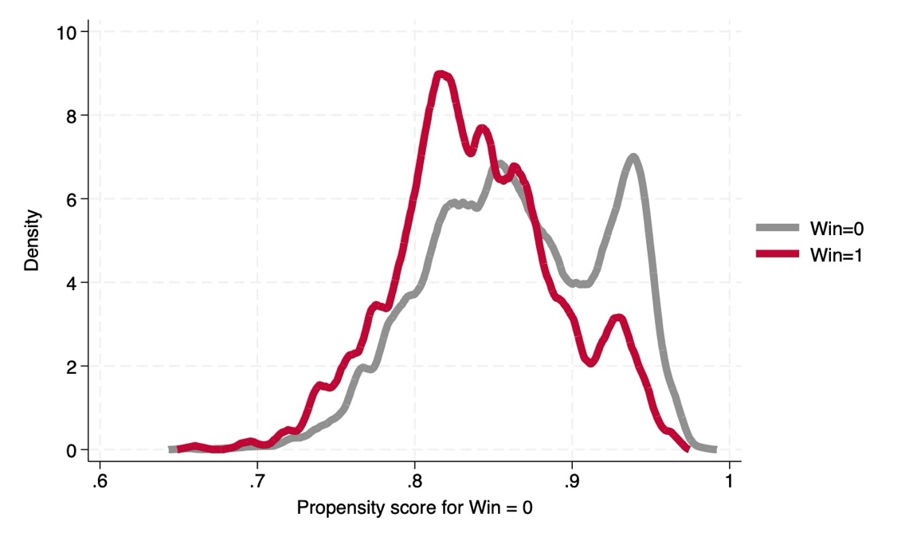
After having positively checked for the baseline assumptions of unconfoundedness, balancing and overlapping of the pre-treatment covariate balancing condition, in Table 14, the result of the ATE post PSM procedure is presented.

Table 14. ATE estimate based on PS Matching
Bankrupt | Coefficient | AI Robust std. err. | z | P>|z| | [95% conf. interval]
ATE  treated  (1 vs 0) | -0.037 | 0.011 | -3.31 | 0.001 | -0.058 | -0.015

The ATE result corroborates previous findings. In particular, at level of 1%, the magnitude of the ATE coefficient is slightly lower that the one estimated through NN-matching.

- Limits: External Validity and Extensive Margin
One limitation to the external validity of the results obtained is attached to the evaluation requirements. Indeed, since the aim posited is to estimate the policy effect on business survival, the financial variables are not available for individual corporations (partnerships). Therefore, our results can only be extended to corporations. The sample of firms involved in the evaluation could be rather specific and their response to the treatment could be influenced by some characteristics of the participating firms; however, since the ISI-Inail programme targets all types of firms, the estimated response could differ from the potential response of the entire population of firms, which also includes partnerships. In the light of this necessary pathway, it is not possible to check whether the effect found for corporations could be equal, less or even greater then for the individual companies not included in our sample.
Finally, it is worth pointing out that our results should only be read along the extensive margin ("whether the effect is there or not, whether it is positive or negative") and not also along the intensive margin (the magnitude of the effect). The objective was to understand whether public initiative to support tangible investments in OSH play an industrial policy role in exerting a positive effect on the survival and resilience of firms.

- Discussion and concluding remarks
Despite the existence of a theoretical link between OSH and firm economic performance, there is still scant empirical literature on the effect exerted by OSH investments on firm survival. This paper investigates the effectiveness of 2013 Inail’s direct aid programme to support firms investments in safer machinery checking if this initiative plays an industrial policy role. Using a unique microfounded database, provided by Inail and Aida, we apply regression adjustment and logistic estimation to perform an Intention-to-Treat analysis between assigned and not assigned to treatment (2013 ISI-Inail Call).
The estimation results show that the evaluated initiative generates an impact on the ability of firms to survive, pinning down a statistically significant negative effect of the policy on the bankruptcy of assigned with respect to non assigned companies.
ITT analysis, however, takes the whole assigned group as treated, regardless of the actual receipt of funds. In our perspective, this could translate in a conservative estimate of the treatment effect (Gupta, 2011). To obtain less conservative estimate, a comparison between treated and the most similar untreated firms is carried out. In order to reduce the risk of committing sample selection bias two alternative types of matching methods are implemented before calculating the Average Treatment Effect (ATE). The first matching method used is the exact matching Nearest-Neighbour (NN) on covariates, based on Mahalanobis distance; the second, following Rosenbaum and Rubin (1983), pairs treated and untreated units using the Propensity Score Matching (PSM).
The estimation results show that the Inail’s policy implemented in 2013 positively affects firms’ survival performance and resilience.
The main finding of this paper is that extending the policy mix in OSH by including in addition to regulation and enforcement (sticks) direct incentives (carrots) could enhance firms’ economic performance.
Therefore, this work emphasises the need to disseminate the knowledge of the economic value of OSH. Indeed, managers must be made aware of the impact of tangible investments in OSH on company performance, since productivity and its improvement through specific interventions is a key element of the economic attractiveness of OSH investments (Steel et al., 2018). This is why legal measures and incentives to support companies need to be complemented by an economic justification to reverse the trend of cutbacks in risk management and company closures due to poor and unsustainable working lives (Takala et al., 2014).

References
Aakvik, A. (2001). Bounding a Matching Estimator: The Case of a Norwegian Training Program. Oxford Bulletin of Economics & Statistics, 63(1).
Abadie, A., Drukker, D., Herr, J. L., & Imbens, G. W. (2004). Implementing matching estimators for average treatment effects in Stata. The stata journal, 4(3), 290-311.
Abadie, A., & Imbens, G. (2002). Simple and bias-corrected matching estimators for average treatment effects.
Abadie, A., & Imbens, G. W. (2016). Matching on the estimated propensity score. Econometrica, 84(2), 781-807.
Andreoni, D. (1986). The Cost of Occupational Accidents and Diseases. Geneva: ILO.
Agarwal, R., & Gort, M. (2002). Firm and product life cycles and firm survival. American Economic Review, 92(2), 184-190.
Angrist, J. D., & Krueger, A. B. (1999). Empirical strategies in labor economics. In Handbook of labor economics (Vol. 3, pp. 1277-1366). Elsevier.
Austin, P. C. (2009). Using the standardized difference to compare the prevalence of a binary variable between two groups in observational research. Communications in statistics-simulation and computation, 38(6), 1228-1234.
Austin, P. C., Grootendorst, P., & Anderson, G. M. (2007). A comparison of the ability of different propensity score models to balance measured variables between treated and untreated subjects: a Monte Carlo study. Statistics in medicine, 26(4), 734-753.
Becker, S. O., & Caliendo, M. (2007). Sensitivity analysis for average treatment effects. The stata journal, 7(1), 71-83.
Bruhn, M., & McKenzie, D. (2009). In pursuit of balance: Randomization in practice in development field experiments. American economic journal: applied economics, 1(4), 200-232.
Caliendo, M., & Kopeinig, S. (2008). Some practical guidance for the implementation of propensity score matching. Journal of economic surveys, 22(1), 31-72.
Cerulli, G. (2015). Econometric evaluation of socio-economic programs Theory and applications. Springer.
D'Agostino Jr, R. B. (1998). Propensity score methods for bias reduction in the comparison of a treatment to a non‐randomized control group. Statistics in medicine, 17(19), 2265-2281.
Dehejia, R. H., & Wahba, S. (1999). Causal effects in nonexperimental studies: Reevaluating the evaluation of training programs. Journal of the American statistical Association, 94(448), 1053-1062.
Esteve-Pérez, S., & Mañez-Castillejo, J. A. (2008). The resource-based theory of the firm and firm survival. Small Business Economics, 30, 231-249.
Fernández-Muñiz, B., Montes-Peón, J. M., & Vázquez-Ordás, C. J. (2009). Relation between occupational safety management and firm performance. Safety science, 47(7), 980-991.
Flury, B. K., & Riedwyl, H. (1986). Standard distance in univariate and multivariate analysis. The American Statistician, 40(3), 249-251.
Frangakis, C. E., & Rubin, D. B. (1999). Addressing complications of intention-to-treat analysis in the combined presence of all-or-none treatment-noncompliance and subsequent missing outcomes. Biometrika, 86(2), 365-379.
Giannetti, C. (2019). Debt specialization and performance of European firms. Journal of Empirical Finance, 53, 257-271.
Gupta, S. K. (2011). Intention-to-treat concept: a review. Perspectives in clinical research, 2(3), 109-112.
Hirano, K., Imbens, G. W., Rubin, D. B., & Zhou, X. H. (2000). Assessing the effect of an influenza vaccine in an encouragement design. Biostatistics, 1(1), 69-88.
Yang, D., & Dalton, J. E. (2012). A unified approach to measuring the effect size between two groups using SAS. In SAS global forum (Vol. 335, pp. 1-6).
Mantel, N., & Haenszel, W. (1959). Statistical aspects of the analysis of data from retrospective studies of disease. Journal of the national cancer institute, 22(4), 719-748.
Morgan, K. L., & Rubin, D. B. (2012). Rerandomization to improve covariate balance in experiments.
Musso, P., & Schiavo, S. (2008). The impact of financial constraints on firm survival and growth. Journal of evolutionary economics, 18, 135-149.
Rosenbaum, P. R. (2002). Observational Studies. 2nd ed. New York: Springer.
Rosenbaum, P. R., & Rubin, D. B. (1983). The central role of the propensity score in observational studies for causal effects. Biometrika, 70(1), 41-55.
Rubin, D. B. (1974). Estimating causal effects of treatments in randomized and nonrandomized studies. Journal of educational Psychology, 66(5), 688.
Shikdar, A. A., & Sawaqed, N. M. (2003). Worker productivity, and occupational health and safety issues in selected industries. Computers & industrial engineering, 45(4), 563-572.
Staffa, S. J., & Zurakowski, D. (2018). Five steps to successfully implement and evaluate propensity score matching in clinical research studies. Anesthesia & Analgesia, 127(4), 1066-1073.
Steel, J., Godderis, L., & Luyten, J. (2018). Productivity estimation in economic evaluations of occupational health and safety interventions: a systematic review. Scandinavian journal of work, environment & health, 44(5), 458-474.
Stuart, E. A. (2010). Matching methods for causal inference: A review and a look forward. Statistical science: a review journal of the Institute of Mathematical Statistics, 25(1), 1.
Ugur, M., & Vivarelli, M. (2021). Innovation, firm survival and productivity: the state of the art. Economics of Innovation and New Technology, 30(5), 433-467.
Veltri, A., Pagell, M., Behm, M., & Das, A. (2007). A data-based evaluation of the relationship between occupational safety and operating performance. Journal of SH&E Research, 4(1), 1-22.

APPENDIX A

Table 1A. Comparison of the balance sheet data
before the policy intervention for untreated, treated and drop-out firms
Before
Untreated | Mean | SD
Maturity | 17.888 | 14.387
Debts | 2,348.147 | 6,078.151
Assets | 1,129.557 | 4,205.085
Production | 3,350.018 | 8,806.721
Revenues | 3,249.617 | 8,671.196
ROE | 8.614 | 20.292
Employees | 17.150 | 58.548
Value Added | 47,439.890 | 29,855.560
ABITDA | 250.961 | 845.050
Treated
Maturity | 20.416 | 15.053
Debts | 2,971.112 | 12,517.830
Assets | 1,421.427 | 3,285.523
Production | 4,279.658 | 10,081.120
Revenues | 4,160.243 | 9,871.803
ROE | 9.037 | 17.147
Employees | 17.675 | 20.626
Value Added | 54,357.950 | 32,890.520
EBITDA | 329.798 | 619.587
Drop-out
Maturity | 15.727 | 13.11
Debts | 3,142.360 | 16,633.580
Assets | 1,029.587 | 3,186.610
Production | 3,847.061 | 13,190.610
Revenues | 3,675.812 | 12,242.800
ROE | 7.968 | 21.973
Employees | 19.482 | 50.002
Value Added | 45,521.990 | 29,314.040
EBITDA | 276.134 | 1,051.108

Table 2A. Comparison of the balance sheet data
after the policy intervention for untreated, treated and drop-out firms
After
Not assigned | Mean | SD
Maturity | 17.888 | 14.387
Debts | 2,623.548 | 7,402.622
Assets | 1,346.607 | 5,195.403
Production | 3,973.213 | 13,291.300
Revenues | 3,834.102 | 13,094.13
ROE | 9.035 | 19.116
Employees | 18.209 | 33.366
Value Added | 52,180.070 | 33,722.980
EBITDA | 315.779 | 1,009.499
Assigned
Maturity | 20.417 | 15.053
Debts | 3,116.239 | 8,093.336
Assets | 1,741.034 | 4,057.304
Production | 4,934.206 | 9,303.179
Revenues | 4,743.951 | 8,904.172
ROE | 11.370 | 18.331
Employees | 19.630 | 22.664
Value Added | 60,248.880 | 34,835.600
EBITDA | 444.731 | 1,033.520
Drop-out
Maturity | 15.727 | 13.114
Debts | 3,267.017 | 13,067.100
Assets | 1,330.922 | 5,322.211
Production | 4,459.459 | 14,717.910
Revenues | 4,228.070 | 12,899.840
ROE | 9.755 | 17.918
Employees | 23.373 | 105.646
Value Added | 51,812.620 | 36,647.770
EBITDA | 360.479 | 1,372.77

Table 3A. Descriptive statistics (number and percentage) relative to
the stratification and dichotomous variables
Variables | Untreated |  | Treated |  | Drop-out
 | Obs. | Percentage | Obs. | Percentage | Obs. | Percentage
Ateco
Manufacturing | 2,857 | 43.6 | 594 | 51.4 | 379 | 37.5
Construction | 1,683 | 25.7 | 240 | 22.5 | 305 | 30.2
Other | 1,881 | 28.7 | 264 | 24.7 | 314 | 31.1
Unknown | 137 | 2.1 | 16 | 1.5 | 12 | 1.2
Company type
Srl | 5,927 | 90.4 | 954 | 89.2 | 902 | 89.3
Spa | 317 | 4.8 | 84 | 7.9 | 57 | 5.6
Cooperative and Corsortia | 286 | 4.4 | 25 | 2.3 | 45 | 4.5
Other | 28 | 0.4 | 6 | 0.6 | 6 | 0.6
Macro region
North | 3,148 | 48.0 | 633 | 59.2 | 295 | 29.2
Centre | 1,294 | 19.7 | 270 | 25.3 | 290 | 28.7
South | 2,116 | 32.3 | 166 | 15.5 | 425 | 42.1
Technology
High | 3,877 | 59.1 | 591 | 55.3 | 648 | 64.2
Low | 2,681 | 40.9 | 478 | 44.7 | 362 | 35.8

Table 4A. Comparison of logarithm and ranked variables describing the balance sheet data
before policy intervention for untreated, treated and drop-out firms

Before
Untreated | Obs. | Mean | SD
(ln)Debts | 6,388 | 6.808 | 1.364
(Ranked)Assets | 6,558 | 42.543 | 24.916
(Ranked)Production | 6,558 | 42.339 | 24.995
(ln)Revenues | 6,328 | 7.143 | 1.403
(Ranked)ROE | 6,558 | 43.021 | 25.120
(ln)Employees | 6,327 | 2.389 | 0.916
(Ranked) Value Added | 6,558 | 42.509 | 25.059
(Ranked)EBITDA | 6,558 | 42.339 | 24.945
Treated
(ln)Debts | 1,025 | 7.103 | 1.103
(Ranked)Assets | 1,069 | 11.488 | 5.773
(Ranked)Production | 1,069 | 11.381 | 5.718
(ln)Revenues | 1,013 | 7.562 | 1.233
(Ranked)ROE | 1,069 | 10.490 | 5.911
(ln)Employees | 1,013 | 2.555 | 0.851
(Ranked) Value Added | 1,069 | 11.605 | 5.622
(Ranked)EBITDA | 1,069 | 11.432 | 5.787
Drop-out
(ln)Debts | 984 | 6.883 | 1.428
(Ranked)Assets | 1,010 | 40.413 | 25.135
(Ranked)Production | 1,010 | 41.522 | 25.229
(ln)Revenues | 977 | 7.099 | 1.473
(Ranked)ROE | 1,010 | 43.305 | 24.755
(ln)Employees | 977 | 2.441 | 0.951
(Ranked)Value Added | 1,010 | 40.078 | 25.114
(Ranked)EBITDA | 1,010 | 41.326 | 25.062

Table 5A. Comparison of logarithm and ranked variables describing the balance sheet data
after policy intervention for untreated, treated and drop-out firms
After
Untreated | Obs. | Mean | SD
(ln)Debts | 6,475 | 6.918 | 1.344
(Ranked)Assets | 6,558 | 42.285 | 24.943
(Ranked)Production | 6,558 | 42.205 | 25.002
(ln)Revenues | 6,390 | 7.212 | 1.505
(Ranked)ROE | 6,558 | 42.768 | 25.107
(ln)Employees | 6,385 | 2.426 | 0.971
(Ranked)Value Added | 6,558 | 42.355 | 25.090
(Ranked)EBITDA | 6,558 | 41.982 | 24.936
Treated
(ln)Debts | 1,064 | 7.226 | 1.239
(Ranked)Assets | 1,069 | 11.329 | 5.676
(Ranked)Production | 1,069 | 11.149 | 5.551
(ln)Revenues | 1,061 | 7.690 | 1.282
(Ranked)ROE | 1,069 | 10.487 | 5.772
(ln)Employees | 1,061 | 2.641 | 0.872
(Ranked)Value Added | 1,069 | 11.192 | 5.511
(Ranked)EBITDA | 1,069 | 11.250 | 5.596
Drop-out
(ln)Debts | 976 | 7.049 | 1.354
(Ranked)Assets | 1,010 | 41.897 | 25.595
(Ranked)Production | 1,010 | 42.870 | 26.033
(ln)Revenues | 961 | 7.204 | 1.509
(Ranked)ROE | 1,010 | 44.113 | 25.333
(ln)Employees | 960 | 2.485 | 1.012
(Ranked)Value Added | 1,010 | 42.246 | 25.924
(Ranked)EBITDA | 1,010 | 43.092 | 25.942

APPENDIX B
As extensively explained in the estimation methodology discussion (Section 3), the Click Day mimics a randomized assignment-to-treatment. As Bryson et al. (2002) underline, in the case of random assignment, we can be confident that the treated and untreated populations are comparable in terms of observable and unobservable characteristics; however, the operational characteristics of the administrative procedure may raise evaluation challenges that need to be addressed when dealing with the impact assessment of the initiative. Considering Inail ISI 2013 call, the advantages offered by the random assignment may diminish in practice due to the administrative filters applied to eligible firms (i.e., drop-out). In our perspective, we have to test if, once drop-out enterprises are removed from assignment group, covariates have a certain predictive power on treatment variable. Therefore, we estimate a logistic model with the treatment variable (that have received funds) as the dependent variable and the whole set of covariates as the independent variables (Table 1B).

Table 1B. Multivariate test of the non-ability of the control variables to predict treatment
Variables | Logistic Model  (Dependent Variable: treatment)
Debts | 0.915*  (0.049)
Assets | 1.003  (0.002)
Production | 1.002  (0.006)
Revenues | 1.164  (0.120)
ROE | 1.000  (0.002)
Employees | 0.873*  (0.070)
Value Added | 1.003  (0.002)
EBITDA | 1.004  (0.003)
Construction | 1.090  (0.344)
Other | 1.085  (0.340)
Unknown | 0.987  (0.309)
Spa | 1.164  (0.168)
Cooperative and Consortia | 0.710  (0.158)
Other | 1.681  (0.779)
North | 0.828  (0.070)
South | 0.420***  (0.046)
Technology low | 1.044  (0.088)
Intercept | 0.095***  (0.055)
Observations | 7,339
$$LR χ^{2}$$ | 201.260
Pseudo $R^{2}$ | 0.0342

Robust standard errors in parentheses: *** p<0.01, ** p<0.05, * p<0.1

As shown in Table 1B, among the continuous variables “Debts” and “Employees” reveal to have some predictive power on treatment status. Among the dichotomous and stratification variables, firms in the South have a lower odds ratio than firms in the Center and they show a predictive power on treatment status. To assess the performance of models, we compute the the Area Under the Receiver Operating Characteristic Curve (AUC) and graph the ROC curve (Figure 1B).

Figure 1B. ROC curve to asses the performance of logistic model about imbalanced datasets
(Dependent variable: treatment)
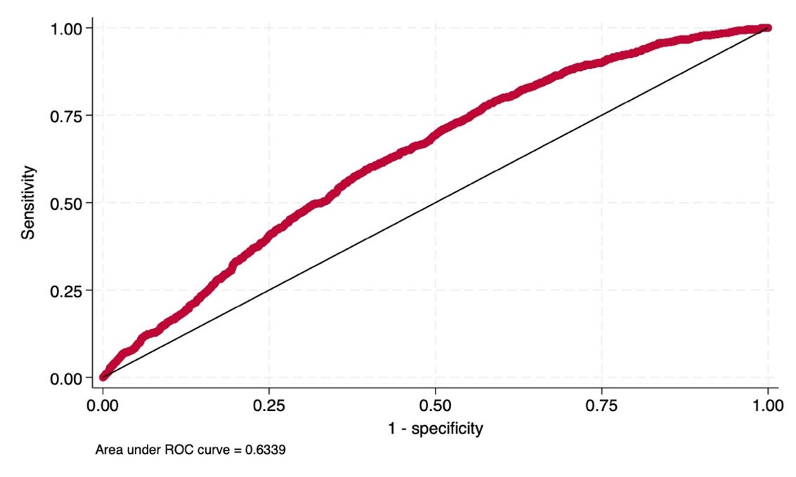
The Area under the ROC curve for “treatment” variable as a dependent variable is 0.63. The value is higher with respect the Area under the ROC curve computed with “assignment” as a dependent variable. From this, one can infer that the elimination of drop-outs from the sample of assigned has worsened the comparability of the units being compared. This implies that a comparison of treated and untreated units without the use of matching techniques would provide biased estimates.

APPENDIX C
The estimate of the Average Treatment Effect based on 1:2 and 1:4 Nearest Neighbour matching are shown respectively in Table 1C and Table 2C.

Table 1C. ATE estimated after 1:2 Nearest Neighbour matching
Bankrupt | Coefficient | AI Robust std. err. | z | P>|z| | [95% conf. interval]
ATE  treated  (1 vs 0) | -0.044 | 0.009 | -4.71 | 0.000 | -0.063 | -0.026

Table 2C. ATE estimated after 1:4 Nearest Neighbour matching
Bankrupt | Coefficient | AI Robust std. err. | z | P>|z| | [95% conf. interval]
ATE  treated  (1 vs 0) | -0.043 | 0.009 | -4.71 | 0.000 | -0.060 | -0.025

Tables 1C and 2C confirm the previous estimate (ATE estimate after 1:1 Nearest Neighbour matching, Table 11), with the magnitude of the effect slightly reducing but maintaining the negative sign and statistical significance at the 1 % level.

APPENDIX D
The estimate of the Average Treatment Effect on the Treated (ATT) is provided in Table 1D.

Table 1D. ATT estimate based on NN Matching
Bankrupt | Coefficient | AI Robust std. Err. | Z | P>|z| | [95% conf. Interval]
ATT  (1 vs 0) | -0.021 | 0.011 | -2.84 | 0.0062 | -0.043 | -0.010

Following, the standardized mean differences are computed, to check the balancing of the covariates (based on pretreatment value of the variables) between treated and untreated group before-and-after matching.

Table 2D. Standardized mean differences of the pre-treatment value of the covariates
between treated and untreated group before (Raw) and after (Matched) PS matching
Variables | Standardized differences
 | Raw | Matched
Maturity | 0.169 | -0.029
Debts | 0.218 | 0.020
Assets | 0.285 | -0.001
Production | 0.314 | 0.014
Revenues | 0.318 | 0.013
ROE | 0.015 | -0.032
Employees | 0.188 | -0.004
Value Added | 0.323 | 0.017
EBITDA | 0.319 | -0.144
Construction | 0.158 | 0.002
Other | -0.086 | -0.005
Unknown | -0.076 | 0.002
Spa | 0.133 | 0
Cooperative and Consortia | -0.115 | 0
Other | -0.023 | 0
North | 0.214 | -0.008
South | -0.392 | -0.003
Technology low | 0.082 | 0.004
As shown in Table 2D the NN matching procedure ensures that the standardized differences of all variables are below the 0.1 threshold at which the balance can be considered negligible.
In Table 3D the ATT is estimate also based on PS matching.

Table 3D. ATT estimate based on PS Matching
Bankrupt | Coefficient | AI Robust std. Err. | Z | P>|z| | [95% conf. Interval]
ATT  (1 vs 0) | -0.023 | 0.012 | -1.98 | 0.048 | -0.047 | -0.0002

The estimate show a negative (decreasing bankrupt) Average Treatment Effect on the Treated at 5% of significance level.
As for the ATE estimate based on PSM, we check if the unconfoundedness (Table 4D), balancing (Table 5D) and overlap (Figure 1D) assumptions hold for unbiased estimate.

Table 4D. Mantel-Haenszel Test
Gamma | $$Q_{MH}^{+}$$ | $$Q_{MH}^{-}$$ | $$p_{MH}^{+}$$ | $$p_{MH}^{-}$$
1 | 2.33318 | 2.33318 | 0.009819 | 0.009819
1.05 | 2.59772 | 2.071 | 0.004692 | 0.019179
1.1 | 2.85055 | 1.82139 | 0.002182 | 0.034274
1.15 | 3.09332 | 1.58362 | 0.00099 | 0.05664
1.2 | 3.32694 | 1.35658 | 0.000439 | 0.087457
1.25 | 3.55219 | 1.13929 | 0.000191 | 0.127292
1.3 | 3.76975 | 0.930882 | 0.000082 | 0.175957
1.35 | 3.98024 | 0.730621 | 0.000034 | 0.232505
1.4 | 4.1842 | 0.537846 | 0.000014 | 0.295342
1.45 | 4.38208 | 0.351976 | 5.9e-06 | 0.362428
1.5 | 4.57433 | 0.172493 | 2.4e-06 | 0.431525
1.55 | 4.76133 | -0.001065 | 9.6e-07 | 0.500425
1.6 | 4.94341 | -0.020211 | 3.8e-07 | 0.508063
1.65 | 5.12089 | 0.142285 | 1.5e-07 | 0.443428
1.7 | 5.29405 | 0.299955 | 6.0e-08 | 0.382106
1.75 | 5.46315 | 0.453108 | 2.3e-08 | 0.325235
1.8 | 5.62842 | 0.602022 | 9.1e-09 | 0.27358
1.85 | 5.79007 | 0.74695 | 3.5e-09 | 0.227547
1.9 | 5.94831 | 0.888125 | 1.4e-09 | 0.187237
1.95 | 6.10331 | 1.02576 | 5.2e-10 | 0.152502
2 | 6.25523 | 1.16005 | 2.0e-10 | 0.123015

Table 5D. Standardized mean differences of the pre-treatment value of the covariates
between treated and untreated group before (Raw) and after (Matched) PS matching
Variables | Standardized differences
 | Raw | Matched
Maturity | 0.169 | -0.014
Debts | 0.218 | 0.051
Assets | 0.285 | 0.009
Production | 0.314 | 0.043
Revenues | 0.318 | 0.038
ROE | 0.015 | -0.007
Employees | 0.188 | 0.041
Value Added | 0.323 | 0.003
EBITDA | 0.319 | 0.015
Construction | 0.158 | 0.014
Other | -0.086 | -0.024
Unknown | -0.076 | 0.007
Spa | 0.133 | 0.037
Cooperative and Consortia | -0.085 | 0.020
Other | -0.023 | 0
North | 0.214 | 0.004
South | -0.392 | 0
Technology low | 0.082 | 0.005

Figure 1D. Overlap between treated and untreated firms after PS matching
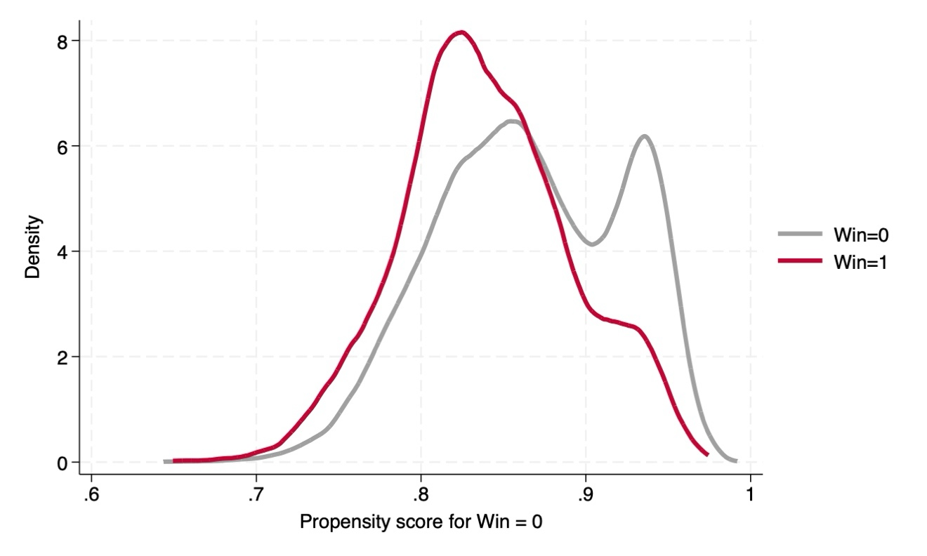
The result obtained (Table 4D, Table 5D and Figure 1D) provide similar evidence to previous results obtained for the baseline estimate of ATE (see Section 4). Thus, we could conclude that the tests performed do not provide evidence of biased estimate of ATT post-PSM.
In both cases (NN and PS estimates), the ATT estimates are lower than the ATE estimates (whichever method is used). Since, in general, if those with the lowest expected gains participate, the ATE will be higher than the ATT (Bryson et al., 2002), it could be inferred that the 2013 Inail policy targeted those firms with the least need in terms of survival.

APPENDIX E
A t-tests for equality of means in the two samples before-and-after PS matching is performed.
Moreover, the standardised percentage bias is computed. The standardised percentage bias is shown before and after matching, together with the achieved percentage reduction in bias.
The standardised percentage bias is the percentage difference of the sample means in the treated and non-treated (unmatched or matched) sub-samples as a percentage of the square root of the average of the sample variances in the treated and non-treated groups (Rosenbaum and Rubin, 1985).

Table1E. t-tests and standardised percentage bias before and after PS mathcing
Variable | Unmatched (U)  Matched (M) | Mean |  | %bias | % reduct |bias| | t-test |  | $$\frac{V(T)}{V(C)}$$
 |  | Treated | Control |  |  | $$t$$ | $$p>|t|$$
Maturity | U | 20.24 | 17.751 | 16.9 |  | 5.08 | 0.000 | 1.09
 | M | 20.24 | 20.447 | -1.4 | 91.7 | -0.31 | 0.758 | 0.97
Debts | U | 7.1028 | 6.8151 | 21.8 |  | 6.31 | 0.000 | 0.88*
 | M | 7.1028 | 7.0365 | 5.0 | 77.0 | 1.15 | 0.252 | 0.93
Assets | U | 48.241 | 41.47 | 28.5 |  | 8.29 | 0.000 | 0.91
 | M | 48.241 | 48.03 | 0.9 | 96.9 | 0.20 | 0.838 | 1.00
Production | U | 48.075 | 40.796 | 31.4 |  | 9.03 | 0.000 | 0.86*
 | M | 48.075 | 47.097 | 4.2 | 86.6 | 0.96 | 0.335 | 0.91
Revenues | U | 7.5621 | 7.143 | 31.8 |  | 8.98 | 0.000 | 0.77*
 | M | 7.5621 | 7.5134 | 3.7 | 88.4 | 0.86 | 0.390 | 0.88*
ROE | U | 41.883 | 41.516 | 1.6 |  | 0.45 | 0.652 | 0.87*
 | M | 41.883 | 42.052 | -0.7 | 53.8 | -0.17 | 0.869 | 0.92
Employees | U | 2.5553 | 2.3889 | 18.8 |  | 5.42 | 0.000 | 0.86*
 | M | 2.5553 | 2.5191 | 4.1 | 78.2 | 0.93 | 0.351 | 0.90
Value Added | U | 48.421 | 40.976 | 32.4 |  | 9.22 | 0.000 | 0.81*
 | M | 48.421 | 48.349 | 0.3 | 99.0 | 0.07 | 0.942 | 0.91
EBITDA | U | 48.265 | 40.793 | 31.9 |  | 9.26 | 0.000 | 0.90
 | M | 48.265 | 47.931 | 1.4 | 95.5 | 0.33 | 0.743 | 0.97
Construction | U | 0.51333 | 0.4346 | 15.8 |  | 4.96 | 0.000 | NA
 | M | 0.51333 | 0.50642 | 1.4 | 91.2 | 0.31 | 0.756 | NA
Other | U | 0.22113 | 0.25763 | -8.6 |  | -2.48 | 0.013 | NA
 | M | 0.22113 | 0.231 | -2.3 | 73.0 | -0.53 | 0.596 | NA
Unknown | U | 0.25271 | 0.28657 | -7.6 |  | -2.22 | 0.026 | NA
 | M | 0.25271 | 0.24975 | 0.7 | 91.3 | 0.15 | 0.878 | NA
Spa | U | 0.08292 | 0.04998 | 13.3 |  | 4.29 | 0.000 | NA
 | M | 0.08292 | 0.07305 | 4.0 | 70.0 | 0.83 | 0.408 | NA
Cooperative and Consortia | U | 0.02369 | 0.0446 | -11.5 |  | -3.09 | 0.002 | NA
 | M | 0.02369 | 0.02073 | 1.6 | 85.8 | 0.45 | 0.651 | NA
Other | U | 0.00592 | 0.00427 | 2.3 |  | 0.73 | 0.466 | NA
 | M | 0.00592 | 0.00592 | 0.0 | 100.0 | -0.00 | 1.000 | NA
North | U | 0.5844 | 0.4781 | 21.4 |  | 6.30 | 0.000 | NA
 | M | 0.5844 | 0.5844 | 0.0 | 100.0 | 0.00 | 1.000 | NA
South | U | 0.15893 | 0.32342 | -39.2 |  | -10.68 | 0.000 | NA
 | M | 0.15893 | 0.15696 | 0.5 | 98.8 | 0.12 | 0.903 | NA
Technology low | U | 0.44719 | 0.40645 | 8.2 |  | 2.45 | 0.014 | NA
 | M | 0.44719 | 0.44423 | 0.6 | 92.7 | 0.13 | 0.893 | NA
* if variance ratio outside [0.88; 1.13] for U and [0.88; 1.13] for M
Sample | $$Pseudo R^{2}$$ | $$LR χ^{2}$$ | $$P>χ^{2}$$ | MeanBias | MedBias | B | R | %Var
Unmatched | 0.036 | 209.19 | 0.000 | 19.1 | 17.9 | 50.9* | 0.63 | 67
Matched | 0.001 | 3.98 | 1.000 | 1.8 | 1.4 | 8.9 | 1.08 | 11
* if $B>25\%$, R outside $[0.5; 2]$

Morever, (Figure 1E) provides a graphical depict of the propensity score by treatment status (treated and untreated).

Figure 1E. Graph of the propensity score histogram by treatment status
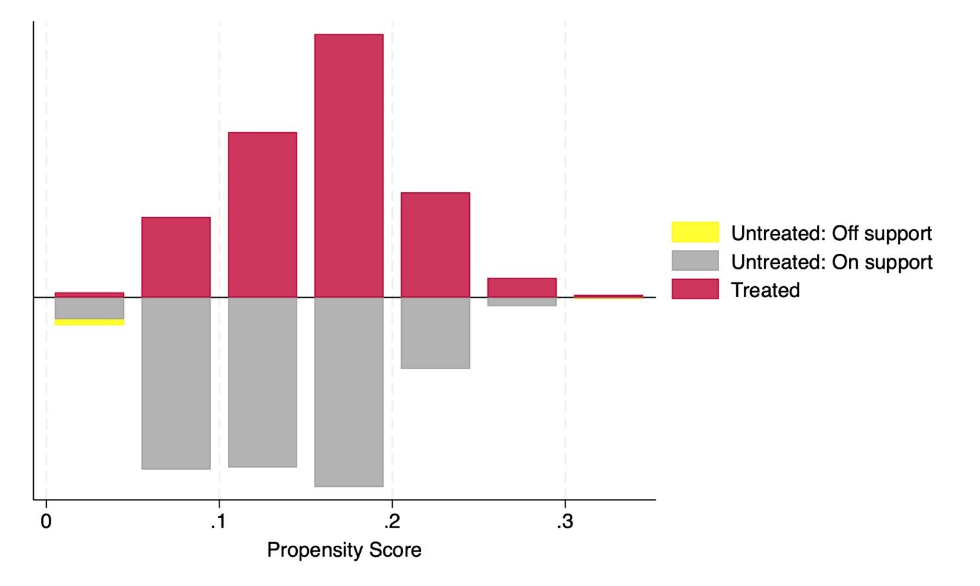

References

Bryson, A., Dorsett, R., & Purdon, S. (2002). The use of propensity score matching in the evaluation of active labour market policies.
Rosenbaum, P. R., & Rubin, D. B. (1985). Constructing a control group using multivariate matched sampling methods that incorporate the propensity score. The American Statistician, 39(1), 33-38.

https://oshwiki.osha.europa.eu/en/themes/external-economic-incentives-prevention.
A detailed overview of the policy under evaluation is presented in Chapter 3, Section 2.
This variable is build based on Istat Sectoral Innovation Intensity classification. A sector is classified as innovative (noninnovative) if the share of innovative enterprises in the total is higher (lower) than the average of the reference macro-sector.
In Appendix A are shown the descriptive statistics for the three groups of firms considered in the analysis: untreated (not assigned) treated (assigned-treated) and drop-out (assigned and not treated).
Practically, we sort the variable from lowest to highest value, and then we assigned a rank on a scale of 1 to 100 from the first to the last observation. The estimates were insensitive to the scale used for generating the rank. Moreover, the estimation are not affected by the alternative normalization or standardization transformation of the covariates subjected to the ranking. All the alternative estimates are available upon request.
In order to avoid the risk of double treatments, the firms that have obtained the grant in subsequent (>2013) editions are excluded from the sample.
We define as “assigned” firms that participated to the Click Day and passed the selection process, including the drop-out firms (see footnote n. 38).
We define as “not assigned” firms that joined the Click Day but didn’t pass the selection process.
The 2013 ISI Call was oriented to support projects falling into one of the following three categories: 1) investment projects; 2) projects for the adoption of organisational models and social responsibility models; 3) projects for the replacement or adaptation of work equipment. Each category has a its own budget allocation.
Drop-out firms are those: i) do not submit documentation after the Click Day ii) failing the administrative check – related to the paperwork iii) fail the technical check - related to the project iv) fail the accountability check – the project realised has to correspond to the project submitted. These companies are those creating the potential selection bias, which is addressed in the remainder of the analysis through the matching procedures (see Section 6).
We have excluded all companies with at least 7 missing (including missing in the Ateco codes) in the values of the balance sheet variables.
For continuous variable, the standardized difference is $d=\frac{\left(\overline{X_{1}}-\overline{X_{2}}\right)}{\sqrt{\frac{s_{1}^{2}+s_{2}^{2}}{2}}}$ where $X_{1}$ and $X_{2}$ denote the sample mean of the variable in each group, and $s_{1}^{2}$ and $s_{2}^{2}$ denote the sample variances, respectively. For binary and categorical data with K levels, see (Yang and Dalton, 2012).
A positive SMD means that the reference group has a higher mean score than the control group. A negative SMD mean that the reference group has a lower score than the control group. A SMD equal to zero means that there is no difference among the two group.
The standardized mean differences are related to different measures of non-overlap between two populations (Yang and Dalton, 2012). For example, a standardized difference of 0.1 indicates that there is 7,7% of non-overlap in the two distributions, that 52% of control group observations with values greater than 52% of treatment group observations, and that the mean of the treated group is at the 54th percentile of the control group. Or even, a standardized difference of 0.2 indicates that there is 15% of non-overlap in the two distributions, that 54% of control group observations with values greater than 54% of treatment group observations, and that the mean of the treated group is at the 58th percentile of the control group (Yang and Dalton, 2012).
The estimates of the RA model are consistent regardless of the alternative ways of measuring covariates (log and rank transformation or levels). All the alternative estimates are available upon request.
In Appendix C we provide the estimation results for the ATE after 1:2 and 1:4 Nearest Neighbour Matching.
The time-frame for pre-treatment variables is 2011-2013.
In Appendix D we provide also the Average Treatment Effect on Treated (ATT) after both NN and PS Matching procedures.
Estimating the magnitude of selection bias with nonexperimental data is not possible (Caliendo and Kopeinig, 2008). However, following Rosenbaum (2002) we use the bounding approach that does not test the unconfoundedness assumption per se, but provide evidence on the degree of significance of the results that depend on this untestable hypothesis. As clearly explain by Becker and Caliendo (2007), the basic question is whether unobserved factors can alter inference about treatment effects, and how strongly an unmeasured variable must influence the selection process to undermine the implications of the matching analysis.
In Appendix E a further covariates imbalance test both on unmatched and matched group is performed.
The analysis was conducted using Stata 18 teffects ra package for the estimation of the ITT, teffects nnmatch teffects psmatch e psmatch2 packages for the estimation of the ATE-ATT post-matching.
The balance of covariates improves even when the 0.1 (10 percent) threshold was already reached, with the exception of the ROE variable, which worsens slightly but still remains well below the threshold necessary to deem a negligible imbalance.
We find that the results hold even when applying 1:2 and 1:4 Nearest Neighbour Matching (see Appendix C)
In fact, as explained in detail in Section 3, the ITT analysis considers all admitted firms regardless of whether we have actually received treatment. The ATE calculated in Table 12, on the other hand, considers only those firms actually treated (receipt of funds).
The balance of covariates improves even when the 0.1 (10 percent) threshold was already reached, with the exception of the ROE variable, which worsens slightly but still remains well below the threshold necessary to deem imbalance negligible.

