A Comparative Analysis of Startup Equity Compensation:
Does Law Matter?
Yifat Aran & Casimiro A Nigro

Abstract
We examine the relationship between legal infrastructures and the propensity of startups to offer equity compensation to their employees. Using a proprietary dataset from Equidam, an international startup valuation service, paired with a metric from Index Ventures, an EU-based venture capital fund, which assesses a country's legal environment's favorability toward startup employee stock options, our study includes over 4,300 early-stage startups across 24 jurisdictions. We identify a moderate and significant correlation between a country's legal favorability to employee stock options and the likelihood of startups in that jurisdiction offering equity compensation. Our logistic regression analysis also points to other crucial factors, such as founders' prior startup experience, engagement with external legal consultants, and a more recent year of incorporation. This suggests that experience and sophistication play roles beyond just legal considerations. We also find that flexibility in stock option pricing, especially in determining the strike price, is a significant legal factor. As equity compensation becomes a focal point in policy debates, especially in the EU, our research offers empirical insights underscoring the importance of regulatory strategies that acknowledge and champion equity compensation practices in startups.

I. Introduction
Sam Altman, CEO of OpenAI and former president of Y Combinator, remarked that "[G]iving equity to employees is perhaps the key element to making startups work. It's amazing to me that some countries make this so hard (sometimes totally economically impractical) and then wonder why they don't have more successful startups." (tweet by @sama, February 14, 2023). Altman’s observation highlights both the pivotal role of equity compensation in Silicon Valley startups and the varied legislative landscapes across countries. This paper examines the nuanced relationship between these local regulatory frameworks and startups' tendency to grant equity compensation to their employees.
Venture capital (VC) is instrumental in driving innovation and fostering economic growth (Kortum & Lerner 2000; Samila, Sampsa, & Sorenson 2011). This assertion is evident in our daily lives, as major market leaders like Apple, Alphabet, Microsoft, and Amazon all began as VC-backed startups. VC funding facilitates the birth of innovative products and services, propelling technological advancements and engendering creative disruptions. Consequently, VC-backed companies are often characterized by higher investment in research and development, a propensity to go public, and a trajectory toward market leadership (Gornall & Strebulaev 2021).
The role of VCs in molding startup ecosystems has been extensively studied, but the role of human capital management practices in the growth and success of VC-backed firms and the broader ecosystems surrounding them remains relatively under-explored. For early-stage startups, where cash constraints are prevalent and employees undertake significant risks by joining an emerging enterprise, equity compensation stands out as an essential consideration. Startups heavily rely on the skills, knowledge, and experience of their employees, which are often their primary assets (Zingales 2000; Hall & Lerner 2010; Dimov & Shepherd 2005). Equity compensation grants of stock options or restricted stock units are commonly used to attract, incentivize, and retain start-up employees (Booth 2006; Cable 2016; Aran 2019). These arrangements allow employees to participate in the potential upside of the company's success, aligning their interests with those of the firm's investors and founders (Booth 2006; Aran 2018).
Furthermore, equity compensation can serve as a strategic tool to curb the outflow of human capital, and by extension, intellectual property from a firm. In this sense, it can function much like a non-compete clause or intellectual property protections (Aran 2018; Alon Beck 2019). Accordingly, the use of stock options in startup employee compensation is negatively correlated with such protective measures (Lie & Que 2019; Bias 2022; Lakkis 2023).
Moreover, equity compensation can contribute to the development of local ecosystems, as employees who strike it rich in an IPO or acquisition often become the next generation of entrepreneurs and investors (Bernstein 2015; Babina, Ouimet & Zarutskie 2017; Ng, & Stuart 2022; Stuart & Sorenson 2003). This "flywheel effect" originates from the early days of the semiconductor industry in Silicon Valley. One of the earliest manifestations of this effect was the emergence of the "Fairchildren," companies established by former Fairchild Semiconductor employees. These companies rose to prominence as major players in the semiconductor sector. In a later wave of this momentum, the "PayPal Mafia" drew public interest. Members of this group founded numerous influential technology firms, including Tesla, Inc., LinkedIn, Palantir Technologies, SpaceX, Affirm, YouTube, Yelp, and Yammer. Beyond these startups, they also initiated the Founders Fund.
However, the prevalence of stock options in VC-backed companies exhibits notable disparities, particularly when comparing the United States (US) to other regions (Hege et al. 2003; Kaplan et al. 2007). Despite the recognition of this phenomenon, there is a lack of consensus regarding its underlying causes. Various factors have been proposed to account for this divergence, including differences in the sophistication levels of European VCs and founders, as well as unfavorable tax treatment. Kaplan et al. (2007) contribute empirical evidence supporting the hypothesis of limited sophistication in European VC markets. Additionally, Henrekson and Sanandaji (2018 a, b) document a negative correlation between the effective tax rate on employee stock options and the extent of VC activity particularly in Europe. However, limitations in the existing literature include the predominantly high-level examination of legal issues, the absence of comprehensive cap table data, and the reliance on relatively small sample sizes to draw these conclusions. A more nuanced understanding of the factors contributing to the differential use of stock options in VC ecosystems is therefore needed.
In this study, we examine the state-level policies and regulations relating to equity compensation and their relation to employee ownership in early-stage startups. We combined data from Equidam, an online platform specializing in cap table management and valuation, with a ranking system from Index Ventures that measures the friendliness of a country's policies toward startup employee stock options (Index Ventures 2022). Our research covers nearly 4,300 early-stage startups from 24 countries, including the US, the United Kingdom (UK), Canada, Australia, Israel, and most European Union (EU) countries. Using Index Ventures’ scale, we compared countries based on the extent to which they support startup employee stock options. This allowed us to analyze key factors affecting the adoption of equity compensation plans including the compatibility of local legal systems with startup employee equity ownership.
We found a moderate and significant positive correlation between Index Ventures’ scale and the inclination of startups to grant equity to their employees, with variations observable across European countries. The US, UK, Israel, and Canada are at the forefront, showing strong positive correlations between favorable stock option policies and high rates of startup employee ownership. In contrast, countries like Switzerland and the Netherlands exhibit relatively high ownership rates despite only having moderate scores on Index Ventures' scale, suggesting the presence of other influential factors. On the other hand, countries such as Germany and Spain lag behind due to their less favorable stock option policies, which correlate with lower employee ownership rates.
In our logistic regression model, we identified several factors that correlate with the likelihood of a startup granting equity to its employees. A one-unit increase on Index Venture's scale, which denotes more favorable legal conditions, corresponded with a 5% higher probability of a startup granting equity compensation. Startups in the pre-revenue phase were more than twice as likely to grant equity compensation compared to those in the seed stage. Founders with a history of working at a startup also had a significant correlation, with the odds being roughly twice as high compared to those without such experience. For each additional employee, the odds of a startup granting equity compensation increase by approximately 0.5%. Furthermore, when startups engage external legal consultants, the tendency to grant equity compensation increases nearly fivefold. Additionally, newer startups, as indicated by each subsequent year of incorporation, correlated with a 12% higher likelihood of offering equity to employees.
Overall, these findings suggest that when shaping a startup’s strategy regarding equity compensation, legal determinants, while significant, are of relatively marginal importance compared to other factors that align more closely with a learning curve explanation. These influential factors include the presence of expert counsel, business growth, and gaining more experience over time and enterprises.
Nonetheless, specific legal aspects may still act as prerequisites for the implementation of equity compensation programs. Their absence could potentially hinder even sophisticated ecosystems from evolving in a manner conducive to widespread equity compensation adoption. Our examination of the individual components of the Index Venture scale emphasizes the critical role of the strike price of stock options (the fixed price at which an employee can purchase a company’s stock, regardless of its actual market price). A one unit increase in the Strike Price score (1-5 scale) significantly enhances the likelihood of a company offering employee equity compensation by approximately 61%, while keeping all other variables constant. This finding underscores the role of flexible stock option pricing policies in fostering employee ownership within startup ecosystems.
Our research findings hold relevance to the ongoing policy discourse within the EU, where the legal landscape concerning startup equity compensation is undergoing significant transformation. This shift is fueled by a growing recognition of equity compensations’ importance among investors and founders. This changing perspective is urging EU lawmakers to reevaluate and modify existing policies to encourage equity ownership for early-stage startup employees. Our study provides empirical insights that aid this debate, highlighting factors that influence startups’ adoption of equity compensation schemes.
II. Contributions to the Literature
Our research contributes to the existing literature by providing a more comprehensive and nuanced understanding of the factors influencing the adoption of equity compensation programs in early-stage startups, particularly in the context of VC-backed companies. Building on the recognized disparities in stock option prevalence, especially between the US and the EU, we extend this discussion by delving into the multifaceted mechanisms at play.
First, while prior studies, such as Kaplan et al. (2007) and Henrekson and Sanandaji (2018 a, b), have pointed to limited VC sophistication and unfavorable tax treatment as potential explanations, our research offers a deeper exploration. We examine various aspects of the legal treatment of employee stock options to identify their relative significance in predicting equity compensation adoption. Our study suggests that factors such as the stage of startup development, engagement with external legal consultants, and the firm’s age are pivotal. Thus, it implies that while legal determinants are important, they have a lesser influence on a startup’s equity compensation approach compared to other factors that support with a learning curve framework.
Second, the interaction between legal frameworks and venture capital activity has received considerable attention in academic literature on entrepreneurship. Foundational insights by Gompers and Lerner in “The Venture Capital Cycle” (Gompers & Lerner 2006) underscore the influence of tax policy on VC demand, indirectly highlighting the impact of legal frameworks on VC activity. This relationship is further influenced by global differences in VC market size and success (Cumming 2010), attributable to factors such as government policies (Keuschnigg & Nielsen 2001), taxes on investors and entrepreneurs (Keuschnigg & Nielsen 2003a, b, 2004), bankruptcy laws (Armour and Cumming 2006), and the strength of a country’s stock market (Black and Gilson 1998; Jeng & Wells 2000).
In the context of shareholder protection, previous works have presented no correlation between shareholder protection variables and VC investments (Jeng and Wells, 2000; Jeng & Wells 2000), and some have even suggested a negative relationship (Allen and Song, 2003). However, recent approaches have shifted the focus from investor protection indices modeled after public companies (such as La Porta et al. 2001) to studying local corporate laws in terms of their impact on founders and VCs’ freedom to design shareholder agreements, financial instruments, and corporate governance structures that suit their needs (Pereira 2023; Pinter 2019; Giudici & Agstner 2019; Toniolo & Pederzini 2020).
Specifically, regarding employee stock options, the literature focuses on taxation rates. In a cross-country study Henrekson and Sanandaji (2018a) find that the tax treatment of employee stock options is a significant factor contributing to VC activity variations. In subsequent work (Henrekson & Sanandaji 2018b), they explore Europe’s lag in VC activity and startup success despite its robust financial and legal infrastructure. They identify the tax treatment of employee stock options as a potential explanation for the stronger growth of the VC sector in the US, suggesting that Europe may enhance its entrepreneurial ecosystems by taxing employee stock options more leniently. Jointly, these studies underscore the potential impact of tax policies regarding employee stock options on venture capital activity across countries.
Our study draws parallels with the work of Henrekson and Sanandaji, delving deeper into the potential mechanisms that might underlie the relationship between VC activity and the legal treatment of employee stock options. While we provide some evidence suggesting that the legal treatment of employee stock options can influence the propensity of early-stage startups to grant equity to their early employees, our findings also indicate that tax rates might not be the predominant factor. Our findings highlight the importance of other factors beyond legal policies, specifically the value of experience and the significance of seeking expert advice, in addition to the ease of setting stock options’ strike prices.
III. Research Design
We first employ a correlational research design that draws from two primary data sources, aiming to discern the ties between startups’ inclination to offer equity awards to employees and the prevailing legal landscapes of various countries.

- The Index Ventures Scale: Assessing Stock Option Friendliness
Our first data source was created by Index Ventures, an EU-based venture capital firm. Index Ventures has created a “scale of stock option friendliness” to assess how various legal systems support startups in providing equity-based compensation to their employees. Six contributing factors are included in the index, with each scored on a 5-point scale where 5 signifies the most favorable conditions.
- Plan Scope: Do all employees and types of companies have access to favorable stock option treatments?
- Strike Price: Is it possible to grant options at an exercise price lower than the most recent price per share (paid by investors) without negative tax implications? Favorable policies take into account the illiquidity, high risk, and lack of preferential rights of employees’ common stock, thus allowing employee options to be valued differently from investors’ stock.
- Minority Shareholders Protections and Bureaucracy: The rights of minority shareholders – including employees who become such when exercising options – in relation to various company decisions may deter companies from offering employee stock options. This factor considers such rights and their applicability to departing employees, as well as administrative costs and burdens associated with establishing and maintaining the employee ownership plan.
- Employee Tax (Timing): At what point are employees taxed – upon share sale, exercise, or grant?
- Employee Tax (Rate): Which tax rate is applied – income, capital gains, or other? Are employee social contributions required, and if so, how much do they amount to?
- Employer Taxation: Does the use of employee stock options have financial repercussions for companies? If so, when do these occur and at what rate? Are employer social contributions required, and if so, how much are they?
As a result, the scale ranks countries on a scale of 6 to 30, with higher scores indicating more favorable legal environments for equity-based compensation schemes. Cronbach’s alpha for this scale of stock option friendliness is 0.917, suggesting a strong internal consistency among its six items. The associated bootstrap 95% confidence interval (0.871 to 0.948) further corroborates this reliability.
Figure 1 provides a comprehensive overview of Index Ventures aggregate scores along with a breakdown of scores pertinent to each individual factor across different countries.
Figure 1. Index Venture scores by country.
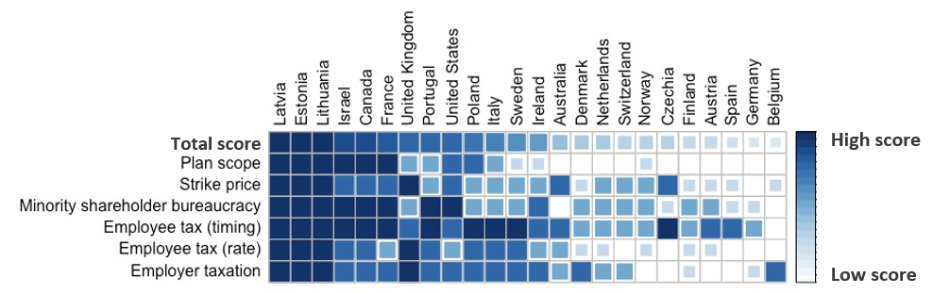
According to Index Ventures, countries with high Index Ventures’ Scores (IVS) have policies that strongly support the use of stock options by startups at all stages of growth and for all levels of employees. These countries have programs that are simple to implement with minimal cost to companies. Stock options can be heavily discounted from previous-round valuations by applying common stock valuations (known as 409A valuations in the US) or without the need for a valuation. Employee taxation is deferred to the point of sale, and taxation on the upside is 25% at most.
For instance, countries such as Lithuania (IVS=30) and Israel (IVS=27), have favorable policies. In Lithuania, the company can choose a strike price, even heavily discounted, without creating any tax liability upon grant. The employee tax is at the point of sale, and income tax is a flat-rate 20% on the spread between strike price and sale price.
In Israel, the policies apply to all limited liability companies, for all employees and board members employed by the company, with the exception of controlling shareholders. The company can choose a strike price, even at a nominal value, without creating any tax liability upon grant (however, US-style 409A valuations are most commonly used). The employee tax is imposed at the time of sale, provided that the options have been held by a trustee for at least two years prior to the sale.
On the other hand, countries with low scores such as Germany (IVS=10), Belgium (IVS=10), and Spain (IVS=11), have policies that are less supportive of employee stock options. This suggests that these countries might have more intricate frameworks, leading to higher costs for companies and less favorable terms, like higher exercise prices or immediate taxation, for employees. In some countries, it is not possible to set a strike price that is lower than the price per share paid in the most recent financing round.
Thus, the Index Venture scale provides a useful tool for comparing the favorability of different countries’ policies to startup employee stock options.
- Equidam Data: Analyzing Startup Employee Equity Ownership
To examine the association between startup employee equity ownership and Index Ventures’ scale of stock option friendliness, we utilize startup equity ownership data obtained from Equidam. Equidam is an EU-based online platform that provides early-stage startups with valuation estimates. The full dataset included 20,973 companies, and we performed the following exclusion criteria to create a cohort of early-stage VC backed dataset (the same company could be excluded for multiple reasons): companies founded before the year 2007 (no employee stock options or other equity incentives were allocated in those companies; excluded 4,429), without VC funding or VC-like funding such as incubator, angel and crowdfunding (excluded 11,384), companies without full commitment of the founders (excluded 3,241), companies in the idea stage (excluded 1,019), with valuation of less than half a million dollars (excluded 1,344), and from countries that are not included in Index Ventures’ scale (excluded 8,512). Following these exclusions, we were left with a dataset consisting of 4,235 early-stage startups incorporated in the 24 countries that are included in Index Ventures’ scale.
Furthermore, Equidam’s dataset incorporates several control variables to aid in comprehensive analysis. These include the ‘Development Stage’ of the enterprise, which is categorized into pre-seed, seed, or pre-revenue stages. The variable ‘Previous Startup Experience’ separates founders into three groups: those without previous startup involvement, those with prior experience working in a startup, and repeat founders who have launched more than one company. Another important variable is the ‘Number of Employees’, which acts as an indicator of the startup’s size. ‘Entrepreneur Age’ is also factored in, distinguishing among startups whose founders are older than 45, between 35 and 45, and younger than 35. ‘Board Presence’ discerns the inclusion of board members who are not the founders. ‘Valuation’ provides the latest valuation of the startup, and a 'Legal Consultants' variable which represents the company's reliance on external legal advice. Lastly, ‘Year of Incorporation’ takes into account the establishment year of the company.

IV. Findings
We used a logistic regression model with various predictive factors to assess the likelihood of employees being included in a startup’s capitalization table.
As seen in Table 1, our analysis was performed on 4,235 companies, and the intercept of the model was statistically significant (p = 0.001), with an odds ratio of 0.00, suggesting that in this sample, in the absence of all predictors, the odds of employee participation in a startup’s capitalization table is virtually zero.
Among the predictors, the score from Index Ventures’ scale for the country where the startup's headquarters is located, the Development Stage (pre-revenue), the number of employees, the presence of external legal consultants, and the Year of Incorporation were statistically significant at the 5% level.
Table 1: The reference point for the model encompasses the following conditions: the Development Stage is categorized as ‘pre-seed’, the founders do not have Previous Startup experience, the Entrepreneurs’ Age falls within the 35-45 bracket, the board composition is exclusively limited to the founders, and there is an absence of external legal consultants.
IV: Employee Equity Participation
Predictors | Odds Ratios | Std. Error | CI
(Intercept) | 0.00 ** | 0.00 | 0.00 – 0.00
Index Venture’s Score | 1.05 ** | 0.02 | 1.01 – 1.08
Development Stage: Seed | 1.24 | 0.31 | 0.77 – 2.03
Development Stage: Pre-revenue | 2.15 ** | 0.52 | 1.36 – 3.49
Previous Startup: Founders worked at a startup | 2.02 * | 0.59 | 1.17 – 3.72
Previous Startup: Founders founded a startup | 1.58 | 0.48 | 0.89 – 2.97
Number of Employees | 1.00 ** | 0.00 | 1.00 – 1.01
Entrepreneurs’ Age: Over 45 | 1.39 | 0.33 | 0.88 – 2.26
Entrepreneurs’ Age: Under 35 | 0.98 | 0.28 | 0.57 – 1.71
Board Presence: Non-founder members | 0.71 | 0.13 | 0.49 – 1.01
Valuation | 1.00 | 0.00 | NA – 1.00
Legal Consultants | 4.76 ** | 2.80 | 1.78 – 19.41
Year of Incorporation | 1.12 ** | 0.04 | 1.04 – 1.20
N | 4,235
R² Tjur | 0.018
* p<0.05 ** p<0.01 *** p<0.001
The Index Ventures Score had an odds ratio of 1.05 (p-value = 0.008), indicating that for each unit increase in the Index Ventures Score, the odds of having an employee in a startup’s cap table increase by 5%.
Compared to companies in the pre-seed stage, pre-revenue startups more frequently compensated employees with equity, as evidenced by an odds ratio of 2.15 (p-value = 0.001). This suggests that pre-revenue startups are over twice as likely to have employees on their capitalization table compared to those in the seed stage.
Previous startup experience of the founders as employees (and probably also as founders though samples size was too small for statistical significance), was also associated with granting startup equity compensation, with an odds ratio of 2.02 (p-value = 0.01).
As expected, the number of employees was also a significant predictor, with an odds ratio of 1.005 (p-value = 0.001). This indicates that for each additional employee, the odds of a startup granting equity compensation increase by approximately 0.5%.
The presence of external legal consultants was associated with a higher likelihood of granting startup equity compensation, with an odds ratio of 4.76 (p-value = 0.008). This suggests that startups with external legal consultants are nearly five times more likely to grant equity compensation to their employees.
Lastly, the Year of Incorporation was significant, with an odds ratio of 1.12 (p-value = 0.002), indicating that for each additional year, the odds of granting employee equity compensation increase by 12%.
Other predictors, the age of the entrepreneurs, the presence of board members other than the founders, and the firm’s valuation, were not statistically significant at the 5% level, suggesting that these factors do not significantly affect the likelihood of employees receiving equity compensation.
In summary, our logistic regression model indicates that while legal factors are significant in shaping a startup's approach to equity compensation, they play a comparatively minor role next to determinants more closely aligned with a learning curve explanation. These determinants include the engagement of external legal experts, founders' prior experience as employees in startups, and aspects of growth and time.
Further, we explore the relationship between Index Venture’s scale and startups’ use of equity compensation in our sample in more detail. For this analysis we excluded five countries for which we lack sufficient data (fewer than 20 companies are included in the dataset for Latvia, Lithuania, Czech Republic, and Estonia) and countries that amended their employee stock option policies during the study period (Italy in 2012, Australia in 2015, Denmark in 2016, Ireland in 2018, Sweden in 2018, and France in 2020).
Figure 2 shows a significant positive correlation between employee stock option policies and early-stage start-up employee equity participation (Pearson R = 0.71; p-value = 0.005), with significant variation across European countries. The friendliness of legal systems to employee ownership appears to be a relatively robust predictor of the percentage of early-stage startups that grant equity to their employees.
Figure 2. Correlation between a country's score on the Index Ventures scale (which represents the legal system's favorability towards employee stock options) and the tendency of early-stage startups in the Equidam dataset to include employees in their capitalization tables.
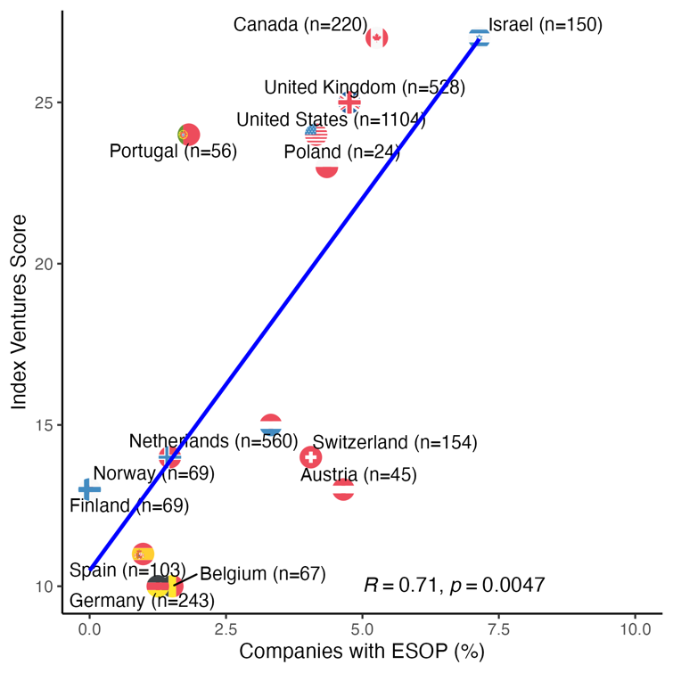
Countries form roughly three clusters based on the correlation between policies related to employee stock options and the rate of early-stage employee participation in start-up ownership. The top-performing group includes the United States, the United Kingdom, Israel, and Canada, which all have relatively favorable policies toward employee stock options and correspondingly high rates of employee ownership in start-ups. Among these states, Israel appears as an outlier with higher rates of employee participation in startup equity.
Meanwhile, Switzerland, the Netherlands, and Austria, despite having only moderate scores on the Index Venture scale, show early-stage startup employee ownership rates that are reasonably high — nearly on par with those of the UK and the US. This emphasizes the importance of a deeper examination of non-legal factors influencing the adoption of equity compensation plans, especially in the context of challenging legal frameworks.
The group of poor performers consists of countries that have relatively unfriendly policies towards stock options and correspondingly lower rates of employee ownership of local startups. This group includes advanced European economies such as Germany, Belgium, Finland, Belgium, and Spain.
Notably, countries such as France and Sweden, which recently underwent significant regulatory reforms, had no companies offering equity compensation in our sample. It remains to be seen whether these changes will influence the startup culture, leading startups to grant equity to their employees more freely.
To discern which of the six factors included in the Index Ventures scale primarily drive these results, we constructed a model incorporating each of these elements for detailed analysis. Similar logistic regression analysis as in the previous section was performed, but this time with the Index Venture elements as the independent variables. The results reveal that the only significant predictor is the 'Strike Price'. The odds ratio associated with this variable is 1.66, and it is statistically significant (p-value = 0.005). This suggests that for each unit increase in the strike price friendliness scale, the odds of a company offering an employee equity compensation increase by approximately 66%, assuming all other variables in the model are held constant. In other words, the higher the Index Venture’s strike price score (meaning more freedom in setting employee stock options’ strike prices), the more likely a company is to offer equity compensation to its employees, given that all other conditions remain the same.
This result is visually represented in Figure 3 using a forest plot, which provides a clear visual interpretation of the effect sizes. The plot's horizontal lines represent confidence intervals, and the fact that the line associated with the 'Strike Price' does not cross the vertical line of no effect (odds ratio = 1.0) confirms its statistical significance.
Figure 3. Forest Plot of Logistic Regression Analysis. This plot displays the odds ratios and 95% confidence intervals for each predictor. The 'Strike Price' variable is the sole significant factor, indicating a robust positive association with the provision of employee equity compensation.
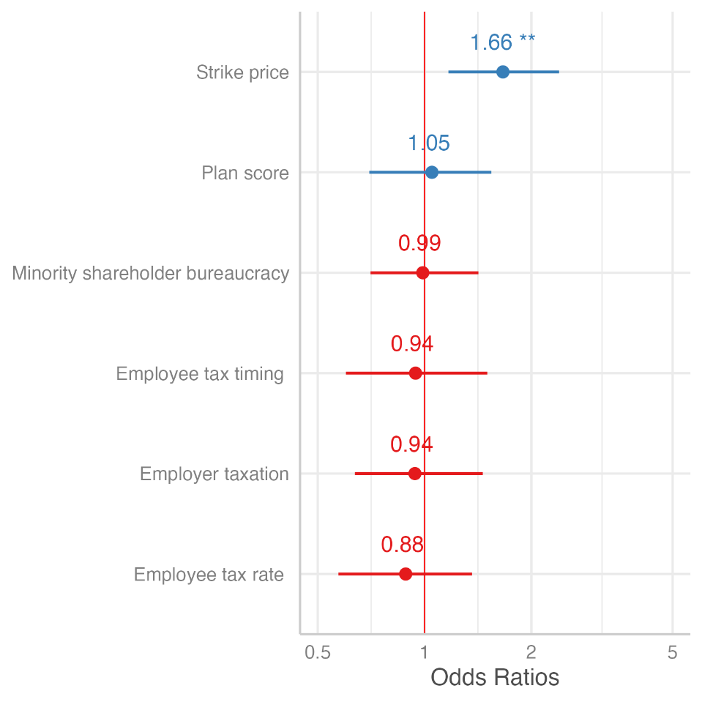
Interestingly, this finding adds nuance to the prevailing literature's emphasis on the employee stock options tax rate as a primary reason for Europe's limited success in nurturing VC ecosystems (Henrekson & Sanandaji 2018a, b). According to the literature, while most countries treat stock options as labor earnings, the US offers a more favorable capital gains tax rate, leading to widespread stock options use in US startups, which is less common in Europe. Our research indicates that even though tax rates play a role, startups are willing to provide equity to employees despite an unfavorable tax climate. high tax rates on employee stock options might still pose challenges for VC activity, potentially by driving up labor costs for startups. Yet, the leading deterrent in offering equity seems to stem from challenges in setting a strike price that accounts for the relatively lower value of the common stock compared to the preferred stock of the investors.
V. Limitations and Future Directions
It is important to note the limitations of our sample and study design. Since Equidam primarily serves startups seeking affordable valuation tools in their early stages, the sample might not reflect the practices of firms at more advanced stages of development or with better funding. Consequently, our results may not be fully generalizable to a broader startup population. Additionally, Equidam's data quality might vary across jurisdictions, given that the company operates globally. Our study has addressed this limitation by focusing on countries for which Equidam has sufficient data on 20 companies or more.
Furthermore, while our analysis illuminates the correlation between a country's legal framework and the propensity of early-stage startups to grant equity to their employees, it does not ascertain causation. To gain a deeper understanding of the causal relationship between regulatory frameworks and startups' utilization of equity compensation schemes, future studies could consider using a natural experiment approach, utilizing the policy changes that have been implemented in different EU states at different times.
Future research could further explore the role of cultural and societal factors in shaping the adoption of equity-based compensation schemes across different countries. It is important to consider that a uniform approach might not be effective across the board, considering the distinct cultural and institutional characteristics of different European countries. These unique characteristics inevitably affect the success of equity-based compensation plans. As such, policies and initiatives aimed at promoting the adoption of these schemes should be designed with the specific needs and circumstances of individual countries in mind, ensuring they are effective and sustainable in their unique ecosystems.
VI. Discussion and Conclusion
To conclude, our research indicates a moderate positive correlation between Index Ventures' scale measuring the friendliness of countries' legal policies toward employee stock options and startups' propensity to offer equity to their employees, though variations exist across countries. Nations like the US, UK, Israel, and Canada lead with strong correlations between supportive stock option policies and high startup employee ownership. In contrast, countries like Switzerland and the Netherlands have relatively high ownership rates, despite only moderate Index Ventures' scale scores, pointing to other underlying factors. Meanwhile, Germany and Spain show lower ownership rates, correlating with less supportive policies. Our logistic regression analysis reveals that beyond legal determinants, factors such as startup growth phase, founders' experience, employee count, external legal consultation, and startup age play pivotal roles in equity compensation strategies, suggesting that factors tied to experiential learning and sophistication hold notable importance in startups' decision-making processes in this issue.
To contextualize our findings, it is important to examine the historical development of startup equity compensation practices across jurisdictions. In the US, startups’ use of employee stock options became widespread during the semiconductor boom of the 1970s and 1980s (Blasi, Kruse & Bernstein 2003). The adoption of equity compensation schemes by Silicon Valley startups can be attributed in part to intense competition for top talent with established firms and the need to retain skilled employees in an environment where non-compete agreements are not legally enforceable (Booth 2006; Aran 2018). Moreover, it reflects the distinctive non-hierarchical work culture that emerged in Silicon Valley, which places a high value on talent. This approach was championed by notable venture capitalists such as Arthur Rock and became part of the blueprint for building a VC-backed startup. (Mallaby 2022).
This practice of granting equity compensation subsequently spread globally alongside the expansion of the venture capital industry. For instance, Israel, often referred to as the "Startup Nation" due to its robust and supportive startup ecosystem (Senor & Singer 2009), was quick to enact accommodating policies regarding equity compensation. These policies, encapsulated in Section 102 of the Israeli Tax Ordinance, were introduced in the late 1980s and refined in the early 2000s, playing a crucial role in the country's startup growth (Aran 2024).
In the UK, the Enterprise Management Incentive (EMI) scheme, introduced in 2000 and revised several times since, is a popular stock option program among tech startups. For larger startups and private companies, other tax-advantaged schemes like the Company Share Ownership Plan (CSOP) and Growth Shares exist, but they are complex to establish and usually reserved for senior employees. The Share Incentive Plan (SIP), offering potential zero tax rates, is another option but has low limits and must be extended to all employees.
Contrastingly, equity compensation has been less prevalent in Continental Europe. European start-ups have traditionally relied more heavily on conventional cash compensation and the legal and regulatory landscape surrounding equity-based compensation has been less favorable. However, the dynamics are transforming as European start-ups vie for greater competitiveness on the global stage. A growing recognition of the value of equity-based compensation among European investors and founders is leading to mounting pressure on local lawmakers and regulators to revise policies pertaining to stock options and other forms of equity-based compensation.
Thus, in 2018, a group of leading European startups, driven by concerns surrounding the existing legislative framework, appealed to the European Commission for policy reforms. Their entreaty, encapsulated in an open letter titled “Not Optional— Europe must attract more talent to startups,” underscored the urgency of rectifying the sporadic, inconsistent, and often punitive regulations overseeing employee ownership. In 2021, the European Commission addressed these concerns as part of the "Start-up Nation Standards" initiative, a comprehensive approach to enhancing the legal framework for startups. This initiative recommends that employee stock options be subject to capital gains tax, instead of income tax, with the tax event deferred until a subsequent liquidity event occurs. Additionally, it suggests allowing startups to issue stock options without voting rights, granting them greater flexibility from a corporate law perspective.
Following the initiation of these guidelines, certain European countries, including Latvia, Lithuania, France, and the Netherlands, have swiftly engaged in proactive measures to bolster the appeal of startups for employees by facilitating the sharing of equity. Currently, several European governments, including those of Germany, Austria, and Belgium, have embarked on exploratory investigations to formulate new policies.
Against this backdrop, the results of this study provide significant insights into the complex interplay between legal policies and the propensity of startups to adopt employee equity compensation schemes, affirming and expanding upon existing literature on the topic.
In "Understanding Venture Capital Structure: A Tax Explanation for Convertible Preferred Stock" (2003), Ronald Gilson and David Schizer challenge predominant theories on the use of convertible preferred stock in venture capital. They highlight US tax law as a pivotal, yet frequently overlooked, factor. According to their thesis, startups issue convertible preferred stock to VCs to mitigate the tax implications on employees' equity compensation. US tax law differentiates between compensatory return, taxed immediately at a higher rate, and investment return, taxed later and at a lower rate. To optimize tax efficiency, they argue, companies seek to reduce the valuation of common stock designated as equity compensation. However, this strategy presents a dilemma: while management desires a low valuation for tax benefits, they simultaneously seek high valuations from VCs. This tension is resolved by issuing convertible preferred stock to VCs, which allows for a credible differentiation between the value of investors' stock and the common stock, harmonizing tax benefits with the company's capital-raising objectives.
While certain elements of Gilson and Schizer's work may not have entirely withstood the test of time—for instance, their underemphasis on the economic significance of liquidation preferences, appears misaligned with more recent findings (Gornall & Strebulaev 2020)—our study concurs with their primary assertion. Our findings emphasize the significance of a legal system's flexibility in setting a low exercise price for employee stock options, detached from the share price in the most recent financing round.
While much of the extant literature singles out the tax treatment of employee stock options as a primary determinant in the development of Europe's VC ecosystem, our empirical findings paint a more nuanced picture. Even in the face of potentially unfavorable tax environments, many startups across European jurisdictions persist in offering equity compensation to their employees. This behavior not only highlights the enduring influence of the Silicon Valley model for startup ownership, which emphasizes employee ownership, but also its adaptability across diverse regulatory landscapes. Such trends in equity awards hint that these compensation methods may transcend mere financial substitutes. They could be deeply embedded in the governance structures of VC-backed companies, aligning employee incentives with the broader company goals. The nuances observed in this study underscore the need for more extensive research on these dynamics across global startup ecosystems.

Bibliography
Aran, Yifat. "Beyond covenants not to compete: Equilibrium in high-tech startup labor markets." Stan. L. Rev. 70 (2018): 1235.
———. "Making Disclosure Work for Start-Up Employees." Colum. Bus. L. Rev. (2019): 867.
———. "The RSU Time Bomb: Regulating Startup Equity Compensation in the Unicorn Era." In Research Handbook on the Structure of Private Equity and Venture Capital, edited by Elisabeth de Fontenay and Brian Broughman. Edward Elgar.
Allen, Franklin, and Wei-ling Song. "Venture Capital and Corporate." Corporate governance and capital flows in a global economy 1 (2003): 133.
Alon-Beck, Anat. "Unicorn stock options-Golden goose or Trojan horse." Colum. Bus. L. Rev. (2019): 107.
Armour, John, and Douglas Cumming “Legislative Road to Silicon Valley | Oxford Economic Papers | Oxford Academic.” Accessed June 8, 2023. https://academic.oup.com/oep/article-abstract/58/4/596/2270138.
Babina, Tania, Paige Ouimet, and Rebecca Zarutskie. "Going entrepreneurial? IPOs and new firm creation." US Census Bureau Center for Economic Studies Paper No. CES-WP-17-18, Columbia Business School Research Paper 17-32 (2017).
Bernstein, Shai. “Does Going Public Affect Innovation?” The Journal of Finance 70, no. 4 (2015): 1365–1403. https://doi.org/10.1111/jofi.12275.
Bias, Daniel. “Illiquid Equity, Labor Mobility, and Talent Allocation.” SSRN Scholarly Paper. Rochester, NY, November 9, 2021. https://doi.org/10.2139/ssrn.3960342.
Black. Bernard S., and Ronald J. Gilson. “Venture Capital and the Structure of Capital Markets: Banks versus Stock Markets - ScienceDirect.” Accessed June 8, 2023. https://www.sciencedirect.com/science/article/pii/S0304405X97000457.
Blasi, Joseph R., Douglas Kruse, and Aaron Bernstein. In the Company of Owners: The Truth about Stock Options (and Why Every Employee Should Have Them). Basic Books, 2003.
Booth, Richard A. "Give me equity or give me death-the role of competition and compensation in Silicon Valley." Entrepreneurial Bus. LJ 1 (2006): 265.
Cable, Abraham J. B. “Fool’s Gold: Equity Compensation & the Mature Startup.” Virginia Law and Business Review 11, no. 3 (2017 2016): 613–41.
Cumming, Douglas, and Sofia Johan. "Phasing out an inefficient venture capital tax credit." Journal of Industry, Competition and Trade 10 (2010): 227-252.
Dimov, Dimo P., and Dean A. Shepherd. “Human Capital Theory and Venture Capital Firms: Exploring ‘Home Runs’ and ‘Strike Outs.’” Journal of Business Venturing 20, no. 1 (January 1, 2005): 1–21. https://doi.org/10.1016/j.jbusvent.2003.12.007.
Gilson, Ronald J., and David M. Schizer. “Understanding Venture Capital Structure: A Tax Explanation for Convertible Preferred Stock.” Harvard Law Review 116, no. 3 (2003): 874–916. https://doi.org/10.2307/1342584.
Giudici, Paolo, and Peter Agstner. "Startups and company law: the competitive pressure of Delaware on Italy (and Europe?)." European Business Organization Law Review 20 (2019): 597-632.
Gornall, Will, and Ilya A. Strebulaev. “The Economic Impact of Venture Capital: Evidence from Public Companies.” SSRN Scholarly Paper. Rochester, NY, June 1, 2021. https://doi.org/10.2139/ssrn.2681841.
Hall, Bronwyn H., and Josh Lerner. "The financing of R&D and innovation." In Handbook of the Economics of Innovation, vol. 1, pp. 609-639. North-Holland, 2010.
Hege, Ulrich, Frédéric Palomino, and Armin Schwienbacher. Determinants of venture capital performance: Europe and the United States. working paper, HEC School of Management, 2003.
Henrekson, Magnus, and Tino Sanandaji. "Stock option taxation: a missing piece in European innovation policy?." Small Business Economics 51 (2018): 411-424.
———. (2018). "Stock option taxation and venture capital activity: A cross-country study". Venture Capital, 20(1), 51-71.
Hill, Kingston. “Growth Challenges for Small and Medium-Sized Enterprises: A UK-US Comparative Study,” n.d.
Jeng, Leslie A., and Philippe C. Wells. “The Determinants of Venture Capital Funding: Evidence across Countries.” Journal of Corporate Finance 6, no. 3 (September 1, 2000): 241–89. https://doi.org/10.1016/S0929-1199(00)00003-1.
Kaplan, S., Martel, F., Strömberg, P.: How do legal differences and learning affect financial contracts? J. Financ. Intermed. 16(3), 273–311 (2007)
Kanniainen, Vesa, and Christian Keuschnigg. Venture Capital, Entrepreneurship, and Public Policy. MIT Press, 2004.
Keuschnigg, Christian, and Soren Bo Nielsen. “Taxes and Venture Capital Support *.” Review of Finance 7, no. 3 (January 1, 2003): 515–39. https://doi.org/10.1023/B:EUFI.0000022144.17225.35.
———. “Public Policy for Venture Capital.” International Tax and Public Finance 8, no. 4 (August 1, 2001): 557–72. https://doi.org/10.1023/A:1011251920041.
———. “Start-Ups, Venture Capitalists, and the Capital Gains Tax.” Journal of Public Economics, ISPE Conference, 88, no. 5 (April 1, 2004): 1011–42. https://doi.org/10.1016/S0047-2727(03)00046-X.
———. “Tax Policy, Venture Capital, and Entrepreneurship.” Journal of Public Economics, Proceedings of the Trans Atlantic Public Economics Seminar on ``Taxation of Financial Incomet`` 22-24 May, 2000., 87, no. 1 (January 1, 2003): 175–203. https://doi.org/10.1016/S0047-2727(01)00170-0.
Kortum, Samuel, and Josh Lerner. “Assessing the Contribution of Venture Capital to Innovation.” The RAND Journal of Economics 31, no. 4 (2000): 674–92. https://doi.org/10.2307/2696354.
Lakkis, Emil. “Human Capital and IPO Timing.” SSRN Scholarly Paper. Rochester, NY, November 2, 2022. https://doi.org/10.2139/ssrn.4279154.
Lie, Erik, and Tingting Que. “On the Use of Option Grants as a Retention Tool.” SSRN Scholarly Paper. Rochester, NY, December 16, 2019. https://doi.org/10.2139/ssrn.3504794.
Mallaby, Sebastian. “Amazon.Com: The Power Law: Venture Capital and the Making of the New Future: 9780525559993: Accessed June 11, 2023. https://www.amazon.com/Power-Law-Venture-Capital-Making/dp/052555999X.
Ng, Weiyi, and Toby E. Stuart. "Acquired employees versus hired employees: Retained or turned over?." Strategic Management Journal 43, no. 5 (2022): 1025-1045.
Pereira, Alvaro. "The Law of Contingent Control in Venture Capital." Colum. Bus. L. Rev. 2023, no. 2 (2023).
Samila, Sampsa, and Olav Sorenson. “Venture Capital, Entrepreneurship, and Economic Growth.” The Review of Economics and Statistics 93, no. 1 (February 1, 2011): 338–49. https://doi.org/10.1162/REST_a_00066.
Senor, Dan, and Saul Singer. Start-up nation: The story of Israel's economic miracle. McClelland & Stewart, 2011.
Stuart, Toby E., and Olav Sorenson. “Liquidity Events and the Geographic Distribution of Entrepreneurial Activity.” Administrative Science Quarterly 48, no. 2 (June 2003): 175–201. https://doi.org/10.2307/3556656.
Toniolo, Anna, and Elisabetta Pederzini. "SMEs’ Equity Financing: Does Corporate Law Matter?." European Company Law 17, no. 6 (2020).
Unger, Jens M., Andreas Rauch, Michael Frese, and Nina Rosenbusch. “Human Capital and Entrepreneurial Success: A Meta-Analytical Review.” Journal of Business Venturing 26, no. 3 (May 2011): 341–58. https://doi.org/10.1016/j.jbusvent.2009.09.004.
Zingales, Luigi. "In search of new foundations." The journal of Finance 55, no. 4 (2000): 1623-1653.

Appendix
Summary Table
 | Level | Overall
n |  | 4,319
CountryName (%) | Australia | 210 (4.9)
CountryName (%) | Austria | 48 (1.1)
CountryName (%) | Belgium | 70 (1.6)
CountryName (%) | Canada | 223 (5.2)
CountryName (%) | Czechia | 12 (0.3)
CountryName (%) | Denmark | 116 (2.7)
CountryName (%) | Estonia | 20 (0.5)
CountryName (%) | Finland | 71 (1.6)
CountryName (%) | France | 76 (1.8)
CountryName (%) | Germany | 253 (5.9)
CountryName (%) | Ireland | 65 (1.5)
CountryName (%) | Israel | 156 (3.6)
CountryName (%) | Italy | 272 (6.3)
CountryName (%) | Latvia | 7 (0.2)
CountryName (%) | Lithuania | 13 (0.3)
CountryName (%) | Netherlands | 571 (13.2)
CountryName (%) | Norway | 72 (1.7)
CountryName (%) | Poland | 25 (0.6)
CountryName (%) | Portugal | 56 (1.3)
CountryName (%) | Spain | 106 (2.5)
CountryName (%) | Sweden | 77 (1.8)
CountryName (%) | Switzerland | 154 (3.6)
CountryName (%) | United Kingdom | 533 (12.3)
CountryName (%) | United States | 1113 (25.8)
Year of INCORPORATION (%) | 2007 | 47 (1.1)
Year of INCORPORATION (%) | 2008 | 42 (1.0)
Year of INCORPORATION (%) | 2009 | 81 (1.9)
Year of INCORPORATION (%) | 2010 | 87 (2.0)
Year of INCORPORATION (%) | 2011 | 111 (2.6)
Year of INCORPORATION (%) | 2012 | 200 (4.6)
Year of INCORPORATION (%) | 2013 | 332 (7.7)
Year of INCORPORATION (%) | 2014 | 512 (11.9)
Year of INCORPORATION (%) | 2015 | 649 (15.0)
Year of INCORPORATION (%) | 2016 | 622 (14.4)
Year of INCORPORATION (%) | 2017 | 721 (16.7)
Year of INCORPORATION (%) | 2018 | 511 (11.8)
Year of INCORPORATION (%) | 2019 | 190 (4.4)
Year of INCORPORATION (%) | 2020 | 128 (3.0)
Year of INCORPORATION (%) | 2021 | 72 (1.7)
Year of INCORPORATION (%) | 2022 | 14 (0.3)

Assistant Professor, University of Haifa, Faculty of Law
Lecturer in Business Law, University of Leeds, School of Law

