GAME THEORY APPLIED TO THE BRAZILIAN ANTITRUST LENIENCY PROGRAM
TEORIA DOS JOGOS APLICADA AO PROGRAMA DE LENIÊNCIA ANTITRUSTE BRASILEIRO

ABSTRACT:

The Brazilian Antitrust Law created the Administrative Council for Economic Defense (CADE), which is responsible for investigating and applying sanctions for acts that violate the economic order and for supervising acts of economic concentration. Game theory focuses on the actions of decision-makers who are aware that their decisions affect each other. The proposed article aims to analyse the legal framework of the Leniency Programme implemented by the Administrative Council for Economic Defense of Brazil (CADE) using the tools provided by game theory, in particular sequential games with perfect information. In view of the two scenarios presented, it was first observed that the benefits provided by the current Brazilian leniency programme are not sufficient for a potential participant in a cartel to decide to propose a leniency agreement. Otherwise, in a second moment, when we introduced the granting of immunity to the applicant in relation to civil damages caused by the practice of the cartel, it was observed that with the addition of this benefit, the Brazilian Antitrust Leniency Programme becomes an important instrument of dissuasion and combat of the practice of cartels.

Keywords: Cartel. Antitrust Law. Leniency. Sequential games. Game theory.
RESUMO:

A Lei Antitruste brasileira estabeleceu ao Conselho Administrativo de Defesa Econômica (CADE) responsabilidades na investigação e aplicação de sanções por atos que violem a ordem econômica e na fiscalização de atos de concentração econômica. A teoria dos jogos concentra-se nas ações dos tomadores de decisão que estão cientes de que suas decisões afetam uns aos outros. O artigo proposto tem como objetivo analisar o arcabouço legal do Programa de Leniência implementado pelo Conselho Administrativo de Defesa Econômica do Brasil (CADE), com as ferramentas fornecidas pela teoria dos jogos, em especial, jogos sequenciais com informação perfeita. Em atenção aos dois cenários dispostos, em um primeiro momento, observou-se que os benefícios oportunizados pelo atual programa de leniência brasileiro não são suficientes para que uma potencial empresa participante de um cartel decida propor o acordo de leniência. De outra forma, em um segundo momento, ao introduzirmos a concessão de da imunidade ao requerente, quanto aos danos civis causados pela prática do cartel, observou-se que com o acréscimo desse benefício, o programa de leniência antitruste brasileiro torna-se uma importante ferramenta de dissuasão e combate a prática de cartéis.

Palavras-chave: Cartel. Direito Antitruste. Jogos sequenciais. Leniência. Teoria dos Jogos.

Introduction
The Brazilian antitrust authority's Leniency Program dates back to the leniency benefit introduced by Law No. 10.149/2000, which amended Law No. 8.884/94, known as the former Competition Law. In its current form, the program is set out in articles 86 and 87 of Law No. 12.529/11, also known as the current Competition Law.
The main objective of the leniency program of the Administrative Council for Economic Defense (CADE) is to detect and punish violations of the economic order, while the other objectives are to guide companies and individuals on their rights under articles 86 and 87 of Law No. 12,529/11 and to guide, encourage and assist applicants to enter into leniency agreements.
In this context, the proposed article aims to examine the leniency program implemented by CADE, the Brazilian antitrust authority, considering the principles and approaches of Game Theory. Two models of sequential games of perfect information will be developed in order to compare any differences between them.
The first game consists of two players: The Applicant, who decides whether or not to propose the Leniency Agreement, and CADE, which, once the Applicant has decided to propose the Leniency Agreement, decides whether or not to accept the proposed agreement. Furthermore, the applicant is shown the probability p of being detected and the probability (1-p) of not being detected by CADE. In the second round, the Applicant and CADE remain the same two players, except that in this second game, the Applicant's reward equation is modified by the inclusion of the immunity from civil damages caused by the cartel if CADE decides to accept the Leniency Agreement.
The purpose of the modeled games is to verify whether the set of incentives and benefits made possible by the Brazilian leniency program can be seen as a tool for persuading potential bidders to participate in a cartel, considering the methodology used.
The first section presents a literature overview, with theoretical studies on leniency policies. The second section shows how CADE's leniency program works, taking into account its procedure and objectives. The third section briefly discusses the concept of sequential games of perfect information, as well as some characteristics of the study carried out by Cristopher Leslie in his article "Antitrust Amnesty, Game Theory, and Cartel Stability" .In the fourth section, the game of CADE's leniency program will be modeled, and the game of CADE's leniency program will be reformulated with the insertion of new variables. Finally, the results and conclusions of this study will be presented.

2. Theoretical Studies on Leniency Policies
The groundbreaking study conducted by Motta and Polo was the first to investigate the effects of leniency on cartels. Their dynamic analytical approach centered on leniency programs during the prosecution phase and the distribution of budgetary resources by a competition authority. However, this study failed to consider the preventive impact of self-reporting, which would bring the analysis more in line with current literature on optimal enforcement of the law.
In the case of civil damages and Leniency, Spagnolo and Marvão note that there is a conflict between public and private antitrust enforcement. The study suggest that the attractiveness of leniency programs for cartel members may be diminished by damages actions if cooperation with the competition authority increases the likelihood of successful litigation by cartel victims.
Buccirossi et al have developed a theoretical model that evaluates the deterrent effect of leniency in different scenarios based on the EU Damages Directive. Their conclusion on the issue of damages rejects the existence of a public-private conflict for EU and USA antitrust enforcement. Additionally, the authors propose a legal structure that lessens or potentially abolishes the responsibilities of leniency applicants. Additionally, it is recommended to grant claimants in future compensatory actions unrestricted access to comprehensive documentation related to leniency.
In similar vein, Silbye suggests that one potential solution to mitigate pro-collusion effects is to either fully exempt the applicant from private damages actions or to allow the leniency program to reward whistleblowers.
The complexity of whether leniency agreements are appealing in cases where companies are accountable for private harm caused by anti-competitive practices, like cartels, is a challenging issue. Significant third-party claims could lead companies to be disinclined to propose leniency agreements as cooperation may not significantly reduce their exposure to private damages. This could potentially stabilize cartels, as companies may be hesitant to join if they believe leniency agreements do not adequately protect them from private harm claims. Balancing the incentives for cooperation and compensating private damages is a crucial consideration for formulating antitrust policies. Hence, comprehending the interplay between leniency agreements and private damages claims is crucial in effectively addressing anticompetitive actions.
In another way, leniency programs can have a stabilizing effect on cartels that survive. When a company involved in a cartel requests leniency and cooperates with authorities, they can offer valuable information that helps identify other members of the cartel. Although this could lead to a decline in the number of active cartels, those that remain may increase their prices due to a decrease in internal competition.

3. The Brazilian Leniency Program
In the Brazilian competition sphere, the benefit of Leniency was incorporated by Law No. 10.149/2000 which amended Law No. 8.884/94, the former Competition Defense Law, with the insertion of articles 35-B and C. It should be noted that this benefit was regulated by Resolutions No. 04/06 and 465/2010, both from the Ministry of Justice.
Currently, CADE's Leniency Program is governed by Chapter VII, specifically Articles 86 and 87 of Law No. 12.529/11, the Competition Defense Law, published on November 30, 2011, which came into force on May 29th, 2012.
CADE's Internal Regulations set out the objectives of its Leniency Program, such as:
I - detect, investigate and punish infractions against the economic order; II - permanently inform and guide companies and citizens in general about the rights and guarantees provided for in articles 86 and 87 of Law No. 12,529 of 2011; and III - encourage, guide and assist applicants to enter into leniency agreements..

The Leniency Program in question allows agents involved in violations of the economic order, after signing a Leniency Agreement with CADE and its subsequent approval, to obtain benefits, both in CADE's administrative sphere and in the criminal sphere. Furthermore, the entire process of negotiating the leniency agreement, from its proposal to its ratification, is confidential.
CADE's current leniency program is also available to the alleged leader of the cartel, unlike the leniency agreement provided for in Law 8884/94.
This program is coordinated by CADE's General Superintendence, which is responsible for negotiating and signing the Leniency Agreement. Similarly, in accordance with article 86, paragraph 4 of Law No. 12.529/11, the CADE Court is the body responsible for decreeing compliance with the terms of the agreement signed, at the time when the respective administrative process will be judged.
The Leniency Agreement within the scope of CADE is applicable to the sanctions described in article 36 of Law No. 12.529/11, however, generally, the proponents of Leniency Agreements are agents who carry out the practice of Cartel, disciplined in article 36, §3, item I and subparagraphs of Law No. 12.529/11.
It should be noted that the Leniency Agreement signed within the scope of CADE is applicable to violations of the economic order determined in Law No. 8,137/90, which defines crimes against the tax and economic order and against consumer relations, and to crimes related to the practice of cartels typified in Law No. 8,666/93, known as the old bidding law, as well as the infraction typified in article 288 of the Penal Code.
Furthermore, the leniency agreement signed by CADE suspends the statute of limitations and prevents the filing of charges against the agent who benefits from the agreement.
However, in the competitive sphere, the Brazilian Competition Law does not exclude the possibility of the signatory of the leniency agreement being held liable for competitive damages in public or private civil actions, nor does it impose an obligation to directly compensate injured consumers as a condition for entering into the agreement.
However, as a result of the publication of Law No. 14.470/22 which amends the Competition Defense Law, those who have suffered losses due to violations of the economic order set out in article 36, paragraph 3, I and II of the Competition Defense Law have the right to double compensation for the damages experienced, in accordance with article 47, paragraph 1 of Law No. 12.529/11.
On the other hand, in the case of signatories to leniency agreements or cease-and-desist agreements, this paragraph does not apply. In addition, the co-authors of the cartel practice and of the influence of uniform conduct who are signatories to leniency agreements or cease-and-desist agreements are only liable for the damages actually caused, while they are not jointly and severally liable for the damages caused by the other agents of the violation of the economic order, in accordance with article 47, § 2 and § 3 of the Brazilian Antitrust Law.
In this way, the signatory of the Leniency Agreement may be subject to possible legal action seeking compensation for damages caused by the anti-competitive conduct, either through actions brought by the Public Prosecutor's Office in the public interest, through public civil action, or through private actions brought by the affected consumers themselves.
The perception of the degree of cooperation required by CADE is seen as quite onerous, as it is generally higher than that expected in investigations in the United States or Europe.
This observation highlights the difference in approach between the Brazilian antitrust authority and authorities in other countries. CADE has adopted a strict stance on cooperation, seeking detailed and substantial information from those involved in cases of anti-competitive practices.
In addition, CADE has adopted an increasingly careful approach when concluding leniency agreements. The authority has demanded a more robust set of evidence to prove illicit practices and, in the case of conduct with an international scope, has asked for compelling evidence of the impacts on the Brazilian market.
However, this stance has led to an increase in the time needed to conclude leniency agreements, in some cases reaching a year's wait.
The search for more solid and robust cases reflects CADE's goal of strengthening its actions and ensuring effectiveness in the repression of anti-competitive conducts. However, it is essential to find a balance between this rigorous approach and the need for speedy proceedings, so as not to unnecessarily harm companies and ensure legal certainty for all parties involved.
Therefore, it can be seen that the leniency agreement is an important instrument for combating illicit competition, enabling the identification and punishment of offenders, the protection of competition and the promotion of economic welfare.

4. Game Theory applied to Antitrust Law
The game theory focuses on the actions of decision makers who are aware that their decisions affect each other. Its main objective is to provide an understanding of the situations in which these decision makers interact.
The sequential games are understood as games in which players carry out their strategic moves in a pre-ordained order. In the context of a game with perfect information, the player who takes subsequent actions is aware of the actions taken by the previous player.
Thus, when making their strategic choice, the player who moves first must take into account that the subsequent player will be aware of their initial action. In this type of game, a player's actions and decisions affect the options available to other players in the future.
The fundamental difference between simultaneous and sequential games is that in sequential games, the second player receives information about the first player's actions before making his own decision.
In the context of a game with perfect information, the player taking subsequent actions is aware of the actions taken by the previous player .
A sequential game is best represented in extended form, using the game tree, since this representation allows visualization of the successive stages of the strategic interaction process.
A game tree is a graphical representation made up of nodes and branches, in which each node depicts a moment in the game when the player makes a decision, and a branch represents a possible action for a player.
However, in order to model a game in extended form, using the game tree, it is necessary to respect certain rules with the intention of preserving the coherence and clarity of the model to be developed.
After conceptualizing a sequential game, it is necessary to define a perfect information game. A perfect information game is a type of game in which all players are aware of the game's story when they make their choices.
In this sense, in a sequential game with perfect information, knowing that all the players are aware of the stages played previously, the player who acts later will take advantage of the information about the actions taken in the previous stage of the game to make the best decision in their own turn, being rational, that is, consistent in the pursuit of their objectives.
Cristopher Leslie developed a study on the application of game theory to leniency programs, in which the game "The Prisoners' Dilemma" is adapted to a leniency program applied to antitrust law.
According to Leslie, by confessing to the cartel, the Applicant would be giving up the profits from the cartel, since the confession would result in the mandatory dismantling of the cartel, eliminating any possibility of participation in future cartels, since a company that reveals the existence of a cartel will not be considered reliable to participate in future cartels, even in different product markets.
Another consequence of the confession is the possibility for third parties to file civil liability lawsuits claiming compensation for the damage caused, given that the third parties would only need to prove the damage suffered as a result of the cartel practice.
The third consequence of the confession observed by the author concerns the company's exposure to state prosecution for crimes associated with the cartel practice and which are not included in the list of immunities under the leniency agreement.
In addition, if the cartel is international in nature, it will be subject to prosecution in other jurisdictions, which will result in a prolonged investigation in which it will be forced to adopt a cooperative stance.
Finally, another effect on the Applicant is the reputational damage that the company will experience, since it will have to deal with the reputational damage resulting from this investigation.
Thus, taking into account the additional costs of pleading guilty, which are not directly related to the punishment for federal antitrust violations, pleading guilty is not the best option.
The author concludes that there are consequences associated with destabilizing cartels, such as the possibility of leaders receiving amnesty, companies that were slow to admit their mistakes being rewarded and the first to confess receiving amnesty, even when the government already has enough evidence to convict all the cartel members.
In this sense, by granting such benefits, the antitrust authority will be generating distrust in cartels, as well as deterring potential cartels and destabilizing existing ones.
Therefore, considering the concepts and rules set out above, as well as certain characteristics presented by the game model produced by Leslie a sequential game of perfect information will be modeled in the next chapter to examine CADE's leniency program.

5. The Brazilian Antitrust Leniency Game
CADE's leniency program is seen as an important tool in the fight against cartels, since by informing on one of those involved, it is possible to identify the other offenders, allowing the cartel to be punished and dismantled.
In this way, it is possible to apply the concept of sequential games described in chapter 2, as well as to model the game of CADE's Leniency Program or the game of Brazilian antitrust leniency, determining the strategic decisions of a company participating in a cartel and of CADE, as a sequential game of perfect information.
The game being modeled is sequential and has perfect information, because the players make their strategic moves in a pre-ordained order, and all the players know the previous moves, i.e. the game's history.
There are only two players in the Brazilian antitrust leniency game: the Applicant and CADE. The Applicant decides whether or not to propose a leniency agreement to CADE and CADE will decide whether or not to accept the leniency proposal.
The order of the moves in the game in question will be as follows: the Applicant will be the first to move, deciding whether or not to propose the leniency agreement, while the second move will be made by CADE, which will decide whether or not to accept the leniency agreement proposed by the Applicant .
As for the pay-offs sought by players, these are what they get after finishing the game, according to their actions and the actions of the other players. It reflects the result achieved by the player based on their strategies and actions, as well as the strategies and actions of the other players involved.
The variable "A" represents the administrative sanction to be applied to a company for practicing the cartel. Among the possible administrative sanctions to be applied, alone or cumulatively, are a ban on contracting with official financial institutions and participating in bids with bodies and entities of the direct administration, as well as indirect administration entities, for a period of not less than five years, and is the publication of the conviction, in a newspaper indicated in the decision, at its own expense, for two consecutive days, for one to three consecutive weeks, according to article 38, I of the Brazilian Antitrust Law. For the proposed model, variable "A" represents a quarter of the gross revenue for the financial year preceding the infraction.
The variable "C" refers to the cost of possible litigation that the Applicant may have to bear if the agreement is not proposed or is not accepted, that is, if the cartel is discovered and an administrative proceeding is subsequently opened.
The variable "I" is related to the costs of investigating the cartel, which CADE may incur if the leniency agreement is not accepted or proposed, For the purpose of the model being made up, the variable "I" is equal to 10% of the value attributed to the variable "M".
The variable "L" comprises the profit earned by the Applicant, as a participant in the cartel, the profit represents 20% of the company's annual gross revenue for the financial year preceding the infraction.
The variable "M" represents the fine or pecuniary sanction imposed on the offender for practicing the cartel. The fine will never be less than the advantage gained by the offender, according to article 37, I of the Brazilian Antitrust Law, i.e. M ≥ L. In the game to be modeled, if the Applicant does not propose the leniency agreement or CADE does not accept it, the fine will be equivalent to 20% of the Applicant´s gross annual turnover in the previous year, considering the possibility of detection of the infraction and its subsequent punishment by CADE.
The variable “Mi” refers to the potential sanctions that may be imposed on other members of the cartel, due to the discovery of the infraction.
The variable "RC" refers to the possibility of being condemned to civil reparation for the damage caused to third parties by the cartel, since this is not covered by the immunities granted in the leniency agreement. For the modeling of the game in question, we have RC= L, if the leniency agreement proposed to CADE is accepted and subsequently approved by the CADE Court, given that the signatory of the leniency agreement is only liable for the damage actually caused, while he does not have joint and several liability for the damage caused by the other agents of the violation of the economic order.
However, in the event that the leniency agreement is not proposed or is not accepted by CADE, 2RC > L, regarding the possibility of the Applicant being sentenced to double the civil damages caused, according to article 47, §1 of Law No. 12.529/11.
Finally, as the game being modeled is based on a company, criminal sanctions are not part of the proposed game as they only apply to employees of the company, according to article 4, II and subparagraphs of Law 8.137/90.
An important concept is that of the classic or hardcore cartel. The classic cartel is conceptualized as an illicit agreement between agents aimed at fixing prices and dividing up the market. According to Silveira,the cartel is defined as an agreement between competitors aimed at fixing prices and delimiting the market. Classic cartels are characterized by being organized and relatively stable. They have a central negotiating body which facilitates the exchange of information and agreements between the participating companies. It should be noted that this type of cartel involves explicit collusion.
The game being modelled involves a food sector company participating in a classic or hardcore cartel, referred to as the applicant. The cartel consists of four other members with the same production structure, producing identical products in terms of quality and quantity, hence homogeneous products. In this context, the variable “Mi” is equivalent to “4L”. The Applicant is considering submitting a Leniency Agreement proposal to CADE.
It should be noted that the potential Applicant is in its second year of participation in the cartel, as well as having gross annual revenues of 100 million dollars in 2022. However, the Applicant has a probability p of being discovered and a probability (1-p) of not being discovered, considering that the variable p will be assigned a value of 0.5, since the probability of the cartel being discovered is 50%, as well as the probability of not being discovered is 50%.
It is important to emphasize that the probability attributed to the possibility of detecting or not detecting the cartel is not based on empirical research; in this sense, it is a theoretical assumption for the purposes of the proposed model.
Therefore, considering the variables available to the Applicant and CADE, the Brazilian antitrust leniency game was modeled as follows:

Figure 1- The Brazilian Antitrust Leniency Game
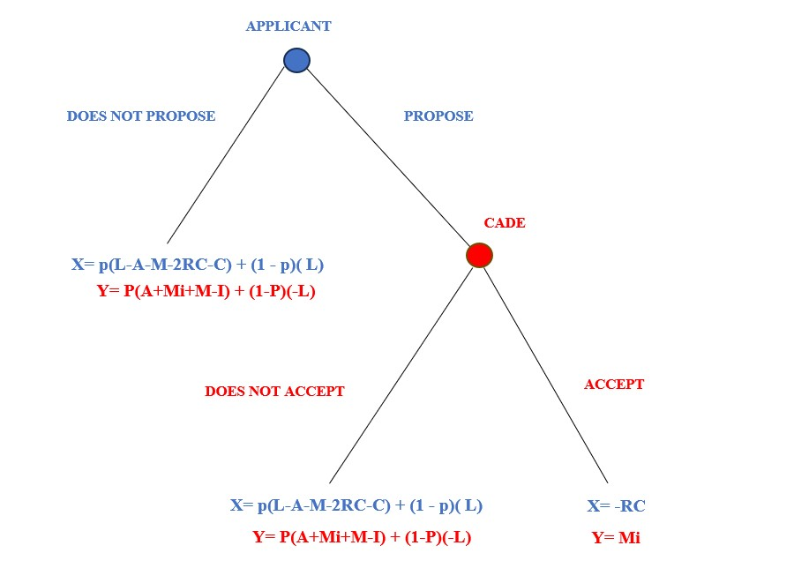
Source: Prepared by the author´s

It can be seen that by not proposing the leniency agreement to CADE, Applicant has a reward corresponding to the value of -13, the reward equation (X) being given by:

X= p(L- A-M-2RC-C) + (1 - p)( L)
X= p(20-5-20-2(20)-1) + (1-p)(20)
X= (0,5)(-46)+ (0,5)(20)
X= -13

However, if a leniency agreement is not proposed to CADE, it will receive a reward corresponding to the value of 41.5. The probability that CADE will detect and impose sanctions as a result of the leniency agreement, as well as the probability that CADE will not detect the cartel, which would incur investigation costs, must be taken into account. The reward equation (Y) is given by:

Y= P(A+Mi+M-I) + (1-P)(-L)
Y= (0,5) (5+4(20)+20-2) + (0,5) (-20)
Y= 41,5

In summary, if CADE accepts the Leniency Agreement proposed by the Applicant, it will receive a reward corresponding to 80, since, by signing the Leniency Agreement with the Applicant, CADE will become aware of the other members of the cartel and, consequently, it will be able to apply the financial sanction related to the practice of the cartel.
Given the decision of CADE to accept the proposed Leniency Agreement, the Applicant will be rewarded with -20, considering that RC= M. The leniency agreement, upon homologated by the CADE Court, extinguishes the Applicant´s liability for the infringement. The company may face civil liability for the damages caused by its participation in the cartel. Therefore, the equation for her reward (X) is given by:
X= -RC
X= -20

If the applicant proposes a leniency agreement, but it is rejected by CADE, then CADE will receive a reward of 41.5. The reward will be calculated in the same way as if the applicant does not propose a leniency agreement. Similarly, if CADE rejects the leniency agreement proposed by the applicant, then the applicant will receive a reward of -13.
Therefore, in order to analyze the sequential game of perfect information developed, it will be necessary to obtain the possible equilibrium of the game in question by applying the concept of Nash equilibrium.
The Nash equilibrium occurs when the strategy chosen by a given player is the best possible response to the strategies of the other players, and this is true for all the players involved.
Regarding the case of CADE, if the Applicant proposes a leniency agreement, the best decision that CADE can make is to accept the agreement, since it will receive a reward of 80, as opposed to a reward of 41.5 if it decides not to accept the agreement.
However, when considering the Applicant's case, the decision "does not propose" the leniency agreement provides a greater reward, since make that action, the Applicant's reward will be -13, whereas "propose" the leniency agreement, your reward will be -20.
In this case, the best decision to be made by the applicant is “Does not propose”, therefore, as it is a sequential game in which the applicant is the first player to make a decision, CADE's decision to “Accept” is not relevant to this first game, as this decision will not occur due to the first action made by the Applicant.
In a simplified way, we obtain a Nash equilibrium: (Do Not Propose), that is, the strategy that provides the best reward to the potential Applicant is not to propose the leniency agreement.
Therefore, in order to illustrate the impact of the immunity from civil liability for damages caused by the cartel on the leniency applicant, a second scenario will be drawn up in which the Brazilian competition law will be modified in such a way that the leniency applicant will also benefit from the immunity from civil liability for damages caused by the cartel.
In this regard, a proposed revision of the Brazilian antitrust leniency game is presented, with the introduction of an immunity from civil liability for damages caused by the practice of the cartel to the applicant of the leniency agreement:
Figure 2 - The Brazilian Antitrust Leniency Game Remodeled
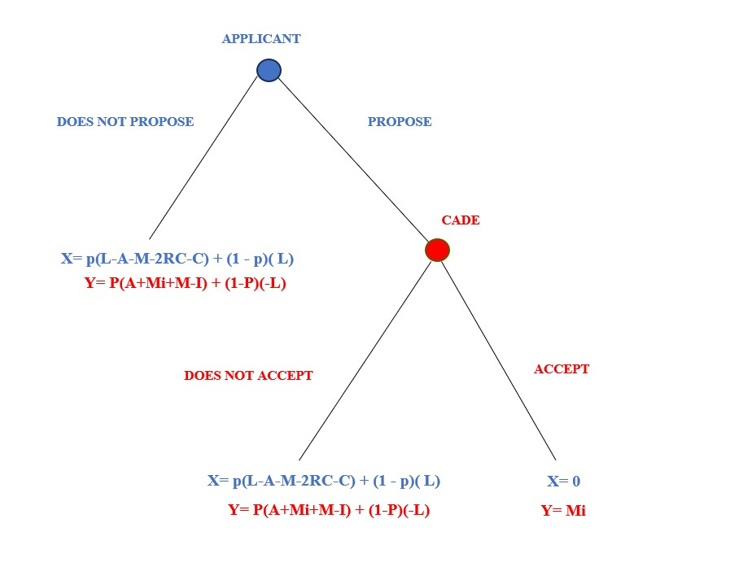
Source: Prepared by the author´s

It is evident that the Applicant receives a reward equal to -13 for not propose the Leniency Agreement to CADE, according to the previous reward equation (X).
However, if no Leniency Agreement is proposed to CADE, it will receive a corresponding reward of 40.5 according to the previous reward equation (Y).
In summary, if the applicant proposes the Leniency Application and CADE accepts it, a reward of Y=80 will be granted due to the financial sanctions that may be imposed on the other members of the cartel.
As a result of CADE's decision to accept the proposed leniency agreement, the applicant shall receive a reward value of 0. The leniency agreement, once ratified by the Administrative Court of CADE, will extinguish the applicant's liability for the infringement. Furthermore, the legislative modification introduced in this scenario, regarding the immunity from civil liability of leniency applicants will be applicable, therefore its reward equation (X) will be equal to 0.
If the applicant propose a leniency agreement but CADE rejects it, the applicant will receive a reward of -13, calculated in the same way as the reward for not proposing a leniency agreement. Otherwise, if CADE rejects the leniency agreement proposed by the applicant, CADE will obtain a reward of 41.5.
In simplified terms, we arrive at two Nash equilibrium: (Propose, Accept) and (Do Not Propose, Do Not Accept). The equilibrium consisting of the ordered pair (Do Not Propose, Do Not Accept) is irrational, since if the applicant had decided to propose the leniency agreement, the decision not to accept would lead to a smaller reward than the decision to accept, i.e. it would be an irrational choice.
Due to the limitations of the Nash equilibrium, which solely necessitates using strategies as best responses to each other without considering the order in which decisions are made, the backward induction method will be used to solve the preceding game. This approach involves examining the game in reverse, beginning from the players' pay-offs and then analyzing the first decision node that appears separately to determine the most optimal choices for each player.
In this regard, the chosen method will be employed to examine the potential subgame perfect equilibrium among the Nash equilibria in the extended form of The Second Brazilian Antitrust Leniency Game.

Figure 3 - The Backward Induction Method applied to the Brazilian Antitrust Leniency Game
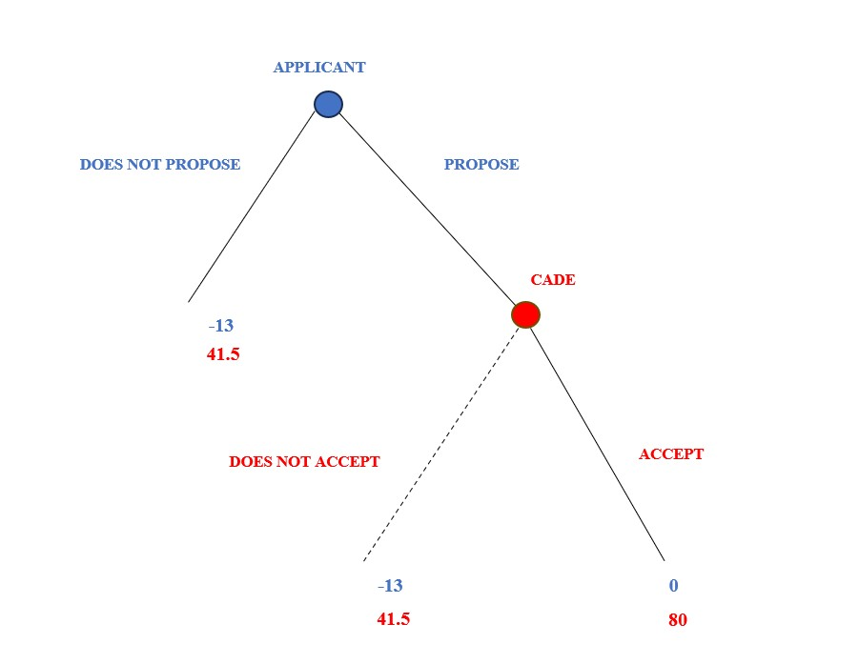
Source: Prepared by the author´s

The analysis of the final decision node shows that the action of (accept) the leniency agreement has a greater payoff for CADE, so the action of (does not accept) it will be eliminated.
In the analysis of the applicant potential actions, the action (Propose) of the leniency agreement offers a greater reward than (Does not propose), according to the game tree below:

Figure 4 - The Backward Induction Method applied to the Brazilian Antitrust Leniency Game
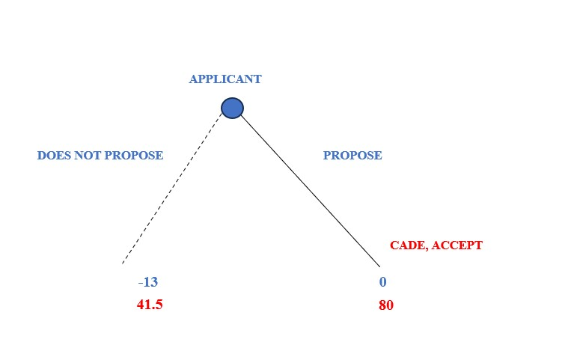
Source: Prepared by the author´s

Therefore, the perfect equilibrium in subgames is formed by the ordered pair (Propose, Accept), as this set of strategies provides the best actions for each player. Thus, after the introduction of the legislative amendment concerning the immunity from civil damages caused by the leniency applicant, the best option in cartel practice is to propose the leniency agreement, as opposed to the first game designed, in which proposing the leniency agreement is not the best course of action.

6. Conclusion
In the first modelled game, the equilibrium is formed by the ordered pair (Does not propose, Accept). Therefore, the best action for the company is to not propose the leniency agreement.
However, in the second game modelled, when the legislative change regarding immunity from civil damages caused by the leniency applicant is introduced, the best option for the company is to propose the leniency agreement, according to the methodology and scenario presented, and in both games it was assumed that there is a 50% probability that the cartel will be detected.
The analysis of the modelled games shows that, depending on the probability of detection of the cartel, the benefits and incentives provided by the leniency agreement may not outweigh the gains made by the offender over time. One widely discussed suggestion is the inclusion of immunity for the applicant in relation to civil damages caused by the cartel practice.
The legal actions for damage compensation are a crucial aspect to consider in public and private antitrust enforcement, apart from leniency policies. In Brazil, there is a tendency to encourage such legal processes, according to the legislative change in the Brazilian Antitrust Law made possible by Law No. 14,470/22. This article propose doubling reimbursement for harmed parties and limiting the liability of leniency applicants in cases involving direct buyers who are not jointly and severally liable, as evidenced by article 47, paragraphs 1, 2 and 3 of Law 12,529/11. However, the previous analysis indicates that encouraging damage claims without providing immunity to recipients is not the optimal approach to deter anti-competitive practices, as it may decrease incentives to report such conduct. Therefore, the challenge for Brazilian antitrust policies is to strike a suitable balance between promoting lawsuits for damage compensation and maintaining incentives for cooperation with antitrust authorities.
Therefore, leniency programs face a delicate balance. They can improve the detection and deterrence of cartels, benefiting competition and consumers. However, they can also contribute to the stabilization of cartels that remain, resulting in increased prices that may harm consumers. Therefore, it is imperative that antitrust authorities and regulators thoroughly evaluate the execution of these initiatives and weigh their impact on both competition and the overall economy.

References
Bierman HS and Fernandez LF, Teoria Dos Jogos (2nd edn, Pearson Prentice Hall 2011)
Bigoni M and others, ‘Fines, Leniency, and Rewards in Antitrust’ (2012) 43 The RAND Journal of Economics 368
Bodnar O and others, ‘The Effects of Private Damage Claims on Cartel Activity: Experimental Evidence’ (2023) 39 The Journal of Law, Economics, and Organization 27
Buccirossi P, Marvão C and Spagnolo G, ‘Leniency and Damages: Where Is the Conflict?’ (2020) 49 The Journal of Legal Studies 379
CADE, Guia do Programa de Leniência Antitruste do CADE (Conselho Administrativo de Defesa Econômica 2016)
Leslie CR, ‘Antitrust Amnesty, Game Theory, and Cartel Stability’ (2006) 31 Journal of Corporation Law 453
Luz RD and Spagnolo G, ‘LENIENCY, COLLUSION, CORRUPTION, AND WHISTLEBLOWING’ (2017) 13 Journal of Competition Law & Economics 729
Marvão C and Spagnolo G, ‘Cartels and Leniency: Taking Stock of What We Learnt’ (2018) 2 Handbook of game theory and industrial organization 57
Motta M and Polo M, ‘Leniency Programs and Cartel Prosecution’ (2003) 21 International journal of industrial organization 347
OECD, OECD PEER REVIEWS OF COMPETITION LAW AND POLICY: BRAZIL (Organisation for Economic Co-operation and Development- OECD 2019)
Osborne MJ, An Introduction to Game Theory, vol 3 (Oxford university press 2004)
Pinha LC and Braga MJ, ‘Leniency and Damage Liability for Cartel Members in Brazil’ (2021) 17 Journal of Competition Law & Economics 877
Rasmusen E, Games and Information: An Introduction to Game Theory (4th edn, Wiley-Blackwell 1990)
Silbye F, ‘A Note on Antitrust Damages and Leniency Programs’ (2012) 33 European Journal of Law and Economics 691
Silveira PB da, Direito Da Concorrência (Forense 2020)
Brasil, Define crimes contra a ordem tributária, econômica e contra as relações de consumo, e dá outras providências 1990 [LEI Nº 8.137, DE 27 DE DEZEMBRO DE 1990]
——, Transforma o Conselho Administrativo de Defesa Econômica (CADE) em Autarquia, dispõe sobre a prevenção e a repressão às infrações contra a ordem econômica e dá outras providências 1994 [LEI Nº 8.884, DE 11 DE JUNHO DE 1994]
——, Altera e acrescenta dispositivos à Lei no 8.884, de 11 de junho de 1994, que transforma o Conselho Administrativo de Defesa Econômica – CADE em autarquia, dispõe sobre a prevenção e repressão às infrações contra a ordem econômica, e dá outras providências 2000 [LEI No 10.149, DE 21 DE DEZEMBRO DE 2000]
——, Estrutura o Sistema Brasileiro de Defesa da Concorrência; dispõe sobre a prevenção e repressão às infrações contra a ordem econômica; altera a Lei nº 8.137, de 27 de dezembro de 1990, o Decreto-Lei nº 3.689, de 3 de outubro de 1941 - Código de Processo Penal, e a Lei nº 7.347, de 24 de julho de 1985; revoga dispositivos da Lei nº 8.884, de 11 de junho de 1994, e a Lei nº 9.781, de 19 de janeiro de 1999; e dá outras providências 2011 [LEI Nº 12.529, DE 30 DE NOVEMBRO DE 2011]
——, Altera a Lei nº 12.529, de 30 de novembro de 2011 (Lei de Defesa da Concorrência), para prever novas disposições aplicáveis à repressão de infrações à ordem econômica 2022 [LEI Nº 14.470, DE 16 DE NOVEMBRO DE 2022]
CADE, Aprova o Regimento Interno do Conselho Administrativo de Defesa Econômica 2019 [Resolução nº 22, de 19 de junho de 2019]

CADE, Aprova o Regimento Interno do Conselho Administrativo de Defesa Econômica 2019 [Resolução nº 22, de 19 de junho de 2019] 56–57.
Christopher R Leslie, ‘Antitrust Amnesty, Game Theory, and Cartel Stability’ (2006) 31 Journal of Corporation Law 453.
Massimo Motta and Michele Polo, ‘Leniency Programs and Cartel Prosecution’ (2003) 21 International journal of industrial organization 347.
Catarina Marvão and Giancarlo Spagnolo, ‘Cartels and Leniency: Taking Stock of What We Learnt’ (2018) 2 Handbook of game theory and industrial organization 57, 67.
Paolo Buccirossi, Catarina Marvão and Giancarlo Spagnolo, ‘Leniency and Damages: Where Is the Conflict?’ (2020) 49 The Journal of Legal Studies 379, 377.
Frederik Silbye, ‘A Note on Antitrust Damages and Leniency Programs’ (2012) 33 European Journal of Law and Economics 691, 699.
Olivia Bodnar and others, ‘The Effects of Private Damage Claims on Cartel Activity: Experimental Evidence’ (2023) 39 The Journal of Law, Economics, and Organization 27, 7.
Maria Bigoni and others, ‘Fines, Leniency, and Rewards in Antitrust’ (2012) 43 The RAND Journal of Economics 368, 390.
Brasil, Altera e acrescenta dispositivos à Lei no 8.884, de 11 de junho de 1994, que transforma o Conselho Administrativo de Defesa Econômica – CADE em autarquia, dispõe sobre a prevenção e repressão às infrações contra a ordem econômica, e dá outras providências 2000 [LEI No 10.149, DE 21 DE DEZEMBRO DE 2000].
Brasil, Transforma o Conselho Administrativo de Defesa Econômica (CADE) em Autarquia, dispõe sobre a prevenção e a repressão às infrações contra a ordem econômica e dá outras providências 1994 [LEI Nº 8.884, DE 11 DE JUNHO DE 1994].
CADE Aprova o Regimento Interno do Conselho Administrativo de Defesa Econômica (n 1) 56–57.
CADE, Guia do Programa de Leniência Antitruste do CADE (Conselho Administrativo de Defesa Econômica 2016) 18.
Brasil, Estrutura o Sistema Brasileiro de Defesa da Concorrência; dispõe sobre a prevenção e repressão às infrações contra a ordem econômica; altera a Lei nº 8.137, de 27 de dezembro de 1990, o Decreto-Lei nº 3.689, de 3 de outubro de 1941 - Código de Processo Penal, e a Lei nº 7.347, de 24 de julho de 1985; revoga dispositivos da Lei nº 8.884, de 11 de junho de 1994, e a Lei nº 9.781, de 19 de janeiro de 1999; e dá outras providências 2011 [LEI Nº 12.529, DE 30 DE NOVEMBRO DE 2011].
ibid.
Reinaldo Diogo Luz and Giancarlo Spagnolo, ‘LENIENCY, COLLUSION, CORRUPTION, AND WHISTLEBLOWING’ (2017) 13 Journal of Competition Law & Economics 729, 12.
Brasil, Altera a Lei nº 12.529, de 30 de novembro de 2011 (Lei de Defesa da Concorrência), para prever novas disposições aplicáveis à repressão de infrações à ordem econômica 2022 [LEI Nº 14.470, DE 16 DE NOVEMBRO DE 2022].
Brasil Estrutura o Sistema Brasileiro de Defesa da Concorrência; dispõe sobre a prevenção e repressão às infrações contra a ordem econômica; altera a Lei nº 8.137, de 27 de dezembro de 1990, o Decreto-Lei nº 3.689, de 3 de outubro de 1941 - Código de Processo Penal, e a Lei nº 7.347, de 24 de julho de 1985; revoga dispositivos da Lei nº 8.884, de 11 de junho de 1994, e a Lei nº 9.781, de 19 de janeiro de 1999; e dá outras providências (n 13).
ibid.
OECD, OECD PEER REVIEWS OF COMPETITION LAW AND POLICY: BRAZIL (Organisation for Economic Co-operation and Development- OECD 2019) 63.
ibid 64.
ibid.
Martin J Osborne, An Introduction to Game Theory, vol 3 (Oxford university press 2004); Eric Rasmusen, Games and Information: An Introduction to Game Theory (4th edn, Wiley-Blackwell 1990).
H Scott Bierman and Luis Florentin Fernandez, Teoria Dos Jogos (2nd edn, Pearson Prentice Hall 2011) 112.
Osborne (n 22); Rasmusen (n 22).
Bierman and Fernandez (n 23) 112.
Leslie (n 2).
ibid 458.
ibid 459.
ibid.
ibid.
ibid.
(n 2).
Brasil, Define crimes contra a ordem tributária, econômica e contra as relações de consumo, e dá outras providências 1990 [LEI Nº 8.137, DE 27 DE DEZEMBRO DE 1990].
Direito Da Concorrência (Forense 2020) 75.
Rasmusen (n 22) 168.
Lucas Campio Pinha and Marcelo José Braga, ‘Leniency and Damage Liability for Cartel Members in Brazil’ (2021) 17 Journal of Competition Law & Economics 877, 35.

